# Four members of the band performing in a playground. Two of the band members stand on colourful with their arms raised in the air. The singer is in a wheelchair in front of them, and a sousaphone player behind them. They are all wearing colourful festival costumes and smiling at the audience who are out of shot.

Doorstep Jamboree. Credit: Suzi Corker

# The Uncancellable Programme by Oily Cart Sensory and inclusive theatre created for and with disabled children, young people and their families during and post-COVID-19 times

Dr Maria Varvarigou, October 2021

This is a condensed version of the report. For the full report, and different formats of both the condensed and full report, please visit: <https://oilycart.org.uk/resources/the-uncancellable-programme-report/>

# Foreword by Jenny Sealey MBE

Artistic Director/ CEO of Graeae Theatre

It is a brave company that puts themselves under evaluative scrutiny in the middle of a pandemic when none of us knows the rules!

It is imperative to remember the impact of the pandemic on young disabled people and their families and how side-lined they have been without resources and support to navigate such uncharted waters. The pandemic has sorely exposed the inequality in our society on many levels and it is those theatre companies who have human rights at the centre of their ethos that have been a shining light.

The young people and their families who have had the Oily Cart experience have been inspired, felt a sense of belonging and a relief that finally someone understands and is listening to them and wants to be in their world.

This creatively intense report covers an extraordinary intense moment in our lives and cements the true value of what this company is about – Resilience, Innovation, Care, Respect and Wisdom, Openness and Honesty, and Dare.

These elements have been the bedrock of Oily Cart since day one, so I expected nothing less. Now with Ellie Griffiths and Zoë Lally leading a new team, this has been amplified, with added gold dust.

By access, I mean emotional, visceral and communicative access, at the heart of the artistic endeavour. The process is challenging because it is never a case of one glove fits all.

This report is not a guide on how to make sensory theatre, but on what it can be, how it is received and how bloody important it is.

The report challenges normative theatre making processes and for me, it exposes the rigidity, stuffiness and elitism of mainstream ways of working and oh how I wish the mainstream world would be brave enough to invest and break rules as Oily Cart does.

We all need to learn from Oily Cart’s incredibly rich, complicated, frustrating, risk-taking, moving and epic journey to NOT CANCEL ANYTHING.

A world without Oily Cart would be truly rubbish. Read this and applaud them as I did, and keep an eye / ear out for what they will do next. I most certainly will.

# **Contents**

Language Note p. 3

About the Author p. 3

Chapter 1: Introduction and Background p. 4

Chapter 2: Evaluation Aims and Methods p. 8

Chapter 3: Doorstep Jamboree p. 11

Chapter 4: Space to Be p. 18

Chapter 5: Something Love p. 25

Chapter 6: Conclusions and Key Messages p. 30

Bibliography p. 36

Oily Cart would like to thank the following organisations for their generous support:

Arts Council England, BBC Children in Need, Esmée Fairbairn Foundation, Garfield Weston Foundation, The Leathersellers’ Company Charitable Fund, The Rix-Thompson-Rothenberg Foundation and the Baily Thomas Charitable Fund, Taurus Foundation, True Colours Trust, Wandsworth Council

Ref. Charity No. 1000799

 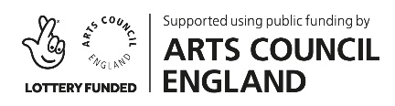

## Language Note

Oily Cart’s work is underpinned by the Social Model of Disability, which was developed by the disabled community. Under the Social Model, a person is disabled by barriers within society rather than a health condition, impairment or difference. Oily Cart is moving away from medicalised and institutionalised labels that are common in school and hospital settings, and is committed to using language that comes from a place of ownership, to describe the individuals they work with and for. Oily Cart use this language in line with identity-first language, e.g. ‘Autistic child’, which is preferred by many in the Autistic community, while acknowledging this will not fit with some Autistic individual’s preference for person-first language.

## About the author

Maria Varvarigou is a Lecturer in Music Education at Mary Immaculate College, University of Limerick. Maria has been researching the impact of music making on health and wellbeing across the lifecourse, effective music teaching and learning in higher and professional education and in primary school education, and intergenerational music making for many years. She is currently researching the impact of facilitating therapeutic community music for others on the quality of life of student musicians. Maria is passionate about aural music learning, traditional musics, and group singing. She is the co-author of two books: *Active Ageing with Music: supporting wellbeing in the Third and Fourth Ages* (2014) published by the IoE University Press; and *Contexts for Music learning and participation: developing and sustaining musical possible selves through informal, non-formal and formal practices* (2020) published by Palgrave.

## A note from the author

I would like to acknowledge that I am not disabled. I am grateful, therefore, to the disabled and non-disabled members of the Oily Cart team for the unreserved support that they offered me on how to communicate and present the findings from the *Uncancellable Programme* in a more inclusive way.

### Chapter 1: Introduction and Background

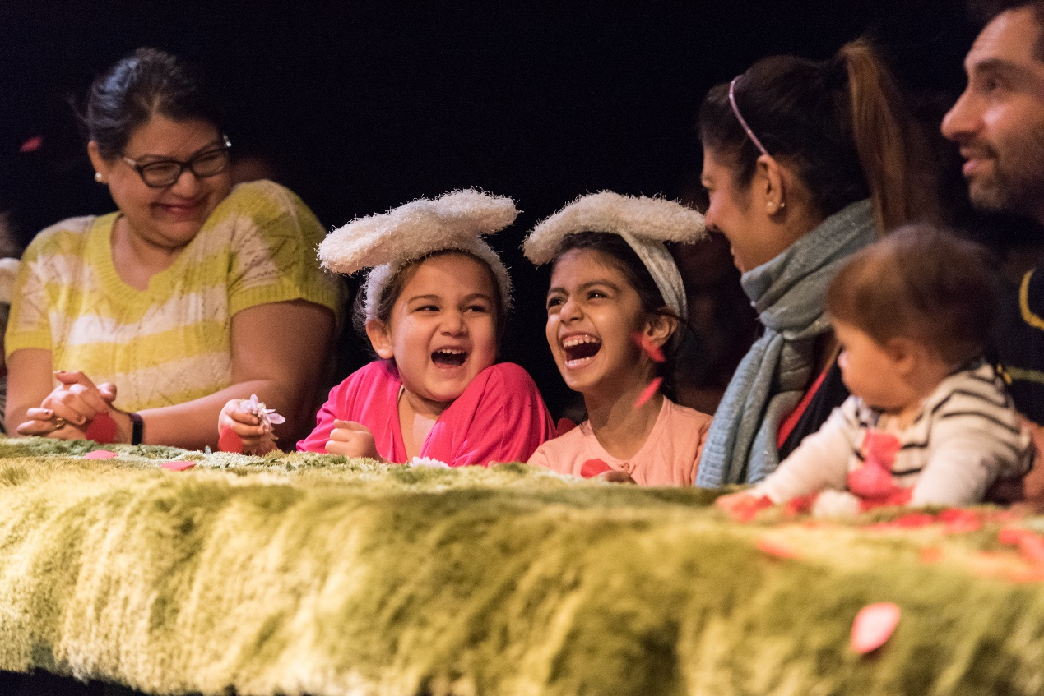

In A Pickle (2016). Credit: Neal Houghton

**About Oily Cart**

Oily Cart has been creating innovative, sensory and highly interactive productions for and with children and young people since 1981. These productions have toured across the UK and internationally. The organisation was founded by Tim Webb MBE, Claire de Loon and Max Reinhardt, who aspired to make theatre more democratic, and for places where theatre had never been before. In 1988 the company began creating work for disabled and Autistic children and young people.

From early on, Oily Cart has begun the creative process of their productions ‘from the ground up’, by thinking about the people with the most barriers to access first. Therefore, their point of departure has been working in a sensory way. Oily Cart productions use sounds, smells, touch, light, music and movement to create immersive imaginary worlds. Past shows have seen audiences floating in hydrotherapy pools, bouncing on a trampoline or even flying up in the air. More importantly, Oily Cart productions and projects are made for and with children and young people, regardless of their age or barriers to access.

Ellie Griffiths, the Artistic Director of Oily Cart, describes sensory theatre as follows:

Sensory theatre acknowledges the whole of each person in the audience, young person or adult, treating every sense with equal respect. People often say that we have 5 senses whereas actually we have 33. This offers us a much broader palette to work with creatively than most theatre makers make use of. At Oily Cart we work to create moments of beauty, that are not just visual. One of the most accessible performance languages is touch.  This quote is from Margaret Atwood, and it says “Touch comes before sight, before speech. It is the first language and the last, and it always tells the truth.” Sensory theatre goes beyond words and strips back to what is human. It values embodied, intuitive knowledge just as much as intellectual knowledge. In this way, it levels the playing field, and gives audiences of different abilities and perspectives equal opportunity to enjoy and contribute.[1]

During the COVID-19 pandemic Oily Cart has been exploring ways to expand its reach and make sensory theatre accessible to disabled children and young people who are shielding. Unable to create close-up, interactive shows that use touch as a central technique, or tour to theatres, schools, or any of the places the company normally perform, Oily Cart reimagined the entire format of how they usually work.

The *Uncancellable Programme* was the company’s response to the COVID-19 pandemic to ensure that the organisation could continue to create theatre for and with their audience in a safe way*.* The programme included three projects: **Doorstep Jamboree**, **Space to Be** and **Something Love**.

**The Context**

The COVID-19 pandemic has profoundly changed the daily life routines of many families and young children around the world. A study by Morgül, Kallitsoglou and Essau (2020) found that the emotions and behaviours of children in the UK were very much impacted by the pandemic. For example, from a sample of 927 caregivers who filled in an online survey between July and August 2020, it emerged that the children being cared for (their age range was 5-11 years) were

‘…bored (73.8%), lonely (64.5%), sad (43.4%), frustrated (61.4%), irritable (57.1%), restless (52.9%), worried (52.4%), angry (48.6%), anxious (45.2%), and were more likely to argue with the rest of the family (29.7%) during the lockdown compared to the pre-COVID-19 period’ (p. 45).

In the same vein, a report commissioned by Disabled Children’s Partnership (2021) entitled *‘#LeftInLockdown – Parent carers’ experiences of lockdown’*, shed light on the challenges that the lockdowns of the COVID-19 pandemic have created for disabled children and young people and their families. Similarly to the study by Morgül, Kallitsoglou and Essau (2020), this report also found that the parents experienced increased caring responsibilities for themselves and the disabled children’s siblings, as well as expressed concerns about the disabled children’s behaviour and mental wellbeing. In particular:

* 72% of the parents reported that during lockdown they were providing a lot more care compared with the amount before lockdown.
* 68% also reported that non-disabled siblings were also providing a lot more care.

Families reported experiencing a decline in both mental and physical health, which was often the result of financial and other support being withdrawn:

* 70-80% of parents reported worsening emotional and mental health for both their children and themselves, although a minority reported improvements
* Parents also reported that lockdown was having a negative impact on their children’s friendships (83%), learning and communication (86%), behaviour and emotions (87%), mental health (78%), general health (67%) and disability (64%)[2].

As individuals and communities are starting to envision a new future beyond the pandemic it is worth considering how the arts in general, and sensory and inclusive theatre in particular, could contribute to rebuilding disabled children’s and young people’s confidence to return to cultural venues post-lockdown, whilst also recognising the ongoing need for cultural offers for those who face barriers to attending in-person events.

Andrew Miller, the first UK Government Disability Champion for Arts and Culture and co-founder of #WeShallNotBeRemoved[3], compared the responses of people who self-identified as disabled with those who self-identified as non-disabled to a national audience survey launched by Indigo in the summer of 2020. The findings underscore a disparity in the attitudes of disabled versus non-disabled people to returning to cultural venues post lockdown. For instance, of the 4,000 (15%) who identified as disabled, 77% considered themselves to be ‘vulnerable to Coronavirus’, whilst only 28% of non-disabled audience members reported being at risk. That has ramifications for on-site visits to cultural venues and the booking of tickets for live shows. Furthermore, 26% of disabled audiences reported that they will not consider returning to venues at all until a vaccine or treatment for Coronavirus is available, whilst 41% reported considering returning to venues that implement social distancing regulations alongside appropriate hygiene measures.

Interestingly, digital engagement emerged as a viable alternative, with disabled people reporting that they would consider attending events that are available online. Yet, Andrew Miller underscored that many disabled people in the Indigo survey lacked confidence in using technology. Additionally, through anecdotal conversations with families who have accessed digital theatre, it appeared that digital theatre experiences were not always particularly accessible to or meaningful for disabled people who experience barriers to seeing or hearing, as well as for people who don’t communicate verbally. What is more, there are inequalities when it comes to disabled people’s internet access. The Glasgow Disability Alliance, for instance, reported that only a third of disabled people in Glasgow had access to home broadband or IT during the pandemic. Therefore, although digital engagement could potentially make theatre more accessible to disabled people who have home broadband or IT, theatre companies should really explore new ways of making theatre experiences not only accessible but also meaningful and enjoyable for their target audience.

As vaccinations against COVID-19 become available, the arts sector should be strategic about how to re-engage disabled people with the arts making sure that all possible barriers to access and engagement are removed.

### Chapter 2: Evaluation Aims and Methods

The evaluation of the *Uncancellable Programme* investigated three areas related to sensory theatre productions created for and with disabled young people and their families.

Firstly, with a focus on the **audiences**, this report examined the perceived impact of the three projects on the people who participated and experienced the productions physically and over online platforms, through

* An analysis of the results of the Impact and Insight Surveys (IIS) to participant families, as well as advisors from the creative team of *Oily Cart* and peer evaluators *(*for *Doorstep Jamboree, and Space to Be)*;
* An analysis of responses to an additional set of questions from a peer evaluator (*for Doorstep Jamboree*); and
* An analysis of Case Studies and videos from all three projects.

Secondly, with a focus on the **organisation**, this report considered

* Whether Oily Cart met their intended aims for each of the three projects; and
* Links between the findings from this evaluation and Oily Cart’s Business plan / Theory of Change, for instance any reported impact under the organisation’s key objectives: Shows and Creative projects; Exploration; Creative Diversity; Driving Change; and Resilience.

Thirdly, with a focus on **practice** for the future, this report

* Presents and compares the three projects in terms of their outreach impact and the response of diverse audiences to the different types of activities / opportunities for engagement offered;
* Reflects on which models of practice were effective, and which could have benefits beyond the pandemic;
* Explores ways for Oily Cart to gather feedback from young people who communicate differently and do not rely on verbal language; and
* Shares the overall learning experiences at audience, organisation and practice level with the wider sector.

At this stage it is important to recognise that the disabled children’s and young people’s voices weren’t really represented in the data. Collecting responses on the personal experiences of disabled young people is not an easy task neither for the parent / carer attending the shows alongside the child or young person, nor for the researchers. This is an area that merits careful attention from practitioners and researchers in the fields of disability and the arts, so that future projects can be more effective at capturing the voices of all the audience members and the artists involved. With young people who do not communicate through verbal language, this is a vital intention, but in reality, this may take years to take small steps towards.

The different data collected and analysed includes:

**Audience Feedback Surveys -** distributed to parents, carers and observers attending the performances. These included questions on Performance Dimensions (core dimensions set by Arts Council England’s Impact and Insight Toolkit). These were:

* **Captivation** – the extent to which the shows held the audience’s interest and attention;
* **Rigour** – the extent to which the shows were well thought through and put together;
* **Distinctiveness** - the extent to which the shows were different from things the audience had experienced before;
* **Relevance** - the extent to which the shows had something to say about today’s world;
* **Challenge** - the extent to which the shows challenged the audience to think in a different way;
* **Local Impact** - the extent to which it was important for the shows to happen through the different types of delivery;
* **Concept** - the extent to which the shows were an interesting idea; and
* **Innovation** - the extent to which the shows were introduced to the audience in a different way.

The surveys also included a series of statements, framed as continuum scales ranging from Strongly Disagree (0) to Strongly Agree (100). Each survey participant could select any point on the continuum, open questions and demographic information.

## **Creative Team and Peer Evaluator Feedback Surveys –** one pre- and one post- the performances for members of the creative team; and one post-performance for the peer evaluators. Like the audience feedback survey, these included Performance Dimension questions (with the addition of Excellence, Originality and Risk), statements framed as continuum scales and open questions.

**Online Artist Surveys -** for *Something Love*, the artists received an online survey that included three questions: (1) what worked well? (2) what could we do differently in the future? and (3) any other comment.   
  
**Peer Evaluator Additional Questions –** a peer evaluator for Doorstep Jamboree also answered a further set of questions focused on collaborating with, reaching and advocating for disabled audiences and artists during and post-COVID-19.

### 

### **Case Studies –** transcribed conversations with families / artists who participated in the projects.

### **Videos / photographs –** footage and images from all three projects have been viewed by the evaluator, with observations informing the analysis of the findings from the other methods detailed above.

### Chapter 3: Doorstep Jamboree

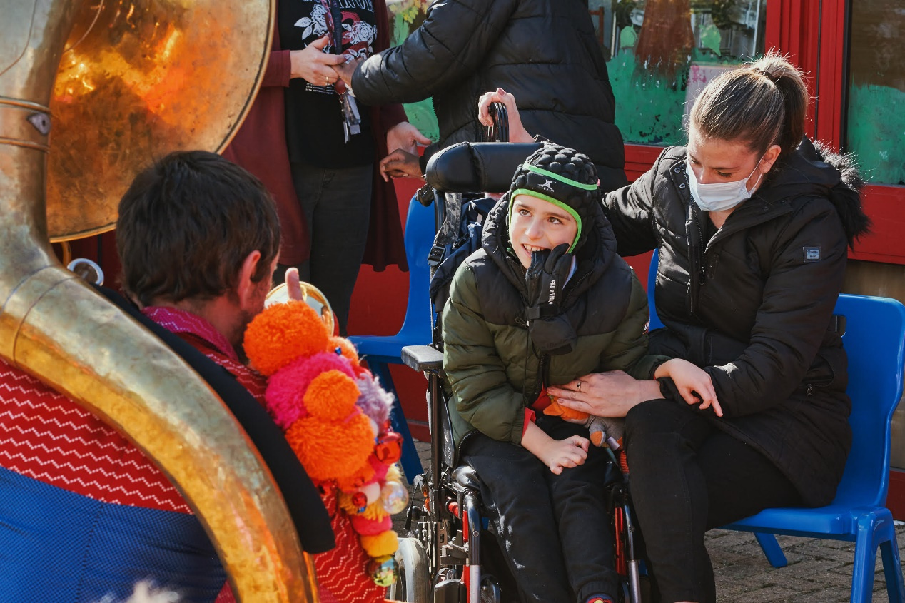

Doorstep Jamboree. Credit: Suzi Corker

*Doorstep Jamboree* is an adaptation of the show Jamboree, a piece of gig-theatre made for and with disabled young people. The premise of the show is that the audience are receiving a visit from the travelling Jamboree band, who play Balkan-inspired music. The band collect tunes on their travels, making music with all the young people they meet. In *Doorstep Jamboree*, the band performed gigs on families’ doorsteps, in school playgrounds, or via Zoom, playing tunes that had each been inspired or influenced by a young person they had collaborated with (during a series of school workshops across the UK in the previous *Jamboree* tour). As part of *Doorstep Jamboree*, audience and cast enjoyed shared musical experiences, with the young people controlling the musical set list and improvising with the band.

There were **31 performances** attended by **129 young people.**

**Key points**

* The participating audience, the creative team and the external evaluator gave very high ratings to *Doorstep Jamboree* for all Performance Dimensions.
* There were three different types of performance of *Doorstep Jamboree*: on people’s doorstep, on school playground and through the online app Zoom. The Zoom Performances reportedly achieved a more direct dialogue between the performers and the participating audience compared to the other two types of performance.
* For the first time in Oily Cart sensory theatre productions, the music was co-created with disabled young people, and the audience could improvise with the musicians and exercise control over the set list in performances.
* The music, including personalised songs featuring the young person’s name, were identified as the most effective element of the show, followed by the costumes, use of movement and dance, the props; and audience-performers’ interactions.
* *Doorstep Jamboree* included a diverse cast: disabled and non-disabled performers, as well as performers from different cultural backgrounds. This approach to casting promoted Creative Diversity.
* The format and content of *Doorstep Jamboree* were developed through collaborative conversation amongst the cast, the creative team, the audience and peer evaluators.
* By delivering the show in open spaces such as people’s gardens or school playgrounds Oily Cart managed to bring the community together raising the visibility of disabled children and young people in our societies as well as the profile of disabled audience as artists.
* The three different types of performance offered variety of access to the participating audience. The Zoom performance emerged as the most effective model for co-creating and delivering sensory theatre beyond the pandemic.

## **Responses to Rating Scales**

Audience survey respondents’ experience (average):

* 94% felt that *Doorstep Jamboree*was safe and well thought-through in terms of COVID-19 precautions.
* 94% would recommend the *Doorstep Jamboree*experience to others.
* 93% found *Doorstep Jamboree*an enjoyable shared experience.
* 92% reported that the young person / people responded well to the live music of *Doorstep Jamboree.*
* 92% reported that the experience was fun for the young person / people attending

When asked to describe their experience of the performance in three words, respondents used words such as *unique, fun, joyous, magical, enchanting, enjoyable, interesting, inclusive, captivating, engaging and mesmerising*.

The creative team reported an increase on their ranking of the performance dimensions after the show, compared to their ratings before the show was shared with the audience. This could be due to their uncertainty as to how the audience would respond to this innovative show. Similarly, the creative team was modest when rating *Doorstep Jamboree* before the performance was launched compared to the peer evaluators who rated the performance after it was launched.

**Comparing the creative team’s ‘before’ and ‘after’ responses**

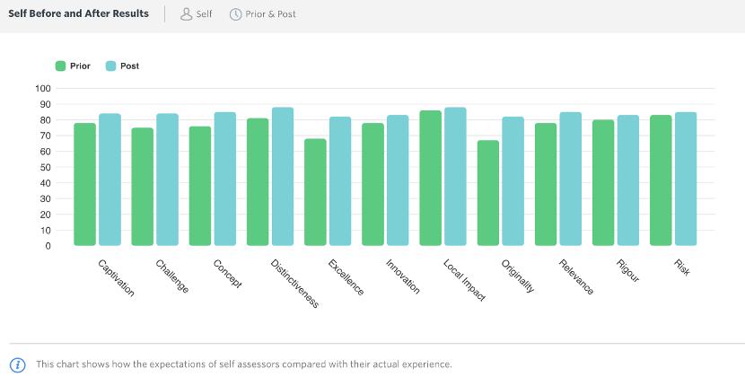

**Comparing the creative team’s ‘before’ and the peer evaluators’ ‘after’ responses**

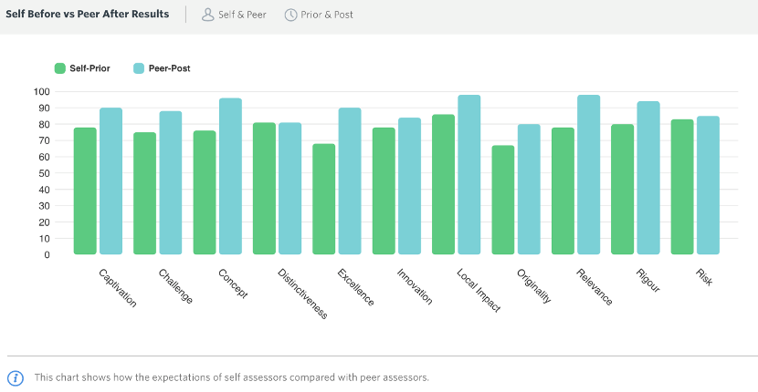

## **The most impactful components of *Doorstep Jamboree***

On the elements of the show that were particularly liked by the young person / people attending the responses identified the **music** as the element liked the most. The responses about the power of music in stimulating the audience in sensory and inclusive theatre productions is consistent with responses from previous evaluation reports on Oily Cart shows (Varvarigou, 2016; 2017; 2018; 2019). In particular the audience commented on how *‘the change in tone of voices and sounds’, ‘the changes in speed’, ‘the changes in beat and tempo’,* the musical instruments, and ‘*the variety in rhythms’* attracted the participants’ attention and mesmerised them.

The **costumes** were colourful and bright and equally captivating. The audience recognised that the combination of music, movement through dancing, and visuals (bright costumes and attractive props) resulted in a *‘unique, magical, captivating, and mesmerising’* performance.

Our son was, in the first instance, astounded to see the Jamboree hosts in striking **costumes** saying hello to him. Even more, he stood enthralled, delighted to make choices of songs to perform the special gig for him! He remained spellbound as the whole show was tailor-made for him… He thoroughly enjoyed the unique **music**, and was mesmerised by the flow of **rhythm** and captured by the **speed of the songs** - slow, faster and slower!! The Jamboree artists and musicians enchanted him in stunning **costumes** [,] individually interacting with him in such careful details - singing to him, dancing with him, personally coming near to the screen, talking though the stages of the gig and unwrapping the story of each unique songs… He certainly felt he was part of the entire **special musical show**!! And for us, we were thrilled to know how the whole team was dedicated to deliver such an exceptional performance to children and families like ours [,] beginning with chatting through our little boy's personal preferences. This was a magical show for our entire family!!! (Zoom Performance)

Unlike responses that appeared in previous Oily Cart evaluations (Varvarigou, 2018; 2019), the use of props appeared to be less commented on by the participants. This was probably due to COVID-19 restrictions that constrained the performers to favour aural and visual stimuli over tactile or olfactory stimuli, so that a safe distance amongst performers and audience was guaranteed. Finally, some participants appreciated the opportunities that the young people had to be addressed by name and to interact directly with the performers. It was also noted by one family that the package they received by Oily Cart prior to the performance, containing a social story, sensory instrument and ideas sheet, enabled them to better follow the performance and take advantage of the moments for interaction.

When asked to identify the most effective elements of the show, the creative team and peer evaluators offered a similar response to the audience, recognising that live **music** was very powerful in encouraging participation and enjoyment. They also expressed the view that *Doorstep Jamboree* was successful because of its **outdoor format** and the fact that the performances were **personalised** (for small, family audiences).Other elements identified were the show’s flexibility and responsiveness to the needs of the audience – *‘the carefully tailored unique* ***modes of delivery’*** and the high levels of **expertise of the cast** in making each performance not only a musically, vocally and artistically excellent performance, but an inclusive one. Furthermore, the use of **movement** brought ‘to life the costumes and props’.

To the question inquiring about the most effective elements of *Doorstep Jamboree*, the creative team and peer evaluators referred to the three different COVID-safe formats of the same show and the fact that the cast explored different ways of finding connection and intimacy without relying on physical contact. In particular, the Zoom performances were commended for retaining the sensory and interactive character of Oily Cart shows.

## 

## **The social impact of *Doorstep Jamboree***

*Doorstep Jamboree* offered socially distanced, mobile and versatile sensory theatre experiences; visible to the wider community, as well as accessible through online platforms such as Zoom.

Performances managed to bring the community together and to raise awareness with regard to disabled people. This is probably a significant finding with reference to performances outside people’s homes or in school playgrounds, in contrast to Zoom performances. Being visible as a disabled person by attending and participating in a live face-to-face performance, such as in a garden or at one’s doorstep, allowed members of the community, such as neighbours, to also feel part of the experience. This led to new relationships being formed and to a recognition of the needs of individuals who experience social exclusion, in particular disabled individuals or older people:

*This is the best performance group I have ever known which caters for people with disabilities - the Jamboree performance was enthralling and the positive phrases used support young people to build* ***confidence and feel empowered****. (Survey)*

*It was nice* ***community engagement****. It was really nice because normally you feel that you’re the ones taking from the road and the community – you know, you have constant cars outside the house and deliveries and people taking your parcels for you because you’re busy and all the rest of it. So, having something that gave them [the neighbours] something back, even in a small way, was really nice. (Case Study)*

Peer Evaluator, Daryl Beeton, indicated that *Doorstep Jamboree* allowed the voices of disabled young people to be heard through facilitating interaction such as sharing the control over the order of the playlist of the songs with the audience.

Secondly, *Doorstep Jamboree* raised the public’s awareness about disabled people as artists:

*I wasn't expecting there to be a 'political' [side] (I say this with a small but important 'p') to the situation we are faced with. This was led by the guest artists, Miss Jacqui, which I felt gave a very different feel/edge to the work. Therefore, I felt the doorstep version lacked this.* ***If the guest artist can’t be there then how does their voice still be heard or be visual on the doorstep****?... Oily Cart has a strong position due to its profile to be more political and be the voice of those who don’t have one. They should continue to develop and* ***include disabled artists*** *within their work, only then will a true voice start to direct, and be the best voice, the advocacy.*

Thirdly, it was reported that *Doorstep Jamboree* reached families who were shielding and engaged them in *‘personalised and intimate experiences, despite social distancing’.* Two of the post-survey participants, in particular, stated that they found the Zoom performances particularly successful in engaging the audience in a personalised manner. Daryl Beeton identified the Zoom performance, as opposed to the other two types of performances, as the one that achieved a two-way dialogue between audience and cast most effectively. He also found the Zoom performance as the most effective in reaching families who were shielding. Nonetheless, he argued that although the Zoom performance offered a fuller show, *Doorstep Jamboree* performances on doorsteps or in school playgrounds, brought the show to life in a way that cannot be achieved through Zoom.

## **The future**

The audience members were invited to suggest changes in the *Doorstep Jamboree* productions so that they better meet the needs of the audience. Similar to previous evaluations of Oily Cart productions (Varvarigou, 2016; 2017; 2018; 2019), very few audience members offered suggestions, stressing that the performance *‘was perfect’* and needed no change. One audience member proposed the **use of sign language** to better support the experience of disabled children with hearing impairments:

*[My child] has got a hearing impairment and relies a lot on lip reading if the person’s up close or Makaton signing. The cue cards to show which song she wanted next, we did find quite useful, and then I was there to sign the key words. But for a child that’s D/deaf or has a hearing impairment, maybe you could find opportunities to add in some sign where possible. (Case Study)*

Another focused on the music and suggested that the show could also include **‘more mellow’ tunes** as they were all ‘quite energetic.

Aspects of this project that could be developed further, according to the creative team, included the development of an album from *Doorstep Jamboree* ‘*to raise the visibility and profile of the audience as artists*’. One of the creative team participants cautioned that highly personalised shows such as *Doorstep Jamboree* might not be sustainable long term, however, they could become a blueprint that could inform the design of future shows.

*The pandemic meant that close up forms of sensory theatre were not possible and indoor gatherings likewise. So, Ellie, the Artistic Director, came up with the ideas of how to bring the show to its audience where they were: doorstep performances delivered to their home, Zoom performances online and pop-up festival / playground performances. All those ideas meant that we were creating sensory theatre in ways that we had never tried before…I noticed that the feedback was greater for these shows than for a usual show, which I think has something to do with the level of* ***personalisation****, and* ***care*** *taken for each individual (Doorstep / Zoom) and also the need for something positive at this time… The high level of input for such small audiences (one family at a time) is* ***not sustainable long term****, but I think there is a huge amount we can take from this model and put into our future planning.*

Regarding ways that Oily Cart could improve their offer for shielding families, Daryl Beeton expressed the view that sending families tactile parcels and guiding the carers more as to how to act as a ‘*bridge between performance and young person*’ would be an effective way forward. He also stressed that supporting, challenging and training D/deaf, disabled and neurodivergent artists to make work for young audiences would be the most effective way to push the boundaries of sensory theatre practice and to promote creative diversity beyond the pandemic:

*Let the sensory work be made by people who live in and experience the world [in a] sensory [way]. There needs to be support to embrace, challenge and train neurodivergent artist to make work for young audiences.*

Finally, when asked about how the experience of creating a show for one family at a time could inform and / or enrich new models of sensory theatre practice for the future, Daryl Beeton replied that this very experience could help ‘theatre’ as an artform that should primarily place its focus on the audience’s *‘needs, desires and responses’, to ‘readdress the hierarchy between “performance” and “participation”,* better allowing the audience to experience the creative potential of theatre:

*It allows individuality, allows the show to be* ***fully inclusive*** *by responding in the moment to the needs, desires, response of the audience in front of you. Theatre is too fixed, to rigid but we need to provide so many different ways for our audiences to enter the creative worlds of theatre and we need to readdress the hierarchy between ‘performance’ and ‘participation’ [so] both can fully inform how the other reacts and responds.*

### Chapter 4: Space to Be

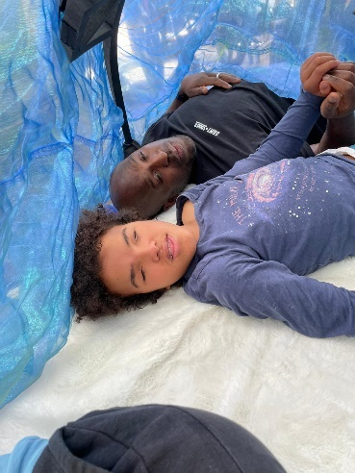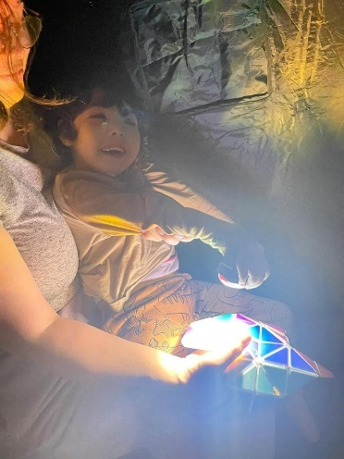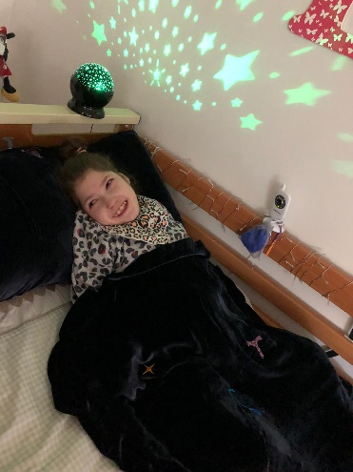

Space to Be. Images supplied by families.

*Space to Be* was developed with the aim to enable families who have at least one disabled child to enjoy a safe, high-quality piece of sensory theatre during the COVID-19 pandemic. The ultimate objective was to promote sensory wellbeing for both the adult(s) of a family alongside the wellbeing of the disabled child or young person under their care. This was envisioned as being achieved by offering the parents and carers a series of sensory experiences that they could use to connect with their disabled child, who might communicate differently to them. Oily Cart hoped that *Space to Be* would reach under-represented families across the UK, who have fewer opportunities to experience Oily Cart productions.

Oily Cart sent each family participating in *Space to Be* aStarter Packthat contained all the information they needed to prepare for the experience. This pack was primarily aimed at the adult of the family and tried to set the tone for *Space to Be* – ‘an experience that invites them to take time to “just be” (quote from the Starter Pack).

*Space to Be* could be experienced over five days as follows: Five boxes were delivered to each home, labelled Day 1-5. Each box contained different sensory experiences inside it. Instructions for each sensory activity could be found inside the box lids, and families were also sent links to preparatory videos. It is worth underscoring here that the concept of constellations that connected the packages of *Space to Be* was used as a metaphor that tied the show together, it made it theatrical and a unique emotional journey for the audience, rather than just a series of activities on five consequent days.

These findings focus on Tour 1, which toured to **every region of the UK,** for **46 shows** to **91 children and young people**.

**Key points**

* *Space to Be*, was an innovative sensory theatre production that participant families could experience with no performer present either physically or virtually.
* The Oily Cart creative team worked collaboratively with consultant families, and disabled artists to devise this production. This collaborative and creative process meant that sensory theatre activities embraced the diverse needs of the disabled children and their families.
* Experiencing *Space to Be* remotely and at one’s own home reportedly enabled families to share sensory theatre experiences they otherwise would not have accessed.
* The voice of disabled young people was integrated into the recorded soundtrack, the only performer was someone with a lived experience of disability, and the story / theme of *Space to Be* aimed at reflecting the families’ experience and stories back to them.
* The parent or carer felt appreciated and special by being given the opportunity to engage in sensory theatre experiences that were devised only for them as part of *Space to Be.*
* The shared experience of *Space to Be* re-enforced special bonds between family members, and enabled the parents / carers to dedicate time to sharing these experiences with their children.

## **Responses to Rating scales**

Audience survey respondents’ experience (average):

* 97% felt that *Space to Be*was safe and well thought-through in terms of COVID-19 precautions.
* 96% would recommend the *Space to Be*experience to others.
* 92% reported that *Space to Be* made their child and family feel good
* 92% found *Space to Be* an enjoyable shared experience
* 91% felt that *Space to Be*was accessible for their child and family
* 90% felt that *Space to Be* created opportunities to connect with their child in a different way
* 89% reported that they enjoyed the change to their daily routine

Similarly to *Doorstep Jamboree*, the creative team appeared to be modest in their ratings about the impact of that*Space to Be*would - and afterwards, did - have on its target audience. However, on the whole, the creative team and peer evaluator rated *Space to Be*highly in the post-survey.

**Average scores on *Space to Be* Performance Dimensions (Post-survey, Creative Team & Peers)**

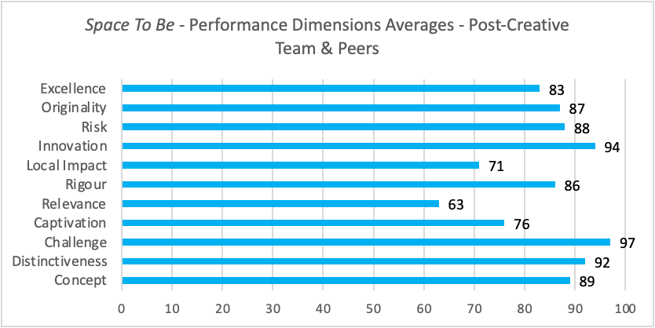

## **The Impact of key elements to sensory theatre experiences at home**

When asked about what their child liked the most from the elements of *Space to* *Be,* the parents / carers identified the Lyra (the show’s name for the kalimba instrument) as potentially the artefact with the most impact on the disabled children and young people (*‘They all loved* ***Lyra*** *and have requested one’*). Other props that the children liked through their sensory theatre experiences were the lights; the vibration / resonance box; the shiny mirror sheet; the music or other sounds; and the use of voices.

*My son really enjoyed the den activity with the* ***lights****. It was really calming for him and he enjoyed us all laying together without everything else going on around us. (Audience Survey)*

*The* ***resonance box*** *was fantastic and the children really enjoyed using it to make the different noises and vibrations, in particular they enjoyed creating different effects for their eldest sister who really enjoyed the experience. (Audience Survey)*

*We LOVED!! the rectangle covered in* ***mirrors and the torch*** *- it has inspired us to want to re-create these lovely experiences. (Audience Survey)*

## **The social Impact of *Space to Be***

The Oily Cart creative team reportedly set out to create a piece of sensory theatre that was responsive to the experiences of many families in lockdown and / or those who were shielding, who were potentially very isolated, neglected, and managing increased caring responsibilities due to the removal of support, and to enhance their overall wellbeing. They aimed to achieve this by engaging the adults and the young people in sensory experiences together. The uniqueness of *Space to Be* according to the survey and the Case Study responses was attributed to four parameters:

1. *Space to Be* gave the Creative Team the opportunity to explore **new ways of working,** from the devising stage of the process to the artistic delivery of a show without performers. In particular, the Oily Cart creative team explored different ways to support the adults of each family unit as best as possible to facilitate the show happening, in the absence of a lead performer.
2. Offering sensory theatre experiences remotely made *Space to Be* accessible to families who otherwise wouldn’t have had the opportunity to experience them.
3. It was the first time that Oily Cart *‘opened up the sensory experience to all the family members and not just the disabled young person…’* *(Post-survey creative team and peers).*
4. It was also the first time that Oily Cart created an activity especially for the adult. This activity took place on Day 1 of the project.

### **New ways of working – co-creating a sensory theatre show with the audience**

Co-creating a sensory theatre show in consultation with families that have disabled members, as well as with disabled artists, meant that the voices of disabled people and the stories of families with disabled children and young people were heard in a creative way:

*The only performer was someone with lived experience of being a wheelchair user and barriers to access. The voices of disabled young people were integrated into the recorded soundtrack. The story / theme was all about reflecting the families’ experiences and stories back to them. (Post-Survey Creative team and peer)*

New ideas on what to use and how to use it to effectively explore sensory theatre experiences with disabled children and young people were beneficial not only for the families who engaged in the devising process, but also to the families who used them:

*My son has sensory processing disorder and finds it very difficult to regulate. We provide lots of opportunities for him to get sensory feedback but we have realised through this experience that he needs a lot more calming activities. Space to Be has shown us that we could do it as a family activity. (Audience Survey)*

### **An accessible but remote sensory theatre experience**

The fact that *Space to Be* took place at each family home, giving complete autonomy to the family about when to engage in the sensory theatre activities, was praised by the survey participants and also heralded as a new way for families to experience sensory theatre during and beyond the pandemic. Sensory theatre experiences that took place at one’s own home appeared to be more accessible to families who otherwise faced barriers, such as constraints around Changing Places facilities in venues, and carrying bags with their children’s medication, to giving their disabled children similar sensory theatre experiences:

***I think if it wasn't online and at home, I don't think Child A would have got the opportunity in real life****… For us, going to things is usually stressful… we have to prepare the day before, think about how many bags you need, think about if there are going to be changing facilities and all the rest of the things, like medical bags etc. Doing it at home takes out the travel time of going somewhere and takes that stress away and* ***pre-covid we probably wouldn't have got this opportunity to do it.*** *(Case Study)*

In addition, the guidance and props sent to them to facilitate the sensory theatre experiences resonated with the families, enabling them to create intimate and private sensory theatre moments at home.

### **Sensory theatre experiences open to the whole family**

The survey participants emphasised that the shared experience of *Space to Be* re-enforced special bonds between family members, and enabled the parents / carers to dedicate time to sharing the experience with their child:

*It created situations in which my* ***children were open to trying something new****, which led to* ***new connections and positive moments****. (Audience Survey)*

For one particular family *Space to Be* reportedly helped the parents to enjoy an activity that they did not have to create on their own from scratch.

*It was particularly helpful as often we are expected to create all our own resources to make the world accessible for our children and then by the time we all get to experience it; the adults are stressed and tired and not so excited about the experience. This allowed us all to approach the experience fresh and excited too which clearly impacted on how we all enjoyed it. (Audience Survey)*

**Designing an activity especially for the adult**

The survey and the Case Study participants underscored the importance of dedicating Day 1 of the project to the primary adult, the person who devotes a substantial part of their life caring for the disabled child, and the rest of the family. The parents / carers themselves also expressed gratitude for being allowed to have some ‘me time’. They considered the Starter Pack and Day 1 of the show as a gesture of appreciation by the Oily Cart team for the time and energy that the parents put into their caring roles:

*As a carer, I found day 1 to be such a* ***profoundly personal and moving*** *experience, that I cried. No one ever asks the parent how they are feeling or recognises their sacrifice of time and energy in their caring role. This activity, targeted at the carer,* ***gave permission*** *to just be in the moment, forget about their caring responsibilities and spend time on themselves…* *The day 1 activity definitely has potential to help SEND parents and carers to develop self-care and mindfulness. (Post-survey Creative Team and Peers)*

## **The future**

The creative team recognised that *Space to Be* allowed them to experiment with new ways of creating sensory theatre experiences that could be adapted in future Oily Cart productions. These included offering sensory theatre experiences whereby packages are connected with soundtracks; using Zoom as a platform for co-creating the show with their collaborating families; opening up the experience to all family members, such as the planetarium on Day 5; and preparing special activities for the adults only.

Overall, the targets set by Oily Cart for *Space to Be* to bring the families together during the challenging and isolating times of lockdowns and families shielding, and to bring the family members into the worlds of their disabled child were met successfully. The creative team and peer evaluator felt that the different components of *Space to Be* were better connected than some other Oily Cart theatre-based shows. In particular, the fact that *Space to Be* took place over a week, which enabled for the activities to be repeated multiple times, afforded higher levels of engagement from the audience. The length of sensory theatre shows that take place remotely could be potentially one of the areas that Oily Cart and other sensory theatre companies develop further.

In addition, there was some flexibility in terms of the time period that each family could select to engage in the show, which also increased the level of engagement. Offering flexibility in accessing the show on time periods that suit each family is another area that could be explored by Oily Cart and other sensory theatre companies.

Devising activities only for adults (and possibly siblings) could be a third area of further development. In *Space to Be,* this was embraced and commended by the parents / carers themselves. Reportedly, having a special sensory theatre experience on their own empowered the adults by making them feel appreciated and recognised as a group that also deserves sensory theatre experiences for their wellbeing and self-care.

Many parents / carers expressed a desire to participate in future experiences at home. This was very important for them because of the barriers their children face to accessing on-site experiences in arts and culture venues. Also, some parents reported that they preferred to engage in sensory theatre experiences in private, so that their children feel more relaxed:

*It was also very good for us to be engaged in an experience in which there were no eyes or ears on us, so the sensory kids could relax and fully be themselves. So anything on offer would be welcomed! (Audience Survey)*

Notably, the parents / carers expressed a thirst for getting more guidance on how to devise sensory theatre experiences themselves, so there is a fertile ground for offering professional development initiatives to parents and carers:

*A 'follow up' experience with 'Polaris' - perhaps something to watch, a Zoom experience, a recipe to do together at home (star biscuits?!?), something from you to link back to the memory of the experience and engage [child’s name] in a focussed way because of the link to Oily Cart (rather than just another of Mummy's ideas!). (Audience Survey)*

Finally, there was one family who underscored how relevant *Space to Be* was for their teenager in terms of the types of activities that it included. They compared *Space to Be* with other sensory theatre shows that they had attended in the past, which they described as *‘amazing, but generally …quite babyish’*. *Space to Be* was successful in catering for this age, the teens, and it was suggested that Oily Cart should certainly look into devising more shows that appeal to young people.

### Chapter 5: Something Love

**

Something Love. Credit: Franki Ayres

*Something Love* was an exploration into sensory film designed for and with Autistic young people. The creative team included Autistic and disabled artists, including those who have experienced social isolation due to barriers to access. *Something Love* was the initial research and development phase of the creative process, aiming to experiment with how sensory theatre can translate into film work, and how to create in an accessible way, working remotely.

This evaluation was completed before the projects were released. To date, the films have had **4,400+ views.**

**Key points**

* *Something Love*, enabled disabled, non-disabled and Autistic artists to collaborate remotely to create two short films.
* Scaffolding the creative process through offering support from a Creative Enabler, an Access Lead, and an Artistic Lead, recognised the extra layers of support that disabled and Autistic artists need in order to engage in creative and collaborative processes.
* The different modes of communication that *Something Love* promoted beyond written emails gave voice to the diverse perspectives of the project’s artists, enriching their communication.
* Adopting ‘soft endings’ at the end of each session allowed for smooth transitions from group activities to time for individual refection and realisation, and offered opportunities to the artists to discuss accessibility issues with the Lead Artist and Access Lead.
* The pacing of the creative process of *Something Love* took into consideration and responded to the various accessibility or communication needs of its artists, though the process could have been slowed down further.
* Access audits, surveys, and check-ins collected feedback from the artists of *Something Love* about the challenges that they faced at different moments of the process.
* *Something Love* made targeted efforts to cater for the changing needs of young, aspiring and professional artists across the spectrum of disability and neurodivergence in accessing high-quality artistic experiences and in producing artistic work of high standards.

### **Enhancing Accessibility**

Accessibility emerged as one of the salient features of this project. The Case Study participants spoke extensively about accessibility. On the one hand they reported that *Something Love* was *‘the most accessible experience from the very start of the project’ (Case Study A)*. Having an access person, who they could go to for guidance or support; having mid-way conversations about their experiences of the project; and having these conversations orally as opposed to in a written form, featured as three key parameters to accessibility:

*One thing I have been reflecting on about working with Oily Cart, is that I really believe the organisation is serious about accessibility – these evaluation conversations, having an* ***access person*** *on hand whose role is reinforced at each meeting. I found the* ***mid-way chat*** *really useful, which is partly about knowing you as the access person were the person who was really thinking about it or the person to go to, but also for me because it was a conversation rather than having to answer questions in written form, especially when it's about this material which is really quite tough actually. Having* ***a friendly conversation*** *was important for me so that I could genuinely share any kind of problems or issues I was having, and it wasn’t going to result in defensiveness. (Case Study A)*

The collaborating artists underscored that the support that they received from the Collaborating Artist and Creative Facilitator, Max Alexander, as well as the Access Lead, helped them navigate a process that was remote and that they experienced for the first time:

*In terms of the process, it’s structural things that make it more accessible, so having Max on board as a facilitator was really important and essential…probably even more important because we were doing everything on Zoom and it was remote and it was a film, all things we’ve never done before. (Case Study A)*

On the other hand, the sense of accessibility that was experienced overall, was challenged when decisions had to be made about the ways that the creative process could be organised, such as the timeline and work schedule. One survey participant acknowledged that changes are bound to occur, especially for ventures that take place for the first time, but they expressed the wish that these changes were communicated clearly and at earlier stages of the process. They concluded by highlighting that Oily Cart is receptive to offering accessible creative opportunities; nonetheless, by its nature, the process of achieving this is not straightforward and it requires people and organisations to be ready to listen and respond to the barriers that disabled people face:

*The answer of how to truly co-create or truly make an accessible process for people involved is really quite messy and maybe not conducive to organisational working – like, maybe it’s impossible for an organisation to do. Oily Cart’s strength is being able to adapt a process and make it better, but that process is still structurally not fit for the people working within it…*

*…You [organisations] have to really be looking to listen to how the ways you are working is inaccessible. No one gets it right all the time – the most important thing is to really genuinely be trying to listen to the stuff that’s difficult to hear. (Case Study A)*

Working remotely was not identified as a barrier to participation in creative projects. Engaging in creative collaborative activities remotely was effective and it indeed opened up access, as it allowed the pacing to be tailored to the needs of each individual:

*Elements or the whole process online can be done and really opens up access for some artists. It allows shorter bursts of activity where energy is focused purely on the project rather than travel etc (Case Study D).*

This view was echoed by the participants in Case Study C. However, they expressed the view that being in the same room with the young artist would help other collaborators to understand them better:

*…In front of a screen in the living room with a jumble of toys around him, you're only gonna learn so much about him. (Case Study C).*

On the issue of accessibility, the participants of Case Study B expressed the view that the young artist not only found the whole project accessible but also that they were aware that through their involvement, they contributed to making theatre more accessible for other young people:

*I say all in all, he really enjoyed the whole thing. He just loves being part of it and he is very aware of the whole issue around access for people with additional needs, and he will tell people, I helped to make theatre more accessible, you know, he’s proud of that, so he does understand the need for that. (Case Study B)*

### **Fostering Communication**

The theme of Accessibility intertwined with the theme of Communication. When discussing accessibility, the artists recognised that, on the one hand, working remotely opened up access, but on the other hand it created communication barriers, for instance in relation to schedules for meetings, or personal responsibilities:

*Working remotely opened up access but also created some* ***communication barriers*** *and it was hard to judge how everyone was feeling or getting on with the creative process. (Case Study D)*

Three of the artists praised Oily Cart’s openness to promoting communication beyond written emails, such as through pre-recorded videos or Slack[4] messages. This variety of modes of communication allowed participants to express themselves beyond written language, which at times could be difficult to decipher. They stressed, however, that when communication came from different angles it often became overwhelming:

*There was a lot of* ***communication*** *coming from different angles, on different platforms, which for me personally was at times a bit overwhelming. Sometimes it was Slack, sometimes it was emails, sometimes there was a crossover of the two…I also think language, written language can be more difficult to decipher sometimes (Case Study E)*

Oily Cart’s flexibility to facilitate communication in ways that suited each individual was equally praised by the young artists and their parents:

*And the Creative Facilitator and other artists would understand the fact that he didn't want to verbalise anything, and be very patient with him typing out all his answers in the* ***chatbox****, and whatever. And he found that really fun… (Case Study B)*

### **Facilitating Artistic Experiences – process and product**

The Case Study participants were encouraged to talk about their artistic experiences of creating *Something Love*. One participant identified the ‘soft ending’ of sessions as a very productive part of the creative and the collaborative process. These were moments where they had the opportunity to make a smooth transition to being on their own after a group session, and to comfortably express what they felt about the creative process or make a new contribution:

*I liked the* ***soft endings*** *at the end of sessions. What it offers me in particular is a way to transition from being with others to being on my own... It also gives an opportunity for you to say, if there wasn’t previously an accessible way for you to say whatever was on your mind, your contribution. (Case Study A)*

Lastly, it was highlighted that the final product, the two films, met the artists’ expectations and they enjoyed the fact that they viewed the premiere of these films together with the whole team:

*I think the choice to gather everyone together for a premiere was really important too, for closure and a sense of* ***collective achievement****. (Case Study A).*

## **The future**

The artists in *Something Love* recognised that having access audits at the beginning of the process were elements to be sustained and built upon by Oily Cart. They also expressed the view that further attention needs to be given to communicating the timeline and work schedules, so that all artists involved are clear about the practicalities of the project from as soon as possible in the creative process. Working remotely was not recognised as a barrier to engaging in a creative collaborative process by the artists. However, one of them stressed that it created communication barriers, and one of the parents of the young artists expressed the view that working face-to-face with Autistic young people could help neurotypical young people and adults to better collaborate with young Autistic artists.

Asked what tips they would share with other companies looking to make their creative processes more accessible, the artists included making sure that there is always an Access worker and / or Creative Enabler from the beginning of the project to support disabled artists. In addition, access audits were identified as having significant importance, alongside the provision of emotional support to all involved in these creative endeavours:

*Do* ***Access audits****, make sure you have* ***access riders****, budget for creative enablers, put as much in place to support barriers through mental health as you do any other disability. Emotional support is required for this, including for the core team. (Case Study D).*

Another artist recommended a **slow process** that allows more time for every step:

*Time is another thing, just give people more time, factor in more time – it’s always better for everybody just to have a bit more time. (Case Study E)*

Recommendations on how to support more effective communication amongst group members who work remotely included being mindful of how one uses language and one’s attitudes within a space:

*So, I’d say that’s something to be really mindful of – my top tip would be to be mindful of language and attitudes within a space. (Case Study E)*

### Chapter 6: Conclusions and Key messages

#### The impact of the Uncancellable Programme on the audience and creative collaborators

With regard to the audience and participants in the projects, there was strong evidence through their responses to online surveys, Case Studies, and through photographs and videos of the productions that:

* all three projects were **captivating**; **enjoyable**; a **shared experience** amongst non-disabled, disabled and neurodivergent people;
* all three projects created opportunities for adults and siblings – especially for *Space to Be* - to **observe** the disabled or neurodivergent child or young person and to **connect** with them in different ways during and after the end of the shows;
* the theme of each production was based on an **interesting** idea;
* the audience felt **safe** in terms of COVID-19 precautions;
* the projects were **well thought-through**;
* all three projects were **relevant** to today’s world;
* it was important that they took place **during lockdown** and when families were shielding. This was a period that many UK families with disabled or neurodivergent children and young people experienced isolation and a decrease in their wellbeing;
* all three shows **challenged** the audience and the cast to equal measure: *Space to Be,* for instance, took place only remotely and this involved a lot of organisation and discipline on the part of the families who needed to carve time from their daily routines to devote to these sensory theatre experiences.
* the artists were not afraid to **try new things**; and
* that the shows were **ground-breaking** and the best examples of its type that they had seen.

The audience identified **elements of the shows** that were particularly liked:

* **Music** was time and again identified as the most liked sensory experience for all involved. In *Doorstep Jamboree*, the music took centre stage in the show, as the show itself was about an interactive gig performed by the Jamboree Band. In *Space to Be* the music from the soundtrack sent alongside the props; and the kalimba instrument were loved by the family members. Many families were reportedly planning to purchase a kalimba instrument for daily use at home. In *Something Love*, the music was identified as the glue that kept the different parts of the creative process together.
* The **costumes**, **dancing** and **movement**, other **props** and audience-performer interactions (either face to face or via Zoom) were also identified as liked in *Doorstep* *Jamboree*. The use of lights, the resonance box, mirrors, voices and other sounds, enhanced the sensory theatre experiences of *Space to Be*.
* In *Something Love* ‘soft endings’ at the end of each session, tailoring the pacing of the creative process to the needs of the individual artists, and supporting the artists in creating a narrative through repetition and reoccurrence of objects, were identified as effective ways of facilitating the creative process and their overall sensory theatre experiences.

**Access**

* *Doorstep Jamboree’s* public performances on one’s doorstep or in a school playground raised the general public’s awareness on issues around arts and cultural participation for disabled children and young people, as well as the visibility of disabled artists and of disabled children and young people as artists.
* *Space to Be* was accessible to all members of the family - non-disabled, disabled and / or neurodivergent - to enjoy together in their own time and at their own pace, supporting family coexistence during the difficult COVID-19 lockdown periods.
* The parents of one of the young artists in *Something Love* reported that their child was proud that through participating in the project they had contributed to raising awareness around access for disabled people.

**Communication**

* *Something Love* fostered communication by promoting a variety of communication routes, such as through online platforms, or video-recorded messages.
* Through *Doorstep Jamboree,* Oily Cart also tested ways to communicate over Zoom with young people who communicate differently and do not rely on verbal language.

**Inclusion and Diversity**

* Performances on Zoom for *Doorstep Jamboree* were identified as the most effective in reaching families who were shielding.
* Zoom performances for *Doorstep Jamboree* and the videos available as part of the *Space to Be* performances reportedly made sensory theatre experiences more inclusive for the whole family and for families with disabled children who would not have otherwise visited arts and culture venues.
* *Space to Be* included a special sensory theatre experience for the parent or carer to enjoy alone.
* All three projects included diverse casts and creative teams, such as disabled lead artists / decision-makers; neurodivergent artists, non-disabled artists, and cast and creative team members from different cultural backgrounds.

## The impact of the Uncancellable Programme on Oily Cart

Oily Cart met their intended aims for each project. Overall, the *Uncancellable Programme*:

1. Enabled families who have at least one disabled child to enjoy a safe, high-quality piece of theatre during the COVID-19 pandemic;
2. Offered the parents and carers creative ideas and tools (props such as the kalimba instrument or the shiny mirrors sheets and torch light) to use to connect with their disabled child.
3. Had a positive impact on the wellbeing of the audience, with *Space to Be* being reported as having the strongest impact on both the disabled child and the family as a whole.
4. Managed to involve families who have fewer opportunities to experience Oily Cart’s work as well as face barriers to accessing arts and cultural venues.
5. Explored ways of remotely reaching young people who face barriers to engagement with in-person performances. *Something Love*, in particular, worked with disabled and Autistic artists to identify barriers created by standard Oily Cart creative processes. The barriers identified were connected to accessibility and ways of communication.

Direct links could be drawn between the findings from the evaluation of the *Uncancellable Programme* and Oily Cart’s Theory of Change Key Objectives.

**Table of Oily Cart's Theory of Change Key Objectives.
1 Shows and creative projects: High-quality theatrical experiences created for and with disabled babies, children and young people who experience multiple barriers to access, across the UK and internationally.
2 Exploration: Pushing the boundaries of sensory performance practice through research, collaboration and artistic development
3 Creative diversity: Inviting diverse perspectives to enrich all of our working practices
4 Driving change: Advocating for the rights of disabled individuals to lead active cultural lives.
5 Resilience: Making sustainable choices that nurture our resources (creative, financial, organisational and the planet). These resources will allow us to be responsive to our audiences' changing needs. **

* **Key Objective 1**: The music in *Doorstep Jamboree* had been **co-created** with young people, and the audience had agency over the set list and improvisation. *Space to Be* was the first Oily Cart production to offer high-quality sensory theatre experiences **remotely**. This was really powerful because it allowed families with disabled and/or neurodivergent children who may not typically access arts and cultural venues to engage with high-quality sensory theatre experiences. *Something Love* also enabled disabled, non-disabled and Autistic artists to **collaborate remotely** to create two high-quality artistic films.
* **Key Objective 2**: *Doorstep Jamboree* was performed in three different formats: on people’s doorstep, in school playgrounds and through the online app Zoom. Experimentation with these three types of performance, and the very positive feedback that Oily Cart received about the Zoom performances, helped the organisation realise that productions that were 100% online and remote could have an equally significant impact on the sensory theatre experiences of the audience as face-to-face productions. The parents and carers of the *Doorstep Jamboree* audience agreed that Zoom Performances were actually better at achieving a more direct dialogue between the performers and the participating audience. *Space to Be* explored new ways of both working remotely to devise a new production and of delivering a production that participant families could experience at home, with no performer present either physically or virtually. This remote collaborative and creative process meant that sensory theatre experiences embraced the diverse needs of neurodivergent and disabled children and their families. Similarly, *Something Love*, explored ways that disabled artists, non-disabled artists and Autistic artists could collaborate remotely to create short films.
* **Key Objective 3**: The format and content of *Doorstep Jamboree* were developed through collaborative conversation amongst the disabled and non-disabled artists, the creative team, the audience and peer evaluators. Similarly, in *Space to Be,* the creative team in collaboration with consultant families and disabled artists worked remotely to devise the new production. The different modes of communication that *Something Love* promoted beyond written emails gave voice to the diverse perspectives that disabled, non-disabled and Autistic artists had on enhancing accessibility, fostering communication and facilitating artistic experiences that could enrich their collaborative practices.
* **Key Objective 4**: The *Uncancellable Programme* has taken several steps to *Drive Change* by advocating for the rights of disabled individuals to lead active cultural lives.
  + *Doorstep Jamboree* included a diverse cast, such as disabled and non-disabled artists and performers and creative team members from different cultural backgrounds, through all the stages of developing the production.
  + By delivering *Doorstep Jamboree* in open spaces such as people’s doorsteps / gardens or school playground, Oily Cart managed to bring the community together, raising the visibility of disabled children and young people as well as the profile of disabled audience as artists.
  + In *Space to Be* the only performer was someone with lived experience of being a wheelchair user; the voices of disabled young people were integrated into the recorded soundtrack; and the story was all about reflecting the families’ experiences and stories back to them.
  + In *Space to Be* the parent or carer felt appreciated and special by engaging in a sensory theatre experience entirely designed for them.
  + *Something Love* adopted devising approaches, such as ‘soft endings’, that allowed for smooth transitions from group activities to time for individual refection and realisation. It also created structures that offered opportunities to the artists to discuss accessibility issues through the Access Lead; and to get support with creative processes such as through the Lead Artist and the Creative Enabler.
  + The pacing of the creative process of *Something Love* took into consideration and responded to the various accessibility or communication needs of its artists.
  + Access audits, surveys, and check-ins collected feedback from the artists of *Something Love* about the challenges that they faced at different moments of the process.
* **Key Objective 5:** In terms of promoting *Resilience*, the three different types of performance of *Doorstep Jamboree* offered variety of access and catered for the changing needs of the audience. Likewise, *Space to Be* recognised and catered for the need for shared sensory theatre experience amongst family members, where the disabled child or young person could take a leadership role permitting the other members of the family to ‘enter their world’ (Grace, 2018). The shared experience of *Space to Be* re-enforced special bonds between family members and siblings, and enabled the parents / carers to dedicate time to sharing these experiences with their children. The need for inclusion and collaboration amongst people across the spectrum of neurodivergence and disability was also promoted in *Something Love*, acknowledging the changing needs of young, aspiring and professional artists in accessing high-quality artistic experiences and in being offered support to produce artistic work of high standards.

#### 

#### The impact of the Uncancellable Programme on practice for the future

There are many implications for future sensory theatre practice that have emerged from the *Uncancellable Programme*.

* **Giving the audience options to engage in the way that suits them best**: Online and remote sensory theatre experiences were equally valued to face-to-face experiences, and in the case of *Doorstep Jamboree* and *Space to Be* they were rated higher than face-to-face experiences in managing to achieve a more direct dialogue between the performers and the participating audience, and in being more accessible.
* Offering a **blended approach** to sensory theatre experiences: Oily Cart will continue to offer a blended approach to sensory theatre experiences beyond the pandemic so that it can reach families still shielding or experiencing barriers to accessing venues.
* **Taking accessible practices forward**:
  + Collaborative processes of devising a sensory theatre production should involve from the very first stages of the process the voices, experiences and perspectives of the target audience and the creative team importantly, including, importantly, disabled artists themselves.
  + Offering disabled and neurodivergent artists different layers of support on artistic and operational issues could facilitate their creative and collaborative engagement throughout all the stages of creating sensory theatre experiences for others.

To conclude, designing productions whilst being guided by recommendations and the practice of experts in the field of disability could create greater potential for future projects to be more accessible and inclusive. For instance, one could identify strong links between the content and elements of *Space to Be* and suggestions on ways to facilitate ‘sensory being’ (p. 144) found in Joanna Grace’s book *Sensory Being for Sensory Beings* (2018). Influences and recommendations that come directly from research (also see Goodwin’s doctoral thesis, 2019) and the guidance of disability experts signify how salient it is for practice and research on sensory theatre to go hand in hand.

Last but not least, it is important to acknowledge the challenge of collecting data from disabled young people on their experiences of sensory theatre. This is definitely an area that merits further attention from sensory theatre researchers and artists. Nonetheless, as it emerged from the feedback received through online surveys and Case Study conversations with the parents / carers in *Space to Be* and *Something Love*, it is salient that future productions and projects allow the audience and artists to offer their feedback regularly and through a variety of modes of communication: from written evaluation forms to video and audio messages, to oral conversations and written emails, as well as through Zoom calls when young audience and / or artists communicate differently and do not rely on verbal language.

##### Bibliography

Autismtoolbox, (2019) ‘What does neurodiversity mean’, Retrieved on 20th January 2021 from <http://www.autismtoolbox.co.uk/what-does-neurodiversity-mean>

Caldwell, P. and Horwood, J. (2008) *Using Intensive Interaction and Sensory Integration.* London: Jessica Kingsley Publishers.

Disabled Children’s Partnership (2021) #LeftInLockDown – Parent carers’ experiences of lockdown. London. Retrieved on 25th March 2021 from [https://disabledchildrenspartnership.org.uk/wp-content/uploads/2020/06/LeftInLockdown-Parent-carers%E2%80%99-experiences-of-lockdown-June-2020.pdf](https://disabledchildrenspartnership.org.uk/wp-content/uploads/2020/06/LeftInLockdown-Parent-carers’-experiences-of-lockdown-June-2020.pdf)

Doukas, T., Fergusson, A., Fullerton, M. and Grace, J. (2017) *Supporting people with Profound and Multiple learning disabilities – Core and essential service standards.* Retrieved on 20th January 2021 from <http://www.pmldlink.org.uk/wp-content/uploads/2017/11/Standards-PMLD-h-web.pdf>

Fergusson, A. (2019) Raising the Bar Through Inclusive Theatre. Evaluation by the *Isle of Brimsker* by Frozen Light, Norwich: Frozen Light. Retrieved on 10th December 2020 from <https://www.frozenlighttheatre.com/resources/evaluationreport>

Goodwin, J. (2019) *Sharing an aesthetic space of refuge with a school for pupils with profound and multiple learning disabilities: Golden Tent.* Unpublished Doctoral thesis. Winchester*:* University of Winchester.

Grace, J. (2018) *Sensory-Being for sensory-beings: Creating entrancing sensory experiences.* Oxon: Routledge.

Griffiths, E. (2016) ‘Looking to the Future: Sensory Performance Work for Neurodivergent Audiences.’ [*Winston Churchill Memorial Trust*](https://www.wcmt.org.uk/fellows/reports/looking-future-sensory-performance-work-neurodiverse-audiences)*,* Accessed on 23rd June 2021.

Mattaini, M. (2020) ‘Creating autistic space in ability-inclusive sensory theatre’, *Youth Theatre Journal,* 34:1, 42-54.

Morgül, E., Kallitsoglou, A. and Essau, C. (2020) ‘Psychological effects of the COVID-19 lockdown on children and families in the UK’, *Revista de Psicologia Clinica con Niños y Adolescentes,* 7(3), 42-48.

Oily Cart, (2021) ‘About [Oily Cart]’, Retrieved on 20th January 2021 from <https://oilycart.org.uk/about/>

Shoenenberger, H. (2019) ‘Slow Theatre: Creating Multi-Sensory Experiences.’ [*ASSITEJ Magazine*](https://www.assitej-international.org/en/assitej-in-the-world/the-magazine/)*,* 58-59.

Terribile, B. (2020) *Interactive Theatre for Children: A Multi-sensory and enabling practice.* BA dissertation, Malta: Department of Theatre Studies, School of Performing arts, University of Malta.

1. This is from a seminar ‘Introduction to Sensory Theatre’ delivered as part of the International Sensory Lab by Oily Cart and Rose Bruford online in August 2020.
2. *(Disabled Children’s Partnership, 2021, p.8)*
3. For more information please access <https://www.weshallnotberemoved.com/>
4. Slack is a messaging software that can bring people together as a unified team offering them access to the information they need and by allowing to share and exchange messages.