

The Uncancellable programme by oily cart

**Sensory and inclusive theatre created for and with disabled children, young people and their families during and post COVID-19 times**



DR MARIA VARVARIGOU

OCTOBER 2021

# Foreword by Jenny Sealey MBE

Artistic Director/CEO of Graeae Theatre

It is a brave company that puts themselves under evaluative scrutiny in the middle of a pandemic when none of us knows the rules!

It is imperative to remember the impact of the pandemic on young disabled people and their families and how side-lined they have been without resources and support to navigate such uncharted waters. The pandemic has sorely exposed the inequality in our society on many levels and it is those theatre companies who have human rights at the centre of their ethos that have been a shining light.

The young people and their families who have had the Oily Cart experience have been inspired, felt a sense of belonging and a relief that finally someone understands and is listening to them and wants to be in their world.

This creatively intense report covers an extraordinary intense moment in our lives and cements the true value of what this company is about – Resilience, Innovation, Care, Respect and Wisdom, Openness and Honesty, and Dare.

These elements have been the bedrock of Oily Cart since day one, so I expected nothing less. Now with Ellie Griffiths and Zoë Lally leading a new team this has been amplified, with added gold dust.

By access, I mean emotional, visceral and communicative access, at the heart of the artistic endeavour. The process is challenging because it is never a case of one glove fits all. This quote from Ellie describing sensory theatre says it all.

*“Sensory theatre acknowledges the whole of each person in the audience, young person or adult, treating every sense with equal respect. People often say that we have 5 senses whereas actually we have 33. This offers us a much broader palette to work with creatively than most theatre makers make use of. At Oily Cart we work to create moments of beauty, that are not just visual. One of the most accessible performance languages is touch. This quote is from Margaret Atwood, and it says ‘Touch comes before sight, before speech. It is the first language and the last, and it always tells the truth.’”*

This report is not a guide on how to make sensory theatre, but on what it can be, how it is received and how bloody important it is.

The report challenges normative theatre making processes and for me, it exposes the rigidity, stuffiness and elitism of mainstream ways of working and oh how I wish the mainstream world would be brave enough to invest and break rules as Oily Cart does.

Highlighting three Oily Cart productions, each case study unpacks what ‘fully inclusive’ really means and exemplifies how important it is to know the DNA of your audience and the world in which they inhabit, while exploring the multiple routes to their emotional centres.

**Doorstop Jamboree** It is what is says… theatre on your doorstep or Zoom too, as many young people were still (and still are) shielding. Each in person or online gig was a joyously bespoke riot of sound, song, colour and movement. It was something just for a young person and their family to enjoy together. The feedback evidences that parents / carers feel empowered to be open and honest about their young person’s engagement and what more they needed, whether it was sign language or a quieter focus etc to connect in a different way.

In all three projects – parents/carers being allowed to have a voice and being asked ‘how are you?’ is hugely important. As I have said already, Oily Cart embraces the *whole world* of their young people. This leads nicely onto…

**Space to Be** A production with no performers, but where the parent / carer and young disabled person become the creators of their own sensory narrative within the comfort of their own home and timeframe. Each household was sent carefully considered sensory toolkits to make their theatre. This empowered parents / carers to have a different moment in time with their young person, something surreal and wonderful outside the daily routine and concern of living through a pandemic. As a project, it smashed through barriers of class and reached families who may never have had (for geographic / socio economic reasons) the opportunity to engage with Oily Cart.

This leads onto the third and final project, which dealt with the conflict of slow and fast work.

**Something Love** focused on the learning of making two short films for young Autistic people made by young Autistic artists. The glorious complexity of embracing the world of neurodiversity is that nothing is typical and each individual has their own rule-book of what works for them. The challenge is to create multiple processes which interweave, entwine and collide, working across different time frames, diverse communication styles but all with the same creative brief…to make a film. The learning was profound and will make a lasting impact on the company as they continue to realise the importance of the role of creative enablers, access audits and the necessity of working with disabled, neurodivergent artists.

We all need to learn from Oily Cart’s incredibly rich, complicated, frustrating, risk-taking, moving and epic journey to NOT CANCEL ANYTHING.

A world without Oily Cart would be truly rubbish. Read this and applaud them as I did, and keep an eye / ear out for what they will do next. I most certainly will.

Table of Contents

Foreword by Jenny Sealey MBE 1

Language Note 8

About the author 9

A note from the author 9

Executive summary 10

Chapter 1: Introduction and Background 14

Introduction 15

Sensory and Inclusive Theatre – core principles and practice 20

Core principles of Sensory Theatre productions 22

Sensory Theatre productions in practice 24

The work of Oily Cart 26

Summary 29

Chapter 2: Evaluation aims and Methods 31

Introduction 32

Methods 33

Audience Feedback Surveys 36

Creative Team and Peer Evaluator Feedback Surveys 39

Peer Evaluator Additional Questions 40

Case Studies 41

Videos 42

Summary 42

Chapter 3: Doorstep Jamboree 44

Introduction 46

Responses to Rating Scales 47

The most impactful components of *Doorstep Jamboree* 50

Ways of Participating and Communicating 60

The social impact of *Doorstep Jamboree* 64

Developing the *Doorstep Jamboree* experience further 70

Summary 77

Chapter 4: Space to Be 80

Introduction 82

Responses to Rating scales 86

The Impact of key elements to sensory theatre experiences at home 94

The social Impact of *Space to Be* 99

New ways of working – co-creating a sensory theatre show with the audience 101

An accessible but remote sensory theatre experience 104

Sensory theatre experiences open to the whole family 105

Designing an activity especially for the adult 108

Developing the *Space to Be* experience further 110

Summary 116

Chapter 5: Something Love 117

Introduction 118

Participants and Data analysis 118

Key themes 121

Enhancing Accessibility 121

Fostering Communication 127

Facilitating Artistic Experiences – process and product 129

Developing the Something Love experience further 133

Summary 135

Chapter 6: Conclusions and Key messages 137

The impact of the Uncancellable Programme on the audience and creative collaborators 137

The impact of the Uncancellable Programme on Oily Cart 142

The impact of the Uncancellable Programme on practice for the future 147

Summary 150

Bibliography 151

Performance Dimensions Glossary 153

Appendices 154

Appendix 1 – An overview of Oily Cart evaluation findings (2016 – 19) from the shows 154

Aspect 1: Material resources and Strategies / techniques used. 155

Aspect 2: The specific ways in which each different show had engaged the children and young people attending. 156

Aspect 3: Recommendations on the ways that Oily Cart could improve the quality of the experience offered in each of the four shows. 157

Aspect 4: Techniques for use in the future outside the shows, and casts’ experiences (SPLISH SPLASH, 2019). 158

Appendix 2 – Doorstep Jamboree Audience Feedback Survey 160

Appendix 3 – Doorstep Jamboree Creative Team Feedback survey 164

Appendix 4 – Doorstep Jamboree Online Feedback Form to External Evaluator 168

Appendix 5 – Space to Be Audience Feedback Survey 169

Appendix 6 – Space to Be Creative Team Pre-Survey 175

# Language Note

*Oily Cart’s work is underpinned by the Social Model of Disability, which was developed by the disabled community. Under the Social Model, a person is disabled by barriers within society rather than a health condition, impairment or difference. Oily Cart is moving away from medicalised and institutionalised labels that are common in school and hospital settings, and is committed to using language that comes from a place of ownership, to describe the individuals they work with and for. Oily Cart use this language in line with identity-first language, e.g. ‘Autistic child’, which is preferred by many in the Autistic community, while acknowledging this will not fit with some Autistic individual’s preference for person-first language.*

# About the author

Maria Varvarigou is a Lecturer in Music Education at Mary Immaculate College, University of Limerick. Maria has been researching the impact of music making on health and wellbeing across the lifecourse, effective music teaching and learning in higher and professional education and in primary school education, and intergenerational music making for many years. She is currently researching the impact of facilitating therapeutic community music for others on the quality of life of student musicians. Maria is passionate about aural music learning, traditional musics, and group singing. She is the co-author of two books: *Active Ageing with Music: supporting wellbeing in the Third and Fourth Ages* (2014) published by the IoE University Press; and *Contexts for Music learning and participation: developing and sustaining musical possible selves through informal, non-formal and formal practices* (2020) published by Palgrave.

# A note from the author

I would like to acknowledge that I am not disabled. I am grateful, therefore, to the disabled and non-disabled members of the Oily Cart team for the unreserved support that they offered me on how to communicate and present the findings from the *Uncancellable Programme* in a more inclusive way.



# Executive summary

During the COVID-19 pandemic Oily Cart has been exploring ways to expand its reach and make sensory theatre accessible to disabled children and young people who are shielding. Unable to create close-up, interactive shows that use touch as a central technique, or tour to theatres, schools, or any of the places the company normally perform, Oily Cart reimagined the entire format of how they usually work.

The *Uncancellable Programme* was the company’s response to the COVID-19 pandemic to ensure that the organisation could continue to create theatre for and with their audience in a safe way*.* The programme included three projects:

* *Doorstep* *Jamboree* took place on people’s doorsteps, in school playgrounds and through the video conferencing software app Zoom to disabled young people, with a particular focus on those who communicate differently and do not rely on verbal language, and families still shielding.
* *Space to Be* comprised sensory theatre experiences led by the parent or carer, guided by a series of audio pieces and using sensory packages filled with specially designed and handcrafted objects. These experiences aimed to encourage the disabled and non-disabled members of the participant families to explore new ways of being together in a sensory space, where the disabled person is the expert and guide and their parent or carer the guest who is invited to relearn the world.
* Finally, *Something Love*, was an exploration into sensory film designed for and with Autistic young people. The creative team also included disabled artists, who have experienced isolation due to barriers to access. *Something Love* was a research and development process, aiming to explore how sensory theatre can translate into film work and how to creatively collaborate in an accessible way, working remotely.

This evaluation provided evidence that:

* Digital engagement via Zoom or remotely, even with no live performer involved, was firstly, a powerful and viable means of experiencing high quality artistic sensory theatre activities; and secondly, an alternative way of enabling different people to access cultural experiences in a socially-distanced, and Covid-safe way.
* All three projects responded to the recognised need to involve disabled and neurodivergent artists into the development and performance of sensory theatre productions. Core aims were to include more perspectives in the creative-lead / decision-making process, and to create authentic experiences for this target audience. The *Uncancellable Programme* achieved this by
  + Working with creative teams who have different perspectives, such as disabled artists, non-disabled artists, gender-diverse artists and artists from different cultural backgrounds;
  + Developing the formats and content of the projects through collaborative conversations amongst the disabled and non-disabled artists, the creative team, the audience and peer evaluators; and by
  + Offering a variety of modes of communication, from written evaluation forms to video and audio messages, oral conversations and written emails to all people involved in the projects.

This evaluation also illustrated through specific examples from the projects how accessible and inclusive arts practices could be promoted to enable disabled and neurodivergent children and young people, both as audience and artists, to experience high quality sensory theatre in a range of ways:

* Devising approaches, such as ‘soft endings’, allowed for smooth transitions from group activities to time for individual reflection and realisation.
* The use of music was identified as a component that connected the different parts of the projects in a smooth and enjoyable way.
* The pacing of the creative processes of the three projects took into consideration and responded to the various accessibility and communication needs of its participants.

Finally, the issue of accessibility was seriously considered by enabling audience and artists to select, when possible, the type of performance that they wished to engage in; and by offering the disabled and neurodivergent artists different layers of support to enable them to be creative and collaborative. These layers included expert support on ways that one could express their artistic ideas, as well as support around access and operational issues.

# Chapter 1: Introduction and Background

|  |
| --- |
| **Summary**  This chapter begins by identifying some of the challenges that the COVID-19 pandemic has had on the psychological and the emotional wellbeing of disabled children, young people and their families in the UK. It also focuses on how the pandemic has impacted the arts and cultural experiences of disabled children and young people. The chapter then moves onto exploring what is sensory theatre, how sensory theatre shows offer high-quality artistic experiences to neurodivergent and disabled children, young people, and their families, and it provides a short introduction to *Oily Cart*, a UK company that has been creating innovative sensory theatre shows for many years. The chapter concludes by presenting three different projects that comprised Oily Cart’s latest venture, entitled the *Uncancellable Programme,* which are the focus of this evaluation report.  **Key points**   * The COVID-19 pandemic has had a strong and negative impact on the psychological and emotional wellbeing of both ‘neurotypical’ and ‘neurodivergent’ disabled children and young people, and their families in the UK. * There is a need to re-imagine arts and cultural experiences for neurodivergent and disabled children and young people post COVID-19 times, with an emphasis on promoting accessible, inclusive, and high-quality artistic work. * Sensory Theatre is audience-centered and developed from the ground-up. It focuses on promoting agency in expression and participation for neurodivergent, and disabled children and young people, through creating sensory, immersive, and creative artistic experiences. * During the COVID-19 pandemic, Oily Cart has been exploring ways to expand its reach and make sensory theatre accessible to disabled children and young people who are shielding, through its *Uncancellable Programme,* which included three projects: *Doorstep* *Jamboree*, *Space to Be*, and *Something Love.* |

## Introduction

The COVID-19 pandemic has profoundly changed the daily life routines of many families and young children around the world. A study by Morgül, Kallitsoglou and Essau (2020) found that the emotions and behaviours of children in the UK were very much impacted by the pandemic. For example, from a sample of 927 caregivers who filled in an online survey between July and August 2020, it emerged that the children being cared for (their age range was 5-11 years) were

*‘…bored (73.8%), lonely (64.5%), sad (43.4%), frustrated (61.4%), irritable (57.1%), restless (52.9%), worried (52.4%), angry (48.6%), anxious (45.2%), and were more likely to argue with the rest of the family (29.7%) during the lockdown compared to the pre-COVID-19 period’ (p. 45).*

What is more, the caregivers reported that family coexistence during the lockdown was moderately difficult, and that they experienced psychological distress. It also emerged that children spent significantly more time using screens, and significantly less time engaging in physical activity. Furthermore, the lockdown had significantly influenced their sleep time. Before the lockdown, the caregivers reported that the children slept for half an hour more compared to during the lockdown. Finally, the study revealed a correlation between caregivers’ level of psychological distress and most of the reported emotional and behavioural symptoms of their child. In other words, caregivers with higher psychological distress, were more likely to report that their child or children were more worried, anxious, sad, and/or irritable during than before the lockdown (p. 45). An interesting observation that emerged from this study was that despite nearly 9 out of 10 participants having access to a garden for children to play during lockdown, children’s boredom reportedly increased. This suggests that ‘having a garden may not contribute significantly to mitigating feelings of boredom’ (p. 46). This observation might have implications for how gardens and outdoor spaces, in general, could be used to support children’s mental and emotional wellbeing during times of social distancing and in general.

In the same vein, a report commissioned by Disabled Children’s Partnership (2021) entitled *‘#LeftInLockdown – Parent carers’ experiences of lockdown’*, shed light on the challenges that the lockdowns of the COVID-19 pandemic have created for disabled children and young people and their families. Similarly to the study by Morgül, Kallitsoglou and Essau (2020), this report also found that the parents experienced increased caring responsibilities for themselves and the disabled children’s siblings, and expressed concerns about the disabled children’s behavior and mental wellbeing. In particular, 72% of the parent carers in the Disabled Children’s Partnership Survey reported that during lockdown they were providing a lot more care compared with the amount before lockdown. 68% percent also reported that non-disabled siblings were also providing a lot more care. Furthermore, families reported experiencing a decline in both mental and physical health, which was often the result of financial and other support being withdrawn. In particular, 70-80% of the parent carers reported worsening emotional and mental health for both their children and themselves, although a minority reported improvements. It was also noted that children’s friendships, learning and communications, and mental, physical and emotional wellbeing had been negatively impacted. Some staggering statistics that appear on the report are presented below.

* *83% say the lockdown is having a negative impact on their disabled child’s friendships*
* *86% say the lockdown is having a negative impact on their disabled children’s learning and communication*
* *87% say the lockdown is having a negative impact on their disabled child’s behavior and emotions*
* *78% say the lockdown is having a negative impact on their disabled child’s mental health*
* *67% say the lockdown is having a negative impact on their disabled child’s general health*
* *64% say the lockdown is having a negative impact on their child’s disability or condition’ (Disabled Children’s Partnership, 2021, p.8)*

As individuals and communities are starting to envision a new future beyond the pandemic it is worth considering how the arts in general, and sensory and inclusive theatre in particular, could contribute to rebuilding disabled children’s and young people’s confidence to return to cultural venues post-lockdown, whilst also recognising the ongoing need for cultural offers for those who face barriers to attending in-person events. Andrew Miller, the first UK Government Disability Champion for Arts and Culture and co-founder of #WeShallNotBeRemoved[1], compared the responses of people who self-identified as disabled with those who self-identified as non-disabled to a national audience survey launched by Indigo in the summer of 2020. The findings underscore a disparity in the attitudes of disabled versus non-disabled people to returning to cultural venues post lockdown. For instance, of the 4,000 (15%) who identified as disabled, 77% considered themselves to be ‘vulnerable to Coronavirus’, whilst only 28% of non-disabled audience members reported being at risk. That has ramifications for on-site visits to cultural venues and the booking of tickets for live shows. Furthermore, 26% of disabled audiences reported that they would not consider returning to venues at all until a vaccine or treatment for Coronavirus is available, whilst 41% reported considering returning to venues that implement social distancing regulations alongside appropriate hygiene measures.

Interestingly, digital engagement emerged as a viable alternative, with disabled people reporting that they would consider attending events that are available online. Yet, Andrew Miller underscored that many disabled people in the Indigo survey lacked confidence in using technology. Additionally, through Oily Cart’s anecdotal conversations with families who have accessed digital theatre, it appeared that digital theatre experiences were not always particularly accessible to or meaningful for disabled people who experience barriers to seeing or hearing, as well as for people who don’t communicate verbally and / or who experience the world in a sensory way.

What is more, there are inequalities when it comes to disabled people’s internet access. The Glasgow Disability Alliance, for instance, reported that only a third of disabled people in Glasgow had access to home broadband or IT during the pandemic. Therefore, although digital engagement could potentially make theatre more accessible to disabled people who have home broadband or IT, theatre companies should really explore new ways of making theatre experiences not only accessible but also meaningful and enjoyable for their target audience.

As vaccinations against COVID-19 become available, the arts sector should be strategic about how to re-engage disabled people with the arts making sure that all possible barriers to access and engagement are removed.

## Sensory and Inclusive Theatre – core principles and practice

‘Ability-inclusive Sensory Theatre’ (AIST) (Mattaini, 2020) or ‘Sensory Theatre’ (Terribile, 2020) is a genre of Theatre for Young Audiences (TYA), which serves neurodivergent[2] and disabled children and young people. Given that there is no agreed definition of this type of theatre, I will adopt the term sensory theatre when I refer to these productions or experiences. Sensory theatre companies create inclusive and immersive environments which enable disabled children and young people to experience high quality art that empowers them to express themselves, communicate with others, socialise and be part of community life (Doukas, et al. 2017). They achieve this by adapting performance aspects such as sound, smell, touch, light, balance and movement to facilitate immersive and multi-sensory experiences.

Mattaini (2020) identified three categories of companies that currently produce sensory theatre shows. The first category includes companies that produce performances exclusively for disabled children[3]. The second category includes companies that create TYA alongside sensory work[4]. The third category includes TYA and other theatre companies that have produced at least one sensory show[5]. The sections that follow describe the core principles of sensory theatre productions and how they are applied in practice.

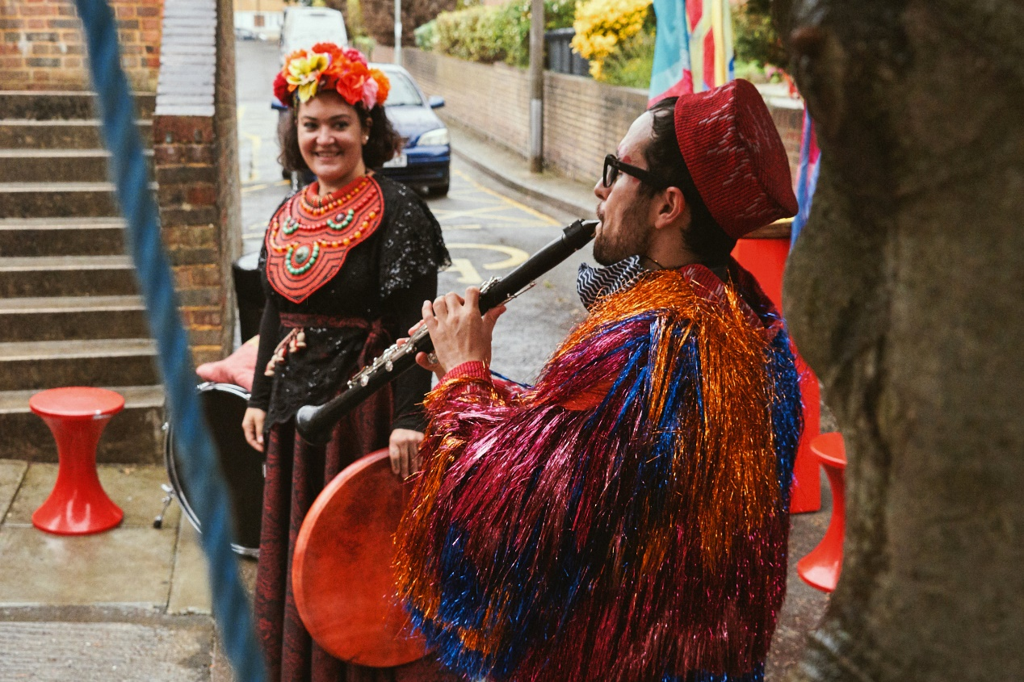

**Image 1.1: Doorstep Jamboree – Cast members performing on doorstep. Credit: Suzi Corker.**

### Core principles of Sensory Theatre productions

Sensory theatre productions are ‘highly intimate’ (Mattaini, 2020, 42) and they are organised around sensory engagement. Every aspect of a sensory theatre show promotes and explores a sensory element. These elements could stimulate any of our senses, including our sense of sound, sight, touch, smell and taste, as well as the sense of our body in space (proprioception) and our sense of movement and balance (vestibulation) (Grace, 2018). Sensory theatre shows respond to the need for artistic expression that every disabled child and young person, as well as ‘sensory being’[6] should have access to. Grace (2018) uses the term sensory beings to refer to individuals who experience the world in a primarily sensory way. This could include a very broad range of individuals, from babies, to neurodivergent children and young people, disabled young people who in some settings might be labelled as having Profound and Multiple Learning Difficulties (PMLD), as well as seniors with dementia.

Mattaini (2020) detailed the core characteristics of sensory theatre productions as follows:

* They are ‘audience centred and focus on the agency of the child to engage in any manner the child finds aesthetically stimulating’ (p.42).
* They are not therapeutic, aiming to ‘fix, help, or otherwise adjust’ disabled individuals. Instead, they aim to provide disabled children and young people access to ‘quality art’ (p.43).
* They create ‘an artistic version of “autistic space”’ (p.44). That is to say, they create immersive environments that offer ‘safety from sensory overload… [where there is] respect for the boundaries of people on the spectrum, and an openness to non-verbal communication’ (p.44).

Although extant academic literature on sensory theatre mainly comes from research that focuses on Autistic audiences, sensory theatre isn’t just for Autistic audience. The immersive and respectful context that sensory theatre creates nurtures creativity, increases concentration, provides a sense of belonging and safety, and supports the development of interpersonal, communication and coordination skills. These allow neurodivergent and disabled children, young people, and their carers and other family members to experience entertainment in a fulfilling way.

Sensory theatre is distinct from ‘sensory-friendly’ or ‘relaxed performances’ in that the theatrical productions are built ‘from the ground up’ with the audience of disabled young people in mind (Mattaini, 2020, p. 43), as opposed to making adaptations of an existing work so that it could cater for the needs of neurodivergent individuals. As Mattaini (2020, p.44) eloquently put it

*Where Sensory Friendly performances make room in neurotypical spaces for people with autism, [AI]ST makes autistic space which neurotypical people can earn an invitation to enter*.

Nonetheless, one should recognise that the ‘autistic space’ – or ‘neurodivergent space’, to use a more inclusive term – created by neurotypical artists for neurodivergent individuals is not the same as the one created by neurodivergent artists. Mattaini (2020) argues that it parallels the tension in TYA, where adults create aesthetic experiences for children. The difference lies in that adults have had first-hand experiences of being children, but neurotypical people lack first-hand experiences of being neurodivergent. Therefore, there is a recognised need for disabled and neurodivergent artists to be involved in the process of creating sensory theatre productions from the very first stages of the creative process.

### Sensory Theatre productions in practice

Most sensory performances take place in schools ‘to facilitate mobility and psychological access for children with disability’ (Terribile, 2020, p. 12), as well as theatre venues that are specially converted to host these productions. Interactivity between performer and participating audience and sensory elements are at the core of sensory theatre productions (Mattaini, 2020; Terribile, 2020). In order for the audience participating to receive personalised attention and to have enough time to respond to the stimuli presented and explored, sensory theatre performances often have a low ratio of performers to the audience participating (from 1:1 to 1:3) (Schoenenberger, 2019). This enables the performer to slow down in order to carefully observe and respond to the reactions of the participating audience. Schmidt-Chapman (2018, cited in Mattaini, 2020, p. 51) calls this “empathetic improvisation”. Phoebe Caldwell call this ‘intensive interaction’ (Caldwell and Horwood, 2008). Sensory theatre productions have a flexible structure to allow for ‘empathetic improvisation’ / ‘intensive interaction’ to take place.

Furthermore, sensory objects have an important place in sensory theatre productions. The exploration of these sensory objects can open up gateways for human connection between performers and participating audience. Through this exploration, the participating audience can practise and demonstrate a sense of agency over interacting with the sensory objects (also in Grace, 2018). It should be noted that before any interaction with a sensory object such as mud, water, bubbles, warm sand, mirrors, brushes, glitter and sponges, to mention a few, the performers always ask for the child’s consent either verbally or through non-verbal modelling.

To conclude this brief overview of sensory theatre principles and practice, Griffiths (2016) and Mattaini (2020) identify two pressing issues for sensory theatre companies. The first revolves around incorporating disabled artists into the development and performance of sensory theatre productions so that they can ‘create authentic autistic spaces’ (p. 53). The second issue addresses the need for sensory theatre companies to expand their TYA work. It is important for sensory theatre companies to develop accessible and inclusive arts practices, that enable disabled and non-disabled child and young person alike to experience high quality performances in a range of ways and venues, should they wish.

## The work of Oily Cart

Oily Cart has been creating innovative, sensory and highly interactive productions for children and young people since 1981. These productions have toured across the UK and internationally. The organisation was founded by Tim Webb MBE, Claire de Loon and Max Reinhardt, who aspired to make theatre more democratic, and to take it to places where theatre had never been before. In 1988 the company began creating work for disabled and Autistic children and young people.

From early on, Oily Cart has begun the creative process of their productions ‘from the ground up’, by thinking about the people with the most barriers to access. Therefore, their point of departure has been working in a sensory way. Oily Cart productions use sounds, smells, touch, light, music and movement to create immersive imaginary worlds. Past shows have seen audiences floating in hydrotherapy pools, bouncing on a trampoline or even flying up in the air. More importantly, Oily Cart productions and projects are made for and with children and young people, regardless of their age or barriers to access. The shows have so far had a significant impact on the lives of those children and young people, and their families and carers (Varvarigou, 2016; 2017; 2018; 2019) (See Appendix 1).

Ellie Griffiths, the Artistic Director of Oily Cart, describes sensory theatre as follows:

*Sensory theatre acknowledges the whole of each person in the audience, young person or adult, treating every sense with equal respect. People often say that we have 5 senses whereas actually we have 33. This offers us a much broader palette to work with creatively than most theatre makers make use of. At Oily Cart we work to create moments of beauty, that are not just visual. One of the most accessible performance languages is touch.  This quote is from Margaret Atwood, and it says “Touch comes before sight, before speech. It is the first language and the last, and it always tells the truth.” Sensory theatre goes beyond words and strips back to what is human. It values embodied, intuitive knowledge just as much as intellectual knowledge. In this way, it levels the playing field, and gives audiences of different abilities and perspectives equal opportunity to enjoy and contribute.[7]*

At present, Oily Cart reimagines theatre for young audiences to make it more inclusive. Representing cultural diversity on stage has always been high on the Oily Cart’s agenda. For instance, each of the productions has a different sound world, with musicians from all over the world collaborating with the company and its Music Director Max Reinhardt in making the sound palette broad and distinct. Often the shows include instruments created especially for their sensory effects, such as huge drainpipes played by a percussionist so that the audience could feel the vibration of the music with their whole body.

During the COVID-19 pandemic Oily Cart has been exploring ways to expand its reach and make sensory theatre accessible to disabled children and young people who are shielding*.* The *Uncancellable Programme* was the company’s response to the COVID-19 pandemic to ensure that the organisation continued to create theatre for and with their audience in a safe way. The programmecomprised three projects:

* *Doorstep* *Jamboree*, which took place between September and October 2020;
* *Space to Be*, which toured between March and August 2021 (Tour 1: March to June; Tour 2: June to August); and
* *Something Love*, which was developed between January – March 2021.

*Doorstep Jamboree* consisted of pop-up performances from the travelling Jamboree band, who played on doorsteps, in school playgrounds and through the video conferencing software app Zoom to disabled young people, with a particular focus on those who communicate differently and do not rely on verbal language, and their families still shielding.

*Space to Be* offered a new sensory experience created for and with ‘sensory beings’ (Grace, 2018) (aged 0-18) and their families to share at home. *Space to Be* was delivered through a series of packages, each with a sensory experience inside to be opened over the course of a week. Performances were led by the parent or carer, guided by accompanying audio pieces and using specially designed, handcrafted sensory props. The focus of *Space to Be* was on promoting sensory wellbeing for both the adult and their disabled child, as well as other members of the family. Sensory wellbeing would be achieved by exploring new ways of being together in a sensory space, where the disabled person is the expert and guide and their parent or carer the guest who is invited to relearn the world.

*Something Love*, was an exploration into sensory film designed for and with Autistic young people. The creative team included Autistic and disabled artists, including those who have experienced social isolation due to barriers to access. *Something Love* was the initial research and development phase of the creative process, aiming to explore how sensory theatre can translate into film work and how to create in an accessible way, working remotely.

## Summary

The COVID-19 pandemic has profoundly changed the daily life routines of many families and young children around the world. Oily Cart’s *Uncancellable Programme* was the company’s response to the COVID-19 pandemic to ensure that the organisation continued to create theatre for and with their audience in a safe way. The evaluation of the *Uncancellable Programme* presents and discusses three projects, each very different to anything the company has ever done before, due to the restrictions of the pandemic. The three projects offered different options of participation for disabled children, young people and their families who were shielding. *Doorstep Jamboree* reworked an existing Oily Cart show and could be performed live or through Zoom. *Space to Be* was a sensory theatre production sent into people’s homes to be experienced remotely, and *Something Love* experimented with sensory film.

**Image 1.2: Something Love – Still Image. Credit: Franki Ayres.**



# Chapter 2: Evaluation aims and Methods

|  |
| --- |
| **Key points**  This chapter details the evaluation aims for the *Uncancellable Programme* and the methods that have been used for data collection*.* The core aims of these three projects were to provide high quality artistic sensory theatre experiences to neurodivergent and disabled children, young people, and their families, and to explore ways that the wider sector could support this target audience in the future. Central to the current evaluation was also to report the impact that these three projects have had on the participating audience, the organisation and sensory theatre practice for the future. The methods for data collection that have been used included online feedback surveys that were filled in by participating Audience, the *Oily Cart* Creative Team and Peer Evaluators, conversations (here termed ‘Case Studies’) with families of disabled children and young people, and disabled artists, and videos from all three projects. |

## Introduction

The current evaluation of the *Uncancellable Programme*, investigated three areas related to sensory theatre productions for disabled young people and their families.

Firstly, with a focus on the **audiences**, this report examined the perceived impact of the three projects on the people who participated and experienced the productions physically and over online platforms, through

* An analysis of the results of the Impact and Insight Surveys (IIS) completed by audiences, as well as members of the creative team and peer evaluators *(*for *Doorstep Jamboree, and Space to Be)*;
* An analysis of a peer evaluator’s responses to an additional set of questions (*for Doorstep Jamboree*); and
* An analysis of Case Studies and videos from all three projects.

Secondly, with a focus on the **organisation**, this report considered

* Whether Oily Cart met their intended aims for each of the three projects; and
* Links between the findings from this evaluation and Oily Cart’s Business plan/ Theory of Change, for instance any reported impact under the organisation’s key objectives: Shows and Creative projects; Exploration; Creative Diversity; Driving Change; and Resilience.

Thirdly, with a focus on **practice** for the future, this report

* Presents and compares the three projects in terms of their outreach impact and the response of diverse audiences to the different types of activities / opportunities for engagement offered;
* Reflects on which models of practice were effective, and which could have benefits beyond the pandemic;
* Explores ways for Oily Cart to gather feedback from young people who communicate differently and do not rely on verbal language; and
* Shares the overall learning experiences at audience, organisation and practice level with the wider sector.

## Methods

For *Doorstep Jamboree* and *Space to Be* the evaluation data have come from Impact and Insight Surveys (IIS): one with the participating audience; two with the Oily Cart creative team – one before the commencement of the performances and one at the completion of the performances. The latter survey for the creative team was also filled in by peer evaluators. For *Doorstep Jamboree*, a peer evaluator also responded to an additional set of questions. All three projects included Case Studies from participating families or artists. For *Something Love,* the evaluation data included a short survey filled in at the end of the project by three members of the Oily Cart Creative team and case study conversations with some of the creative team. In addition, videos from the productions of *Doorstep Jamboree* and *Space to Be* created by *Oily Cart,* as well as videos for *Something Love*, created by the participating artists themselves have informed the analysis of the data for the *Uncancellable Programme* (See Table 2.1)*.*

**Table 2.1: Data collection methods for the three projects of the Uncancellable Programme**

|  |  |  |
| --- | --- | --- |
| **The Uncancellable Programme** | | |
| **Project** | **Method** | Number of responses |
| **Doorstep Jamboree** | Impact and Insight Survey (IIS) for Audience | 25 |
|  | Impact and Insight Survey (IIS) for Creative Team | 3 |
|  | Impact and Insight Survey (IIS) for Creative Team and Peer evaluator | 5 |
|  | Online Feedback Form from Peer Evaluator | 1 |
|  | Case Studies | 4 |
|  | Videos | 2 |
| **Space to Be** | Impact and Insight Survey (IIS) for Audience | 28 |
|  | Impact and Insight Survey (IIS) for Creative Team | 2 |
|  | Impact and Insight Survey (IIS) for Creative Team and Peer evaluator | 3 |
|  | Case Studies | 2 |
|  | Videos | 5 |
| **Something Love** | Case Studies | 5 |
|  | Online Survey for the Creative team | 3 |
|  | Videos | 2 |

## 

## Audience Feedback Surveys

The audience feedback surveys were distributed online to parents, carers and observers attending the performances.

The survey for *Doorstep Jamboree* (See Appendix 2) included questions on Performance Dimensions (core dimensions set by Arts Council England; also see Glossary). These were:

* **Captivation** – the extent to which the shows held the audience’s interest and attention;
* **Rigour** – the extent to which the shows were well thought through and put together;
* **Distinctiveness** - the extent to which the shows were different from things the audience had experienced before;
* **Relevance** - the extent to which the shows had something to say about today’s world;
* **Challenge** - the extent to which the shows challenged the audience to think in a different way;
* **Local Impact** - the extent to which it was important for the shows to happen through the different types of delivery;
* **Concept** - the extent to which the shows were an interesting idea; and
* **Innovation** - the extent to which the shows were introduced to the audience in a different way.

The surveys also included a series of statements about perceived levels of enjoyment, sense of fun, and response to live music; and perceived levels of safety with regard to COVID-19 restrictions. These series of statements were framed as continuum scales ranging from Strongly Disagree (0) to Strongly Agree (100). Each survey participant could select any point on the continuum. The platform functionality worked out the score based on where the responses lay on the bar. The surveys also included open questions around (1) aspects of the shows that the audience liked, (2) differences in participation/communication as a result of the show, and (3) aspects of the shows that could be improved. It further collected demographic information on the age and ethnicity of the participants; on whether the young person that attended was D/deaf, disabled, or living with a long-term health condition. Finally, for *Doorstep Jamboree,* the audience was asked to provide three words that could describe the show.

For *Space to Be,* the audience survey distributed online at the end of the project was very similar to the survey for *Doorstep Jamboree* (See Appendix 5). For example, it asked the survey participants to rate seven Performance Dimensions: Concept, Distinctiveness, Challenge, Captivation, Relevance, Rigour and Local Impact (See Glossary). It also asked the survey participants to provide an example or a comment on the Local Impact of *Space to Be*. Similarly to *Doorstep Jamboree*, the survey also asked the participants to express their level of agreement (from ‘strongly agree’ to ‘strongly disagree’) to a series of statements (See Appendix 5 for details). The survey also invited the participants to offer suggestions on aspects of the show that could be changed to better meet the needs of the audience; information on the family members who engaged in the show, and their age range. The survey participants were then invited to (1) declare whether they or/and the child participating in *Space to Be* could be described as D/deaf, disabled, or living with a long-term health condition; (2) provide background information on their Ethnicity, and self-identified Socio-economic class; and (3) to offer suggestions on anything that Oily Cart could do to benefit the parent/guardians or the family at this time [i.e. during the pandemic]. Finally, the survey participants could express an interest in a parent’s workshop on sensory techniques, as well as whether they would be happy to be contacted for a follow up chat about *Space to Be*.

For *Doorstep Jamboree,* Oily Cart received twenty-five audience feedback surveys. The limited number of audience responses was due to the fact that there were only thirty-one performances overall, thirteen of which were for one young person and their family at a time. For *Space to Be,* Oily Cart received twenty-eight audience feedback surveys. This report was completed before the end of the *Space to Be* touring period, so Oily Cart is expecting to receive more responses from the audience and the artists after the completion of Tour 2. Taking everything into account, sensory theatre productions cater for small audience numbers, therefore, it is important to recognise that although collecting more data would have contributed to a better understanding of the impact of sensory theatre experiences on the audience and the artists, unfortunately, this is not always possible.

## Creative Team and Peer Evaluator Feedback Surveys

Two feedback surveys were distributed to the creative team, one before the commencement of the performances and one at the completion of the performances (See Appendix 3 for *Doorstep Jamboree* and Appendix 6 for *Space to Be*).

These surveys included questions on parameters of the shows around Captivation, Rigour, Distinctiveness, Relevance, Challenge, Concept, Excellence, Risk, Originality, Local Impact, and Innovation (See Glossary). The three dimensions of Excellence, Originality and Risk, were unique to the feedback survey for the Creative Team and Peer Evaluators. Excellence was linked to the statement ‘I expect that it will be one of the best examples of its kind that I have seen’; Risk was linked to the statement ‘I expect that the artists will not be afraid to try new things’, and Originality referred to the show being ground-breaking.

Similar to the audience feedback survey, the statements were framed as continuum scales ranging from Strongly Disagree (0) to Strongly Agree (100). Each survey participant could select any point on the continuum. The platform functionality worked out the score based on where the responses lay on the bar. The survey also included open questions. The pre-show feedback survey asked the creative team for further comments on the ten Dimensions identified; what they wanted to achieve artistically in the project; their view on how well the project was able to engage the target audience; how they planned to represent the audience in this project; which elements of the project would be most effective; whether they planned to try anything new in this project; and whether there were any aspects of the project which should be further developed. The post-show feedback survey asked exactly the same questions. For *Doorstep Jamboree*, Oily Cart received three pre-show feedback surveys from the creative team (Lead Artist Ellie Griffiths, Oily Cart’s Executive Director Zoë Lally, and the Music Director Max Reinhardt) and five post-show feedback surveys that included responses from the creative team and two peer evaluators (disabled theatre-maker Daryl Beeton, and Jeremy Harrison, who leads Rose Bruford’s MA in Actor-Musicianship and Theatre for Young Audiences). For *Space to Be*, Oily Cart received two pre-event Creative team feedback surveys (See Appendix 6); and three post-event feedback surveys that included responses from the creative team and peer evaluator. For *Something Love*, the creative team received an online survey that included three questions: (1) what worked well? (2) what could we do differently in the future? and (3) any other comment.

### 

### Peer Evaluator Additional Questions

One peer evaluator, Daryl Beeton, was invited to expand on his views on how *Doorstep Jamboree*

* enabled the voices of disabled young people being heard during the pandemic;
* could continue reaching families who are shielding;
* could continue advocating for the rights of individuals who experience multiple barriers to access beyond the pandemic; and
* could push the boundaries of sensory theatre practice beyond the pandemic.

The peer evaluator was also invited to suggest how Oily Cart could promote creative diversity beyond the pandemic and how the experience of creating a show for one family at a time could inform and / or enrich new models of sensory theatre practice for the future (See Appendix 4).

### Case Studies

* The Case Studies for *Doorstep Jamboree* included transcribed conversations with four families whose disabled children and young people participated in the productions.
* There were two Case Studies for *Space to Be* with families who had worked with the creative team to develop the show in their role as ‘Family Experts’*.*
* The five Case Studies for *Something Love* were based on conversations with the artists. The two young Autistic artists had different communication styles so it was necessary to have their parents speak for and with them in the evaluations. It is worth mentioning here that the two young Autistic artists were not the only autistic artists on the team that participated in *Something Love*, but they were the only young people.

The transcripts from the Case Studies have been analysed thematically and the responses have been presented alongside the themes that emerged from the analysis of the survey responses.

### Videos

Videos from all three projects have been viewed by the evaluator. Observations from these videos informed the analysis of the findings that emerged from the other methods, detailed above.

## Summary

This chapter presented the aims of the *Uncancellable Programme* evaluation and the different methods for data collection that have been used. The three chapters that follow present the analysis of the data collected as well as key findings on the impact of each of the three projects of the *Uncancellable Programme* on the participating audience, the organisation, and sensory theatre practice for the future. At this stage it is important to recognise that the disabled children’s and young people’s voices weren’t really represented in the data discussed in Chapters 3 to 5. Collecting responses on the personal experiences of disabled young people is not an easy task neither for the parent/ carer attending the shows alongside the child or young person, nor for the researchers. This is an area that merits careful attention from practitioners and researchers in the fields of disability and the arts, so that future projects can be more effective at capturing the voices of all the audience members and the artists involved. With young people who do not communicate through verbal language, this is a vital intention, but in reality, this may take years to take small steps towards.

Image 2.1: Something Love – Still Image. Credit: Franki Ayres and Stella Farina.

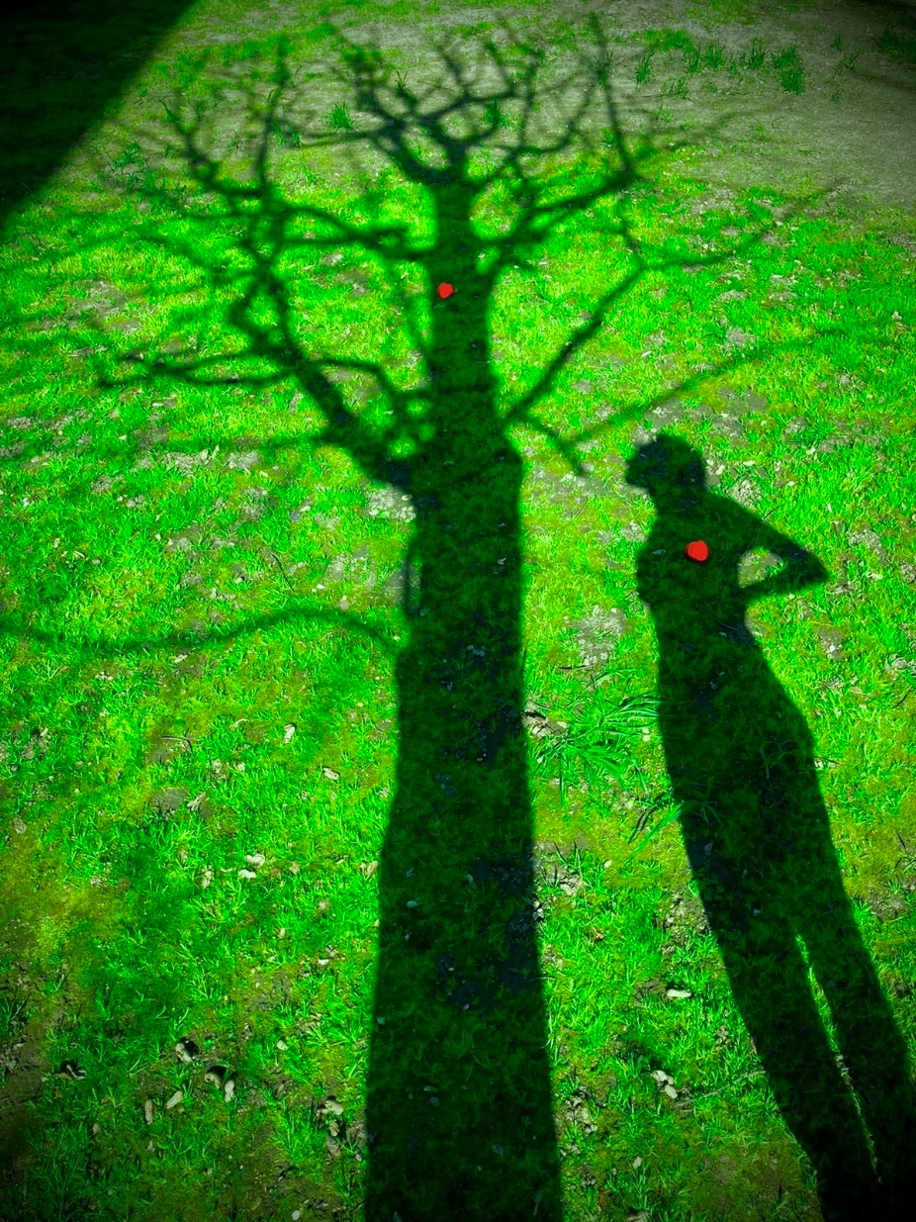

# Chapter 3: Doorstep Jamboree

|  |
| --- |
| **Summary**  This chapter is concerned with the impact of *Doorstep Jamboree,* a piece of gig-theatre made for and with disabled young people, on the participating audience, the creative team and the peer evaluators. This particular project was offered in three different versions: a gig at the audience’s doorstep, a gig in school playgrounds, and a gig via Zoom. The chapter concludes by identifying the impact of the three different versions of the project on the organisation and sensory theatre practice for the future.  **Key points**   * The participating audience, the creative team and the external evaluator gave very high ratings to *Doorstep Jamboree* for all Performance Dimensions. * There were three different types of performance of *Doorstep Jamboree*: on people’s doorstep, in school playgrounds and through Zoom. The Zoom Performances reportedly achieved a more direct dialogue between the performers and the participating audience compared to the other two types of performance. * For the first time in Oily Cart sensory theatre productions, the music was co-created with disabled young people, and the audience could improvise with the musicians and exercise control over the set list in performances. * The music, including personalised songs featuring the young person’s name, were identified as the most effective element of the show, followed by the costumes, use of movement and dance, the props; and audience-performers’ interactions. * *Doorstep Jamboree* included a diverse cast: disabled and non-disabled performers, as well as performers from different cultural backgrounds. This approach to casting promoted Creative Diversity. * The format and content of *Doorstep Jamboree* were developed through collaborative conversation amongst the cast, the creative team, and the audience. * By delivering the show in open spaces such as people’s doorsteps/ or school playgrounds, Oily Cart managed to bring the community together, raising the visibility of disabled children and young people as well as the profile of disabled audience as artists. * The three different types of performance offered variety of access to the participating audience. The Zoom performance emerged as the most effective model for co-creating and delivering sensory theatre beyond the pandemic. |

## Introduction

*Doorstep Jamboree* is an adaptation of the show Jamboree, a piece of gig-theatre made for and with disabled young people. The premise of the show is that the audience are receiving a visit from the travelling Jamboree band, who play Balkan-inspired music. The band collect tunes on their travels, making music with all the young people they meet. In *Doorstep Jamboree*, the band performed gigs on families’ doorsteps, in school playgrounds, or via Zoom, playing tunes that had each been inspired or influenced by a young person they had collaborated with (during a series of school workshops across the UK in the previous *Jamboree* tour). As part of *Doorstep Jamboree*, audience and cast enjoyed shared musical experiences, with the young people controlling the musical set list and improvising with the band. In total, there were 31 performances, attended by 129 children and young people.

## Responses to Rating Scales

From the 25 feedback surveys received from the audience survey it emerged that 15 participants had attended the performance outside the school playground, 6 had attended the performance through Zoom, and 4 had attended the performance on their doorstep. From the four Case Studies that have been analysed, two had participated in *Doorstep Jamboree* performances at their doorstep and two through Zoom. Three of the four families talked about their own and their child’s experiences of the performance. One family talked about the experience of both their disabled children.

Performance Dimensions (See Figure 3.1): The audience members who filled in the survey gave high ratings for all performance dimensions: Rigour (92%), Concept (92%), Distinctiveness (92%), Captivation (90%), Innovation (90%), Local Impact (89%), Challenge (82%) and Relevance (81%). It was evident from their high ratings that *Doorstep Jamboree* held their interest and attention, it was an interesting idea, it was different from things they had experienced before, it was well thought-through and put together, it was introduced to the audience in a new way, it was important that it was happening in the different contexts described above, the performances had something important to say about today’s world and that *Doorstep Jamboree* challenged them to think in a different way.

With regard to the audience responses to questions about their experiences of the show, the survey participants indicated that the young person / people responded well to the live music (92%), the experience was fun for the young person / people attending (92%); it was an enjoyable shared experience (93%); the performance was safe and well thought-through in terms of COVID-19 precautions (94%); and that they would recommend the show to others (94%) (See Figure 3.2). When asked to describe their experience of the performance in three words, they used words such as *unique, fun, joyous, magical, enchanting, enjoyable, interesting, inclusive, captivating, engaging and mesmerising*. This reveals that *Doorstep Jamboree* has had a positive impact on the people that attended.

**Figure 3.1: Doorstep Jamboree Performance Dimensions - Averages**

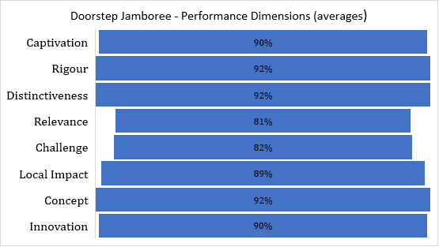

**Figure 3.2: Responses to statements of the Experience of Doorstep Jamboree (averages)**

76% (n=19) of the survey participants reported that the young person attending could be described as D/deaf, disabled, or living with a long-term health condition, compared to 4% (n=1) who did not agree with the statement, 8% (n=2) who preferred not to say, and 12% (n=3) who skipped the question. Finally, the majority of the young people attending could be described as White British (28%, n=7), and Black/ Black British (12%, n=3). 4% (n=1) was the reported percentage for each of the following ethnicities: White Irish, Asian/Asian British Pakistani, Asian/Asian British Chinese, other Asian background, Mixed – White and Black Caribbean, Mixed – White and Black African, Latin American, and other mixed background. 24% (n=6) of the participants filling in the online survey did not respond to this question and 4% (n=1) preferred not to say.

The Creative team reported an increase on their ranking of the performance dimensions (Captivation, Challenge, Concept, Distinctiveness, Excellence, Innovation, Local Impact, Originality, Relevance, Rigour and Risk) after the show, compared to their ratings before the show was shared with the audience (See Figure 3.3). This could be due to their uncertainty as to how the audience would respond to this innovative show. Similarly, the creative team was modest when rating *Doorstep Jamboree* before the performance was launched compared to the peer evaluators who rated the performance after it was launched. In particular, the peer evaluators provided higher ratings in all dimensions. In ‘Distinctiveness’ – i.e. the extent to which this show was different from things they had experienced before and Risk, there seemed to be an agreement between the creative team and the peer evaluators that *Doorstep Jamboree* was very different to what peer evaluators and the creative team had experienced before and that the artists were not afraid to try new things (See Figure 3.4).

## The most impactful components of *Doorstep Jamboree*

On the elements of the show that were particularly liked by the young person / people attending the responses identified the **music** as the element liked the most. The responses about the power of music in stimulating the audience in sensory and inclusive theatre productions is consistent with responses from previous evaluation reports on Oily Cart shows (Varvarigou, 2016; 2017; 2018; 2019; See Appendix 1, Aspect 1). In particular the audience commented on how *‘the change in tone of voices and sounds’, ‘the changes in speed’, ‘the changes in beat and tempo’,* the musical instruments, and ‘*the variety in rhythms’* attracted the participants’ attention and mesmerised them. Moreover, the **costumes** were colourful and bright and equally captivating. Furthermore, the audience recognised that the combination of music, movement through dancing, and visuals (bright costumes and attractive props) resulted in a *‘unique, magical, captivating, and mesmerising’* performance (See Table 3.1).

Survey responses concerning the impact of a series of sensory theatre experiences within the show are provided below.

***Music, dancing, costumes****, visuals, being allowed to make as much noise as possible! (Zoom performance)*

*The* ***bright costumes*** *were captivating along with the* ***music*** *and* ***strong beat****, grabbed the attention of some of [the] children along with the energy in interactivity of the performers (Performance outside school)*

*Both* ***costumes and music*** *held her attention very well! She attended to the screen holding her focus throughout [,] this has been unusual of late. So great to see in this situation. (Zoom performance)*

*Our son was, in the first instance, astounded to see the Jamboree hosts in striking* ***costumes*** *saying hello to him. Even more, he stood enthralled, delighted to make choices of songs to perform the special gig for him! He remained spellbound as the whole show was tailor-made for him. He certainly felt that he was close to nature in live* ***vibrant colours****! He thoroughly enjoyed the unique* ***music****, and was mesmerised by the flow of* ***rhythm*** *and captured by the* ***speed of the songs*** *- slow, faster and slower!! The Jamboree artists and musicians enchanted him in stunning* ***costumes*** *[,] individually interacting with him in such careful details - singing to him, dancing with him, personally coming near to the screen, talking though the stages of the gig and unwrapping the story of each unique songs. While being excited and engaged in* ***music and noise*** *making, the extraordinarily beautiful* ***dance performance*** *entranced him! He certainly felt he was part of the entire* ***special musical show****!! And for us, we were thrilled to know how the whole team was dedicated to deliver such an exceptional performance to children and families like ours [,] beginning with chatting through our little boy's personal preferences. This was a magical show for our entire family!!! (Zoom performance)*

**Figure 3.3: Comparing the creative team’s ‘before’ and ‘after’ responses** 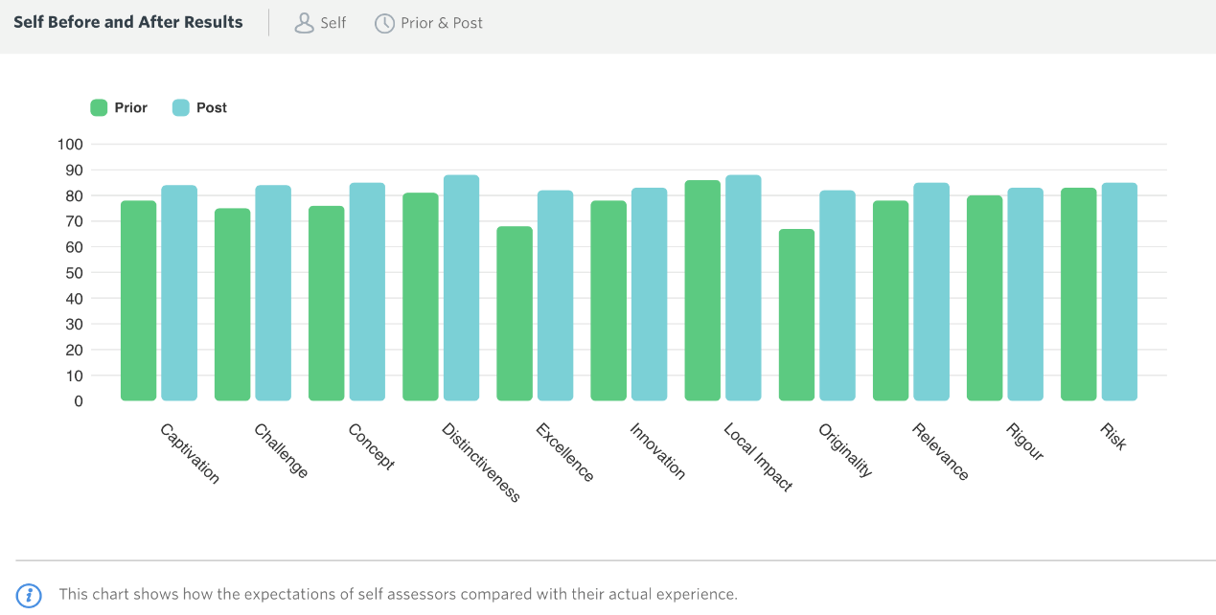

**Figure 3.4:** **Comparing the creative team’s ‘before’ and the peer evaluators’ ‘after’ responses**

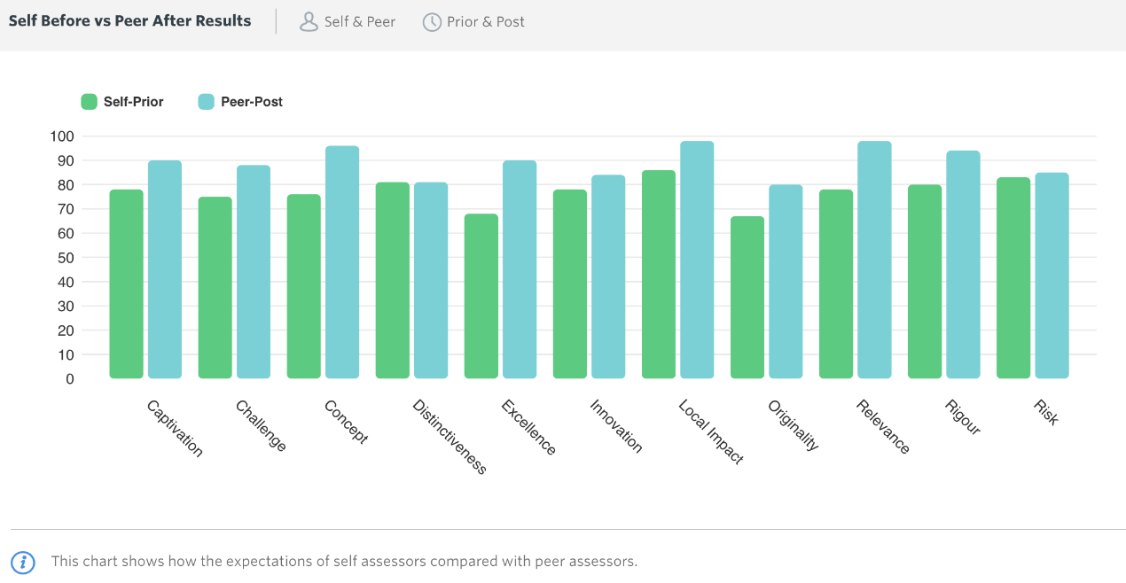

Unlike responses that appeared in previous Oily Cart evaluations (Varvarigou, 2018; 2019) the use of props appeared to be less commented on by the participants. This was probably due to COVID-19 restrictions that constrained the performers to favour aural and visual stimuli over tactile or olfactory stimuli, so that a safe distance amongst performers and audience was guaranteed.

Finally, the audience reported that being addressed by name and interacting directly with the performers was a unique experience for the children and young people who participated in all three versions of the *Doorstep Jamboree.* It was also noted by one family that the package they received by Oily Cart prior to the performance, containing a social story, sensory instrument and ideas sheet, enabled them to better follow the performance and take advantage of the moments for interaction.

No evidence emerged from the analysis of audience responses across the three different types of performances available (on the doorstep, in a school playground, or on Zoom) that audience members liked different elements of the performance based on the type of performance. Having a bigger sample could have enabled a sounder comparison across the three types of performance.

**Table 3.1: What the participants liked about the experience of *Doorstep Jamboree***

|  |  |
| --- | --- |
| Elements | **Exemplar Responses** |
| **Music/ sounds** | * …The huge sousaphone… and the clarinet. * …music was perfect gave opportunities to join in. * The change in tone of voices and sounds along with speed changes was particularly captivating for my Pupil with autism - the pupil would vocalise during the faster and louder moments showing that he was interested. * The music, changes in beat and tempo drew the children’s attention back to the show. * I think the most part where the audience played instruments and then the performers played a variety of sounds, rhythms in a conversation without words was one of the most engaging parts for my son. * Person in wheelchair singing and 3 others with music. It was heart-touching. * I think it was everything combined. The musical instruments were grand and impressive yet the sound was just perfect and varied tones & vibrations. * He thoroughly enjoyed the unique music, and was mesmerised by the flow of rhythm and captured by the speed of the songs - slow, faster and slower!! * The instruments so unusual (the sousaphone was a particular hit). * Child C, my eldest, is profoundly deaf, ASD, ADHD. He loved the gig, he got up and was dancing. He could hear it because the sousaphone is lower pitched, he can hear lower tones better. I think the instruments were perfect. He can't hear high frequencies as well, so the bass clarinet, and the sousaphone stuff were brilliant for that. We discovered new things that we didn't know he could hear**.** And they both loved the singer. (Case Study B) |
| **Costumes** | * The sparkly outfits. * The costumes were so vibrant. * Very interested in the costumes, colours it was very colourful which was great, * Costumes were bright and colourful. * The costumes were great at getting their attention. * The costumes were colourful and bright. |
| **Dancing/ moving** | * The way the musicians and hosts engaged with the audience- the way they moved, facial expression, positioning on the stage. * The level of performance with objects in the air and stomping was well coordinated. |
| **Props** | * The combination of everything, but particularly the bird props that came close to them * The scattered sunflowers were also really popular. |
| **Audience -performers’ interactions** | * The fact that the performers could directly address us by name. * All of the men and women were friendly, positive and interacted well with the children I took. The message that everyone is important and we should all listen to others and be heard came through loud and clear. * The way the musicians read the audience and followed their interests- getting down the children eye level, coming closer, playing faster louder quieter etc * She particularly liked it when the musician lowered themselves so that they were eye level with her. * The package that was sent prior to the performance was also great and the fact that there were signs so that there was much more of an element of audience participation rather than just being a passive spectator of the performance. |

When asked to identify effective elements of the show, the creative team and peer evaluators offered a similar response to the audience recognising that live **music** is a powerful means of encouraging participation and enjoyment.

*The* ***music****, the* ***puppet*** *and perhaps the* ***Zooms****.*

*Some of the* ***vocals*** *created very beautiful musical moments.*

*The strong high-quality* ***music****. Spoken word reflecting and acknowledging the audiences lived experience in the lyrics.*

They also expressed the view that the **outdoor format** and the fact that the performances were **personalised** (for small, family audiences) could make the *Doorstep Jamboree* a unique experience for the people attending and participating.

*I think an* ***outdoor*** *format will work well, helping people feel relaxed and giving them access to live music. I think the Doorstep shows outside people’s homes will make them feel they have had access to a personalised, high quality arts experience.*

*Small audiences, family audiences,* ***familiar non-institutional surroundings****, allowing space and time to facilitate and respond to reactions.*

**Image 3.1: Doorstep Jamboree – performance on the doorstep. Credit: Suzi Corker.**

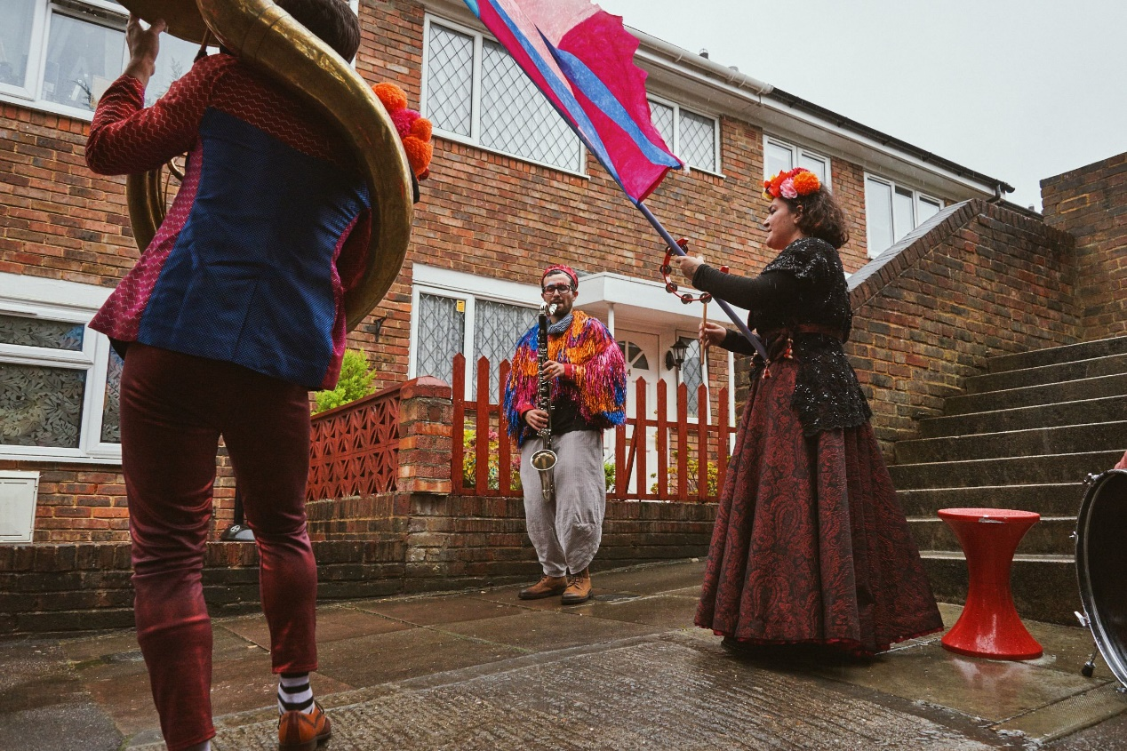

Other elements identified were the show’s flexibility and responsiveness to the needs of the audience – *‘the carefully tailored unique* ***modes of delivery’ –*** and the high levels of **expertise of the cast** in making each performance not only a musically, vocally and artistically excellent performance, but an inclusive one. Furthermore, the use of **movement** brought ‘to life the costumes and props’.

To the question inquiring about the most effective elements of *Doorstep Jamboree*, the creative team and peer evaluators referred to the three different COVID-safe formats of the same show and the fact that the cast explored different ways of finding connection and intimacy without relying on physical contact. In particular, the Zoom performances were commended for retaining the sensory and interactive character of Oily Cart shows.

## Ways of Participating and Communicating

With regard to observed difference in the young person / people’s participation, communication and / or focus during or after the experience, the majority of the audience participants emphasised how engaged, captivated and focused the children and young people attending were (See Table 3.2). They also described instances where the children appeared calm and happy, as well as vocal and physically active. After the performance, the young people attending appeared more communicative, and stimulated. The young people who attended a performance outside their school reportedly returned to their class humming or singing the songs. There was one response where the parent or carer noticed no difference in participation, communication or focus before or after an online show. The parent or carer explained that this was due to the fact that the young person attending *‘is now used to online sessions.’*

Interestingly, no pattern emerged in the data with regard to observed differences before and after the performance in connection to the type of performance attended. In other words, there was no evidence that Zoom performances had limited impact on participation, communication or focus during and after the show compared to performances outside one’s doorstep or in the school playground. As mentioned in the previous section, having a bigger sample could have enabled a sounder comparison on the impact of the production across the three types of performance.

**Table 3.2: Observed differences in participation, communication and focus during and after the experience**

|  |  |
| --- | --- |
| Observations | **Exemplar responses** |
| **During…** | |
| **Focused, engaged, captivated** | * They were largely focused and engaged throughout the performance. * As a parent I was impressed at how captivated the children including my baby was the entire time. * I am amazed they were able to focus for the whole performance. The students who needed a sensory break took one but then came back, mostly without prompting, as they wanted to see the show * Their focus during the session was very good * Both were engaged, interested, * Our daughter had had a rough night’s sleep so was a little tired but she remained totally focused and transfixed for the entirety of the performance. She preferred to observe and listen and moved her own body in participation. * Our child was completely captivated by the performance. * My son was quieter during the performance, which surprised me as he loves music and dance! But he was totally focused for the whole show, and then after singing and chatting about it! for a 2-year-old, I’m very impressed that you managed to hold his attention for 45 minutes- that not the case when I have taken him to other music classes. I replayed some snippets of videos or photos that I took and he was able to copy the rhythm of some of the tunes, so I know he took it all in! * I wasn't able to distract my son even for a moment. He was mesmerised. * Some of the children were very engaged and several who were initially very anxious gradually moved closer and watched attentively. Others who found it initially over stimulating gradually glanced more frequently. |
| **Calm and happy** | * …calm and happy… * Students were both happy and relaxed |
| **Vocal or physically active** | * 100% yes! The pupil was far more vocal - he was looking at the movements of performers. * N. attended well throughout. Her spontaneous actions and responses were great to see. |
| **After…** | |
| **Communicative** | They appeared more communicative after the experience too. |
| **Stimulated** | It did really stimulate my daughter and left her happy, engaged, and both relaxed and stimulated. |
| **Humming/ singing** | * …one came back to class humming…. * Singing the songs back in class. |
| **No difference** | Not especially as A. is now used to online sessions and has music therapy. We do know they thoroughly enjoyed the session though. |

The survey responses overall revealed that *Doorstep Jamboree* was a hugely successful project. It was described as a safe, enjoyable, shared experience that was captivating and inclusive. Disabled children and young people attending appeared to be focused, engaged and captivated during the performance, others were calm and happy, and vocally or physically active. After the performance, they appeared to be communicative, stimulated, and humming/ singing the songs of the show. *Doorstep Jamboree’s* three types of delivery – on the doorstep, in a school playground or on Zoom – appeared to have been received equally positively.

## The social impact of *Doorstep Jamboree*

*Doorstep Jamboree* offered socially distanced, mobile and versatile sensory theatre experiences; visible to the wider community, as well as accessible through online platforms such as Zoom. The audience recognised limitations imposed by the COVID-19 pandemic regarding experiences of touching props and instruments used in the performance, and being closer to one another.

*It would have been great if it could have been more tactile and the audience could touch the props but appreciate this is of course not possible in current pandemic times! (Audience Survey)*

*It’s difficult at the moment because of COVID restrictions but maybe some instruments for the children to join in one of the sections. (Audience Survey)*

However, as it emerged from the audience feedback, the *Doorstep Jamboree* performances managed to bring the community together and to raise awareness with regard to disabled people. This is probably a significant finding with reference to performances outside people’s homes or in school playgrounds, in contrast to Zoom performances. Being visible as a disabled person by attending and participating in a live face-to-face performance, such as in a garden or at one’s doorstep, allowed members of the community, such as neighbours, to also feel part of the experience. This led to new relationships being formed and to a recognition of the needs of individuals who experience social exclusion, in particular disabled individuals or older people.

*This is the best performance group I have ever known which caters for people with disabilities - the Jamboree performance was enthralling and the positive phrases used support young people to build* ***confidence and feel empowered****. (Audience Survey)*

*It was nice* ***community engagement****. It was really nice because normally you feel that you’re the ones taking from the road and the community – you know, you have constant cars outside the house and deliveries and people taking your parcels for you because you’re busy and all the rest of it. So, having something that gave them [the neighbours] something back, even in a small way, was really nice. (Case Study)*

The creative team underscored that despite the challenges that the COVID-19 pandemic imposed on the people working in sensory theatre productions, *Doorstep Jamboree* should make sure that guidelines such as social distances were followed whilst supporting people who were shielding.

*This feels like a* ***huge experiment****! This will involve a very different way of working our creative and performance team to ensure that everything is COVID safe. I expect that some audience members may not be able to engage as fully as with a live show with close-up interaction. I hope this will be valued as a local experience. (Survey)*

*We want to achieve a performance that feels relevant in terms of a response to the COVID crisis and also relevant to families and young people who have been in lockdown and shielding as a result to the pandemic. We want it to be as* ***accessible*** *as possible, including to those still in full lockdown shielding. We want it to bring joy and boost mood. We want to find ways that sensory theatre can still work with social distance*. *(Creative team Pre-Survey)*

The post-survey participants expressed the view that *Doorstep Jamboree* successfully achieved its aims. That is to say, firstly, it raised the public’s awareness of disabled children and young people’s *‘needs and pleasures… after months of being the forgotten sector of the community’*. Peer Evaluator, Daryl Beeton, indicated that *Doorstep Jamboree* allowed the voices of disabled young people to be heard through facilitating interaction such as sharing the control over the order of the playlist of the songs with the audience.

Secondly, *Doorstep Jamboree* raised the public’s awareness about disabled people as artists.

*I wasn't expecting there to be a 'political' [side] (I say this with a small but important 'p') to the situation we are faced with. This was led by the guest artists, Miss Jacqui, which I felt gave a very different feel/edge to the work. Therefore, I felt the doorstep version lacked this.* ***If the guest artist can’t be there then how does their voice still be heard or be visual on the doorstep****?... Oily Cart has a strong position due to its profile to be more political and be the voice of those who don’t have one. They should continue to develop and* ***include disabled artists*** *within their work, only then will a true voice start to direct, and be the best voice, the advocacy. (Post-survey, Creative Team and Peers)*

Thirdly, it was reported that *Doorstep Jamboree* reached families who were shielding and engaged them in *‘personalised and intimate experiences, despite social distancing’.* Two of the creative team and peer post-survey participants, in particular, stated that they found the Zoom performances particularly successful in engaging the audience in a personalised manner. Daryl Beeton identified the Zoom performance, as opposed to the other two types of performances, as the one that achieved a two-way dialogue between audience and cast most effectively. He also found the Zoom performance as the most effective in reaching families who were shielding. Nonetheless, he argued that although the Zoom performance offered a fuller show, *Doorstep Jamboree* performances on doorsteps or in school playgrounds, brought the show to life in a way that cannot be achieved through Zoom.

Box 3.1 presents examples from two Case Studies. The family of Case Study A had experienced a doorstep performance of *Doorstep Jamboree* but due to the pandemic they attended their child’s dance psychotherapy class online. They suggested that Oily Cart could also provide online sensory theatre experiences (which they did at the time through the Zoom version of *Doorstep Jamboree*), which could be experienced by the whole family at home. The parents of Case Study B also underscored the advantage of online provision of sensory theatre experiences. Both Case Studies are offered here as examples that reinforce Daryl Beeton’s view about the uniqueness of sensory theatre performances via Zoom in reaching out to all members of a family and to families who would not normally access sensory theatre shows.

**Box 3.1: The legacy of *Doorstep Jamboree* Zoom performances to disabled children and their families**

|  |
| --- |
| *… At the point of lockdown, we were like, this [the Dance Psychotherapy class] isn’t going to work, because the whole point is that you have a one to one who doesn’t use words necessarily to help you move – it’s all about touch, like Oily Cart, and reading how someone’s body is moving and responding to that. So, they moved everything online so the group became an online session, and what we’ve discovered it is opened up this whole new experience. Before, I drop her off and wait outside during her session and didn’t see what she was doing. Whereas now, because I do the home session with her, you learn a lot as a parent, about how the dance psychotherapy aspects of it work. And I think that’s something that could work for Oily Cart – you have so much knowledge about how people respond in a sensory way, in a way that the general public don’t really get. Even as parents, you don’t stop to think how your child might be processing the world in a sensory way, because that’s not how you navigate the world. Like the package you sent for Doorstep Jamboree, I thought that was really great – there was a sheet with tips, like ‘Try shaking the instrument close to someone’s ear’. As a parent, I think it helps to have someone kind of explain, ‘Think about doing it like this’, and then you can read for yourself whether your child likes it or hates it. Because I think we generally don’t go through life tuned into our senses, a sheet like that was really helpful to think about different ways you could help your child experience the whole thing in a way that was more tailored to how they would want to experience it…* ***(Case Study A)***  *…Doorstep Jamboree was a one-off thing, a nice bonus, and I think that’s the sort of thing we’d be looking for - one-off, little treats for him [via Zoom], like some music – theatre’s not really our world.* ***(Case Study B)*** |

## Developing the *Doorstep Jamboree* experience further

The audience members were invited to suggest possible changes to the *Doorstep Jamboree* productions so that they better meet the needs of the audience. Similar to previous evaluations of Oily Cart productions (Varvarigou, 2016; 2017; 2018; 2019 – See Appendix 1, Aspect 3), very few audience members offered suggestions stressing that the performance *‘was perfect’* and needed no change.

One audience member explained how **sensory engagement** supported children with limited vision, hearing or physical ability to make the most of the performance experiences.

*Obviously COVID was a barrier in terms of being multi-sensory for the performance this time. Under usual circumstances you would be closer with the audience. Being able to feel the vibration of the instruments and to touch materials would make it more engaging for children with limited vision, hearing, physical ability etc. Perhaps there is a way to create vibrations on the ground, or to use lights bouncing off instruments, walls, fabric etc, and fabric/board to create wind etc. (The birds were amazing for this though) (Audience Survey)*

Another audience member proposed the **use of sign language** to better support the experience of disabled children with hearing impairments.

*[My child] has got a hearing impairment and relies a lot on lip reading if the person’s up close or Makaton signing. The cue cards to show which song she wanted next, we did find quite useful, and then I was there to sign the key words. But for a child that’s D/deaf or has a hearing impairment, maybe you could find opportunities to add in some sign where possible. (Case Study)*

A third audience member focused on the music and suggested that the show could also include **‘more mellow’ tunes**.

*All the tunes were quite energetic - one slightly more mellow number might have been nice. And more from the vocalist, maybe. But I'm only saying that because I've been asked the question - it was fantastic as it was! (Audience Survey)*

Two audience members from different families suggested that having a **pre-introduction** to the faces of the performers would help some participants develop familiarity with them, which could enhance the performance experience. This material was provided as part of preparation resources which were posted to the families or emailed to the schools by Oily Cart. Therefore, there appears to be a need for Oily Cart to find different ways to monitor who receives the preparation material.

*Having some pre-introduction to the faces we were to see would be useful in the accompanying material. This would allow us to explain to the children who each person was and what they'd do. (Audience Survey)*

*The only thing was introducing the different people and what they were gonna do. We had a voice from the ether telling us they were setting the sound up and then all of a sudden, the two hosts appeared. Maybe if we’d got a photo or something before that said their names and their instruments and that they were going to get us to choose the songs, that would have been good. (Case Study).*

Facilitating greater familiarity with the characters of the show has emerged as a recommendation in previous evaluations, too (See Appendix 1). Nonetheless, Oily Cart have so far been producing material for each production, such as a Social Story, which detail the characters and their role in the performances. As mentioned above, this material is sent out to all the schools, and the families who participate in the shows. Therefore, perhaps, Oily Cart needs to look more carefully at how they could help everyone attending their shows be aware of those materials in advance. For example, Oily Cart could make sure that the Social Story is at a prominent place in each pack sent to future audience members.

There was also one suggestion for offering a **longer show** [with] some more spinning features – ‘*Wish it was longer - some more spinning features.’*  Finally, one survey participant mentioned that their view was ‘a bit blocked’. This might have influenced the experience of the performance for the young person attending.

Aspects of this project that could be developed further, according to the creative team, included ‘*extremely localised performances*’ on the ‘*doorstep and [through] Zoom*’, and the development of an album from *Doorstep Jamboree* ‘*to raise the visibility and profile of the audience as artists*’. One of the creative team participants cautioned that highly personalised shows such as *Doorstep Jamboree* might not be sustainable long term, however, they could become a blueprint that could inform the design of future shows.

*The pandemic meant that close up forms of sensory theatre were not possible and indoor gatherings likewise. So, Ellie, the Artistic Director, came up with the ideas of how to bring the show to its audience where they were: doorstep performances delivered to their home, Zoom performances online and pop-up festival / playground performances. All those ideas meant that we were creating sensory theatre in ways that we had never tried before. They worked a treat and this phase of the production's touring was much loved by the audience, their carers and families…I noticed that the feedback was greater for these shows than for a usual show, which I think has something to do with the level of* ***personalisation****, and* ***care*** *taken for each individual (Doorstep / zoom) and also the need for something positive at this time…Ideally, we would have had more time to develop each version and for tour booking, but that was limited by the weather. The high level of input for such small audiences (one family at a time) is* ***not sustainable long term****, but I think there is a huge amount we can take from this model and put into our future planning. (Post-survey, Creative Team and Peers)*

The creative team and peer evaluators also suggested that *Doorstep Jamboree* could explore more **modes of collaborating** with the audience, flexible ways of rehearsing for the Zoom performances and for touring beyond the pandemic, and involving more guest artists.

***More modes of collaborating*** *with the audience musically at every stage of the process. (Post-survey, Creative Team and Peers)*

*Ideally longer to rehearse in the Zoom shows….I think the band have an important message so I would like them to be our company house band so they can perform at events and festivals. I think Zoom sensory shows and outdoor shows and at home shows all have lots more mileage as good formats for access. (Post-survey, Creative Team and Peers)*

*[Would] Be interesting to have a* ***series of guest artists*** *each bringing a new twist. (Post-survey, Creative Team and Peers)*

**Image 3.2: Doorstep Jamboree Pre-event Resources**

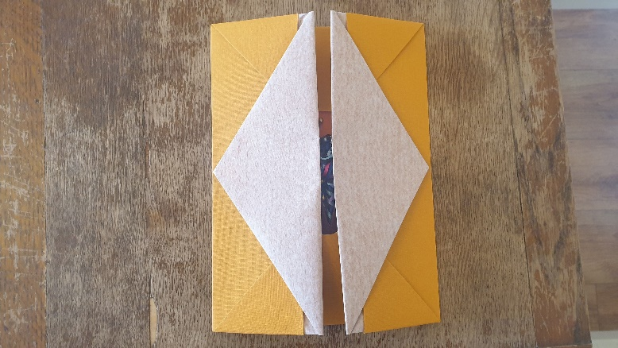

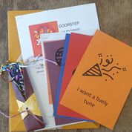

Regarding ways that Oily Cart could improve their offer for shielding families, Daryl Beeton expressed the view that sending families tactile parcels and guiding the carers more as to how to act as a ‘bridge between performance and young person’ would be an effective way forward. He also stressed that supporting, challenging and training D/deaf, disabled and neurodivergent artists to make work for young audiences would be the most effective way to push the boundaries of sensory theatre practice and to promote creative diversity beyond the pandemic.

*Let the sensory work be made by people who live in and experience the world [in a] sensory [way]. There needs to be support to embrace, challenge and train neurodivergent artist to make work for young audiences.*

Finally, when asked about how the experience of creating a show for one family at a time could inform and / or enrich new models of sensory theatre practice for the future, Daryl Beeton replied that this very experience could help ‘theatre’ as an artform that should primarily place its focus on the audience’s *‘needs, desires and responses’, to ‘readdress the hierarchy between “performance” and “participation”,* better allowing the audience to experience the creative potential of theatre. This echoes the perceptions about the role of theatre in disabled children’s life as expressed by the parent / carer in Case Study B (see Box 3.1).

*It allows individuality, allows the show to be* ***fully inclusive*** *by responding in the moment to the needs, desires, response of the audience in front of you. Theatre is too fixed, to rigid but we need to provide so many different ways for our audiences to enter the creative worlds of theatre and we need to readdress the hierarchy between ‘performance’ and ‘participation’ [so] both can fully inform how the other reacts and responds. (Audience Survey)*

To conclude, *Doorstep Jamboree* was very well-received and the performers were praised for their skills and for being sensitive to the diverse needs of the participating audience.

*I think it was excellent. The performers were very* ***sensitive to the diverse needs of the audience****. I wouldn't change anything. (Survey)*

*Please come back... (Audience Survey)*

*This was the BEST show! The costumes, staging and music was exceptional. It was like nothing else I have seen.* ***Miss Jacqui was the perfect front lady*** *- she was [an] exceptional singer and giving* ***an important message about being seen and heard,*** *and being a much-needed positive role model for young people with disabilities. Both the hosts were brilliant, but the younger man brought the show alive with his obvious joy to be on stage and engaging with his audience, which was made possible by the supportive and enabling environment [the] Oily Cart team offered throughout the show. The musicians were amazing- offering alternative music and sophisticated dialogue throughout the show. It was really a privilege to be able to see it. I wish everybody could see it! Thank you so much. (Audience Survey)*

*It was fantastic. Something I could see on a BBC children’s programme in the future. Thank you. (Audience Survey)*

## Summary

In summary, *Doorstep Jamboree* consisted of pop-up performances from the travelling Jamboree band, who played on doorsteps, in playgrounds and through the video conferencing software app Zoom to disabled young people, with a particular focus on those young people who communicate differently and do not rely on verbal language, and families still shielding. The aim was to offer an interactive, sensory show that would bring joy and improve wellbeing during the challenging period of the COVID-19 pandemic, in particular during lockdown. Following social distancing meant that cast and audience had no opportunities for tactile and close-up interactions. Nevertheless, the responses from the survey and case study participants confirmed that *Doorstep Jamboree* had a significant impact on the people who created, participated in and attended it. What is more, *Doorstep Jamboree* was recognised as a unique sensory theatre show that could pave the way for the creation of more sensory theatre productions that offer the audience the option to select the way that they wish to access sensory theatre experiences. Last, but not least, *Doorstep Jamboree* helped to raise the visibility of disabled children and young people as artists and as audience.

*We were so* ***grateful and appreciative*** *that this opportunity was offered to us!* ***Such a treat****, and especially in a time when everything is so restricted and many enriching experiences are not possible. (Audience Survey)*

*Thank you very much for providing us with this* ***unforgettable amazing experience****. (Audience Survey)*

It was **an incredible shared experience**. My husband and I loved it too and our PMLD boy cried when it ended! We won’t forget the music we heard or the fun we shared. Thank you so much Oily Cart! (Audience Survey)

*The most fantastic thing about the performance was the fact that it shone a light on our daughter and raised the community awareness with regards to people with disabilities. We loved how it really brought out the warmth in people, people baked cakes and were so enthusiastic about the event. It was lovely to be able to share the experience with everyone especially the young children and some of the older generation on our street, many of whom have also experienced isolation due to the pandemic in recent days! Thank you. (Audience Survey)*

**Image 3.3: Doorstep Jamboree – the Cast performing in a playground. Credit: Suzi Corker.**

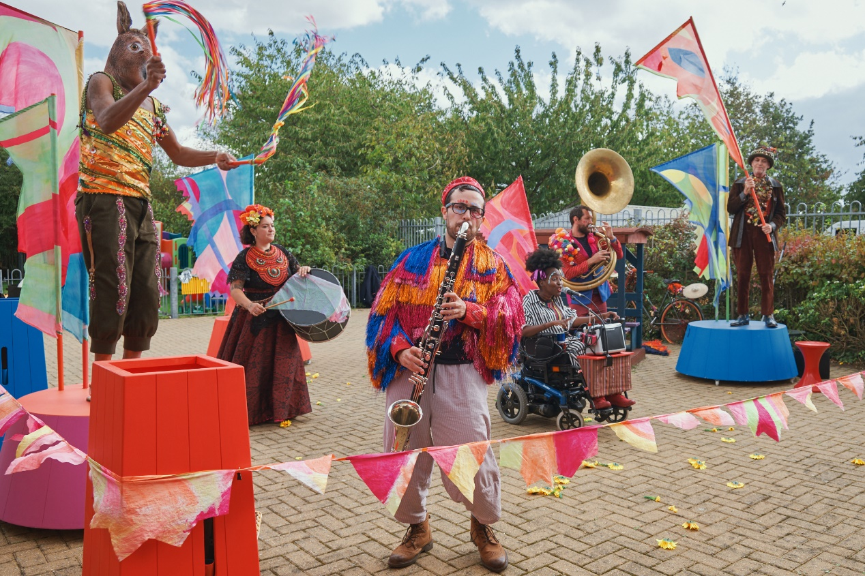

# Chapter 4: Space to Be

|  |
| --- |
| **Summary**  This chapter discusses the impact of *Space to Be*, a sensory theatre show that was developed and carefully scaffolded by Oily Cart, but ultimately performed and experienced by audience in their own homes. The audience were families who had at least one disabled and / or neurodivergent child. This sensory theatre show unfolded over five days: each day families opened a tactile parcel that included sensory props, accompanying sensory audio, and guidance on how they could be used by the members of the family to share meaningful sensory experiences.  **Key** **points**   * *Space to Be*, was an innovative sensory theatre production that participant families could experience with no performer present either physically or virtually. * The Oily Cart creative team worked collaboratively with consultant families, and disabled artists to devise this production. This collaborative and creative process meant that sensory theatre activities embraced the diverse needs of the disabled children and their families. * Experiencing *Space to Be* remotely and at one’s own home reportedly enabled families to share sensory theatre experiences they otherwise would not have accessed. * The voice of disabled young people was integrated into the recorded soundtrack, the only performer was someone with a lived experience of disability, and the story / theme of *Space to Be* aimed at reflecting the families’ experience and stories back to them. * The parent or carer felt appreciated and special by being given the opportunity to engage in sensory theatre experiences that were devised only for them as part of *Space to Be.* * The shared experience of *Space to Be* re-enforced special bonds between family members, and enabled the parents / carers to dedicate time to sharing these experiences with their children. |

## Introduction

*Space to Be* was developed with the aim to enable families who have at least one disabled child to enjoy a safe, high quality piece of sensory theatre during the COVID-19 pandemic. The ultimate objective was to promote sensory wellbeing for both the adult(s) of a family alongside the wellbeing of the disabled child or young person under their care. This was envisioned as being achieved by offering the parents and carers a series of sensory experiences that they could use to connect with their disabled child, who might communicate differently to them. Furthermore, Oily Cart hoped that *Space to Be* would reach under-represented families across the UK, who have fewer opportunities to experience Oily Cart productions.

Oily Cart sent each family participating in *Space to Be* aStarter Packthat contained all the information they needed to prepare for the experience. This pack was primarily aimed at the adult of the family and tried to set the tone for *Space to Be* – ‘an experience that invites them to take time to “just be” (quote from the Starter Pack). The Starter Pack contained:

* An audio introduction to the show.
* A Galaxy chocolate bar (or vegan alternative if requested)
* A Yorkshire Gold teabag. Attached to the tea bag was a note that said *‘The audio introduction you were sent will take as long to listen to as it takes to drink a cup of tea. So, use this tea bag to make yourself a cup, sit somewhere comfy and press play.’*
* A Space to Be postcard, which was addressed to each person in the family. This postcard had the key information about *Space to Be*, including how to contact the stage manager and when the boxes would be dropped off and picked up.
* An illustrated map with symbols for each box which corresponded with the labels on the boxes. This illustrated map would guide the participants in the show through the experience visually, rather than orally.
* A Social Story, if the family had requested one.
* A Star Guide, which acted as a personalised ‘character guide’ adapted for each family on the tour. Each member of the family had a star character with its own colour on one side. On the other side was a constellation that showed which stars were involved on each day. The audio each day referred to these star characters.
* Finally, it included a flyer about how Oily Cart were keeping the production COVID-safe.

*Space to Be* could be experienced over five days as follows: Five boxes were delivered to each home, labelled Day 1-5. Each box contained different sensory experiences inside it. Instructions for each sensory activity could be found inside the box lids, and families were also sent links to preparatory videos. It is worth underscoring here that the concept of constellations that connected the packages of *Space to Be* was used as a metaphor that tied the show together, to make it a theatrical and unique emotional journey for the participants, rather than just a series of activities on five consequent days.

**Day 1** – The first box concerned the adult (parent or carer) of the disabled child or young person. This person was referred to as ‘Source Star’, and was encouraged to have this first sensory experience alone. The first box included a set of instructions, a diagram, headphones and an MP3 player, an eye mask, a small box, a bag with a kalimba, and a scent bag. The adult was asked to find a relaxed and comfortable space in the house, where they could spend fifteen minutes guided by the soundtrack to Day 1.

**Day 2** – The second box was for both the adult (‘Source Star’) and the disabled child (‘Hummm’). The box included a set of instructions; a diagram; one pillow with pillow speakers through which one could hear the audio for Day 2; a velvet blanket with embroidered patterns; and a scent bag. The sensory activities it instigated were to take place between Source Star and Hummm for twenty minutes, lying down together on the pillow.

**Day 3** – The third box was for Source Star, Hummm and another member of the family, called ‘Whoosh’. The box included a set of instructions, a diagram, a scent bag and silver tins. Inside each tin, which had its own audio, there was a shiny rectangle covered in little mirrors and a wrist torch. Day 3 of *Space to Be* revolved around mini sensory experiences for each of the two or three members (if the family included a Whoosh character to join them) to do on their own and together.

**Day 4** – The fourth box included a set of instructions, a diagram, one silver elastic star shape, one resonator (a vibrating box, as audio played from the speakers attached to the resonator) (for more information on resonance boards see Grace, 2018, p. 115-6); and a scent bag. These materials would instigate an active sensory experience for up to four members of the family (Source Star, Hummm, Whoosh and Rumble) to do together.

**Day 5** – The fifth box included a set of instructions, a diagram, four weights, four big branches, one large piece of shiny fabric, one light, one speaker with MP3 player, and a scent bag. These materials would create a mini planetarium tent for the whole family to lie under together and to star-gaze. On this last day of Space to Be, the family was encouraged to slow down, and notice what they saw, heard, smelled and felt.

## Responses to Rating scales

The families who participated in *Space to Be* provided very high ratings to all Performance Dimensions of the show. In particular, they expressed the view that Rigour, Concept, Distinctiveness and Captivation were the most impactful dimensions of the show ranked between 90-100%. In other words, *Space to Be* was well thought-through and put together; it was an interesting idea; it was different from things they had experienced before; and it held their interest and attention. Local Impact and Challenge were ranked between 80-90%. That is to say, the survey participants felt strongly that it was important that the event was happening remotely and that it challenged them to think in a different way. Lastly, Relevance was ranked at 76%, a moderately high rating, suggesting again that the show had something to say about today’s world (See Figure 4.1).

**Figure 4.1: Average scores, *Space to Be* Performance Dimensions - Audience Survey**

The survey participants were also asked to rank their agreement from zero to a hundred to a list of statements about the experience of *Space to Be*. The average scores are presented in Figure 4.2. Overall, they offered very high rankings to all the statements. That is to say, they believed that *Space to Be* felt safe and well thought-through in terms of COVID-19 precautions (97%), they would recommend this experience to others (96%); it made the child and the family feel good (92%); it was an enjoyable shared experience (92%); it felt accessible to the child and the family (91%); it created opportunities to connect to the child in a different way (90%); and they enjoyed the change to their daily routine (89%).

**Figure 4.2: The average scores to a series of statements – Audience feedback survey**

In addition, 82% (n=23) expressed an interest in participating in a parent’s workshop on sensory techniques, as opposed to 10% (n=3) who did not express this interest and 7%(n=2) who did not respond to this question. With regard to the length of *Space to Be,* 82% (n=23) expressed the view that ‘a week was a good length of time’, and 18% (n=5) stated that ‘a week was not enough time’. Moreover, 96% (n=27) of the survey participants expressed the view that *Space to Be* ‘has given [them] ideas that they will use with their child in the future’, as opposed to 4% (n=1) who did not agree with this statement. Regarding socio-economic class, 55% (n=15) self-identified as Working Class, 15% (n=4) as Lower Middle Class; 26% (n=7) as Middle Class; and 4% (n=1) as Upper Middle Class (See Figure 4.3).

**Figure 4.3: Self-identified socio-economic class of the audience participants (number of responses, percentage)**

**Image 4.1: A young Humm explores the lighting effects found in Box 3. Credit:**

**Photo supplied by family.**

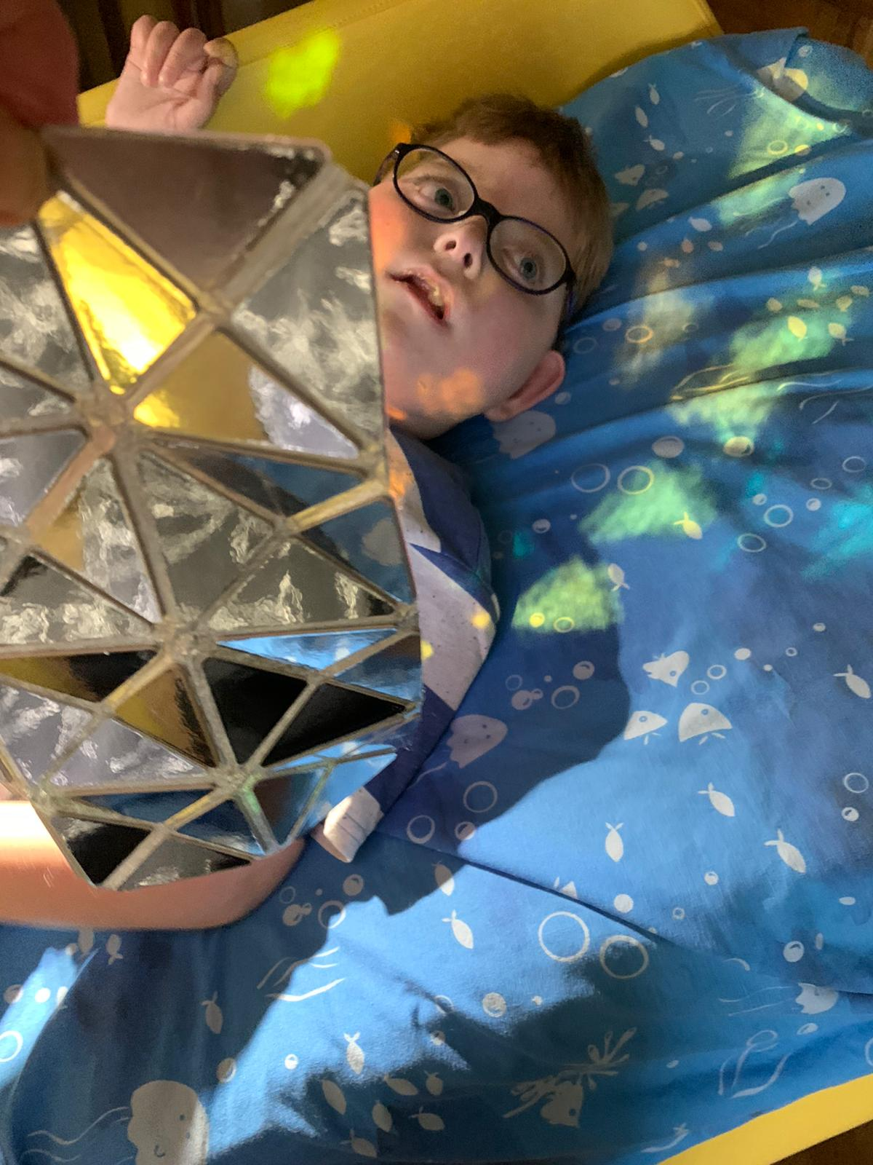

Moreover, 93% (n=26) of the survey participants described their child as ‘Deaf, disabled, or living with a long-term health condition’, as opposed to % (n=2) who did not respond to the question. 71% (n=20) of the adults filling in the online survey would not describe themselves as ‘Deaf, disabled, or living with a long-term health condition’, as opposed to 25% (n=7) who would describe themselves as ‘Deaf, disabled, or living with a long-term health condition’, and 4% (n=1) who did not respond to this question.

Finally, when asked about the Ethnicity of their child, 85% (n=23) identified as White British. There was one child in each of the following categories of Ethnicity (4%): White Irish; Other White background; Mixed – White & Black Caribbean; Mixed – White & Black African; Mixed – White & Asian. One survey participant (4%) did not provide any information.

The two members of the Oily Cart creative team who filled in the pre-survey did not share the same views on some of the Performance Dimensions of *Space to Be*. Figure 4.4 shows the average scores. The highest average score was given to Innovation (80%), followed by Distinctiveness and Risk (79% respectively); Rigour (78%); Concept and Excellence (75% respectively); and Originality (70%). Lower average scores have been given to Captivation and Relevance (65% respectively) and Challenge (56%).

Overall, the Creative Team appeared to be modest on their ratings about the impact that *Space to Be* would have on its target audience. Similarly to their responses for *Doorstep Jamboree*, this could be due to their uncertainty as to how the audience would respond to this new show.

When invited to respond to a series of six statements about the experience of *Space to Be* for the child and the family, only one creative team member offered their rankings. This creative team member felt that *Space to Be* would feel accessible for the child and their family (90%); Safe and well thought-through in terms of COVID-19 precautions (89%); it would create opportunities for parents/ guardians to connect with their child in a different way (86%); it would be an enjoyable shared experience (85%); it would make the child and their family feel good (79%), and the parents / families would enjoy the change to their daily routine (73%).

The post-survey was filled in by three participants – two members of the Oily Cart creative team and a peer evaluator. Figure 4.5 shows their responses to the Performance Dimensions at the conclusion of the project. Similarly to the pre-survey, some of the survey participants also appear to be modest about the impact that *Space to Be* has had on its target audience. On the whole, the survey participants rated *Space to Be* very high on Challenge (97%), Innovation (94%) and Distinctiveness (92%); followed by Concept (89%); Risk (88%), Originality (87%), Rigour (86%) and Excellence (83%). The average score for Captivation was 76% and for Relevance was 63%.

**Figure 4.4: Average scores on *Space to Be* Performance Dimensions (Pre-survey, Creative Team)**

**Figure 4.5: Average scores on *Space to Be* Performance Dimensions (Post-survey, Creative Team & Peers)**

When asked to rate a series of statements about the experience of *Space to Be* on the child and the families, the survey participants offered moderately high ratings (from 80%-88%) suggesting that *Space to Be*: felt safe and well thought-through in terms of COVID-19 precautions (88%); it was an enjoyable shared experience (87%); it created opportunities for the family and the child to connect in a different way (83%); it made the child and the family feel good (83%); the family enjoyed the change to the daily routine (81%); and it felt accessible for the child and the family (80%) (See Figure 4.6).

**Figure 4.6: The average scores to a series of statements – Post- Creative Team and Peers**

|  |  |
| --- | --- |
| Young person wearing headphones. On their lap is the instructions from one of the Space to Be boxes, the kalimba with its velvet yellow bag, and a blue scent bag. | Young person shining a wrist torch onto a shiny mirrored sheet. |
|  |  |

**Image 4.2 (left): A young Humm explores the material of Box 1.**

**Image 4.3 (right): A young Humm explores the lighting effects found in Box 3.**

**Credits: Photos supplied by families.**

## The Impact of key elements to sensory theatre experiences at home

When asked about what their child liked the most from the elements of *Space to* *Be* the parents / carers identified the Lyra (the show’s name for the kalimba instrument) as potentially the artefact with the most impact on the disabled children and young people. What is more, after *Space to Be,* many parents decided either to purchase one or put a kalimba instrument on the ‘to-buy’ list. Other props that the children liked through their sensory theatre experiences were the torch lights; the vibration / resonance box; the shiny mirror sheet; the music or other sounds; and the use of voices (See Table 4.1).

**Table 4.1: What the participants liked about the experience of *Space to Be***

|  |  |
| --- | --- |
| Elements | Exemplar Responses |
| Lyra and music | * He loved the sound of Lyra too. * The new 'equipment' was really engaging. **'Lyra'** particularly calmed our child with additional needs and we're seriously considering looking in to getting one! * They all loved **Lyra** and have requested one. * The Kalimba particularly grabbed my child's attention and Day 3 in particular and Day 5 were highlights. * They also really liked the music that came with each day. |
| Lights | * He loved the **torch light** shining on the reflective item, it was fab what you sent in the post. * My younger son loved the **light projection** and wants one to go to sleep with. * My son really enjoyed the den activity with the **lights**. It was really calming for him and he enjoyed us all laying together without everything else going on around us. * B. loved the visual experiences. The sensory **lights, the mirrored/tiled play toys**. * The **lights and kaleidoscope** were great. * My son’s favourite was day three with the r**eflection and lights**. He was interested in the patterns and colours. * The sensory aspect with the starts and lights |
| Vibration/ resonance box | * The sensory experience but loved the **vibration box and star making.** * **Resonance box and manipulation of vibrations was a real winner with her**. * The **resonance box** was fantastic and the children really enjoyed using it to make the different noises and vibrations, in particular they enjoyed creating different effects for their eldest sister who really enjoyed the experience. * He also enjoyed the sounds from the resonator. |
| Mirrors | * They really love the **star mirror** mats with the lights. * We LOVED!! the rectangle covered in **mirrors and the torch** - it has inspired us to want to re-create these lovely experiences. |
| Voices | * The different **voices** in the pillow with mum behind her * He loved the **voices** in day 2. He responds well to different accents and loved hearing them. |
| Sounds | * My husband really engaged well with the sound tins and as a result, the experience with him, [name of child] and myself was particularity special. * The **sounds** alternative from different locations was good. |

When asked about whether they noticed any difference in the child’s participation, communication and / or focus during or after the experience, the parents / carers mentioned that their children were more focused; engaged and calm (See Table 4.2). They also reported behaviours that they observed, which either impressed them or changed the family dynamic after the show ended. For example, one parent noticed during a sensory theatre activity that they shared together with their disabled child that the child engaged in voluntary movement as well as expressed their dislike for certain noises. Both responses were reportedly very rare for this particular child.

*[Child’s name] reaction was astonishing, she lifted her hand up and kept it in the air for me to hold knowing I was behind her. She has hardly any voluntary movement so this was quite remarkable. She also noticeably indicated her dislike of baby noises on each of the three occasions these could be heard which was hilarious. (Audience Survey)*

Another parent reported that sharing this sensory theatre show with their sibling made the neurotypical sibling develop resilience towards their disabled sibling.

*I asked our younger son what he wanted to say about Space to Be and he gave a thumbs up. I asked what he liked about it and he said 'everything', but quietly, and his sister said "he said 'everything'." I've just noticed that I think she has been a little less frustrated by him since the experience. (Audience Survey)*

**Table 4.2: Perceived differences in the children’s responses as a result of *Space to Be* experiences**

|  |  |
| --- | --- |
| Elements | Exemplar responses |
| Focused | * He really really **focused** on the reflective item, he spent a really long time exploring it. His eye contact[ed my eyes] as we lay under the blanket listening to it. First there was you and there was me. It was amazing-it made me quite emotional actually. * Our daughter is very focused if engaged. So, she was very aware of what was going on, however new experiences piqued her interest which was great to see. |
| Engaged | * Some of the activities we were able to do twice because they were so engaged. * A real willingness to engage and partake. Concentration and desire to stay on task was noticeably increased during each Space to Be. |
| Calm/ relaxed | * Very relaxed throughout the experience. * [Name of child] was calm and regulated following some of the boxes, particularly 2 and 3. * Calm and relaxed. Good for her self-harming. Not as much of that during the week. * Calmer and settled. * My son just really looked forward to opening the boxes and doing the activity together. I defiantly noticed my son was more calm after the activities. * My younger son got to sleep much more easily and calmly. Everyone was a bit calmer. They all willingly participated, and were excited about it. |

## The social Impact of *Space to Be*

The Oily Cart Creative team reportedly set out to create a piece of sensory theatre that was responsive to the experiences of many families in lockdown and / or those who were shielding, who were potentially very isolated, neglected, and managing increased caring responsibilities due to the removal of support, and to enhance their overall wellbeing. They aimed to achieve this by engaging the adults and the young people in sensory experiences together. The uniqueness of *Space to Be* according to the survey and the Case Study responses was attributed to four parameters (See Figure 4.1):

1. *Space to Be* gave the creative team the opportunity to explore **new ways of working,** from the devising stage of the process to the artistic delivery of a show without performers. In particular, the Oily Cart creative team explored different ways to support the adults of each family unit as best as possible to facilitate the show happening, in the absence of a lead performer.
2. Offering sensory theatre experiences remotely made *Space to Be* accessible to families who otherwise wouldn’t have had the opportunity to experience them.
3. It was the first time that Oily Cart *‘opened up the sensory experience to all the family members and not just the disabled young person…’* *(Post-survey, Creative Team and Peers).*
4. It was also the first time that Oily Cart created an activity especially for the adult. This activity took place on Day 1 of the project.

**Figure 4.1: The Social Impact of *Space to Be***

### New ways of working – co-creating a sensory theatre show with the audience

Co-creating a sensory theatre show in consultation with families that have disabled members, as well as with disabled artists, meant that the voices of disabled people and the stories of families with disabled children and young people were heard in a creative way.

*The only performer was someone with lived experience of being a wheelchair user and barriers to access. The voices of disabled young people were integrated into the recorded soundtrack. The story / theme was all about reflecting the families’ experiences and stories back to them. (Post-Survey, Creative Team and Peers)*

New ideas on what to use and how to use it to effectively explore sensory theatre experiences with disabled children and young people were beneficial not only for the families who engaged in the devising process, but also to the families who used them.

*I understand about sensory experiences and taking time to enjoy simple things together. The repetition of words and changes in sound, style and volume during the first ‘there was you and me’ is new to me though. He was really focused and seemed to enjoy that experience. I use music with him a lot, but I liked the impact of repeating the words. (Audience Survey)*

*Dark tent would be good for relaxation and visual stimulation (Audience Survey)*

*Planning our own 'basic' sensory experience. Sometimes I think we complicate the experience too much. Space to Be didn't overwhelm as each experience was focussed and the expectation was one experience at a time - not lots. I think we need to work on building up to the participation of all members of our family. The experience showed us it works really well one-on-one; or two-on-one but with our particular situation, our family became distracted for boxes 4 and 5 with increased numbers of participants. (It was still enjoyable for the children but as adults we felt we were managing the children's experience whereas for the previous boxes it had really felt like we were part of experiencing the excitement.) (Audience Survey)*

*My son has sensory processing disorder and finds it very difficult to regulate. We provide lots of opportunities for him to get sensory feedback but we have realised through this experience that he needs a lot more calming activities. Space to Be has shown us that we could do it as a family activity. (Audience Survey)*

*I'm always looking for ideas that appeal to my son's senses and this week has given me ideas to adapt and create things to use with him in the future. I will be making scented bags for the days of the week, and also adapting a bed canopy for the day 5 light show. (Audience Survey)*

*Just a massive thank you for all of the effort you have gone to, we really appreciate all the time and effort you have put in! (Audience Survey)*

A member of the creative team expressed an initial concern that they had about whether *Space to Be* would be theatrical enough. However, by trialling the sensory theatre experiences out with their own child, by getting positive feedback from the families who experienced it, and by images and videos from the audience, they could identify the show’s ‘narrative structure’ and the theatrical way with which the different sensory elements were brought together.

*One of the big questions in my mind going into this project artistically, was how to make this "theatrical". However, having experienced it directly with my child, and also reading the feedback and seeing images / video from audiences, it definitely felt theatrical. There was more of a narrative 'structure' than I'd expected, and the holistic approach to all the sensory elements brought it together in a very theatrical way. It was undoubtedly beautiful, and I'm pleased with how much we involved the different sensory elements using sound, smells, lights, touch, voice, movement, etc (Post survey - Creative team and peer).*

### An accessible but remote sensory theatre experience

The fact that *Space to Be* took place at each family’s home, giving complete autonomy to the family about when to engage in the sensory theatre activities, was praised by the survey participants and also heralded as a new way for families to experience sensory theatre during and beyond the pandemic. Sensory theatre experiences that took place at one’s own home appeared to be more accessible to families who otherwise faced barriers, such as constraints around Changing Places facilities in venues, and carrying bags with their children’s medication, to giving their disabled children similar sensory theatre experiences.

***I think if it wasn't online and at home, I don't think Child A would have got the opportunity in real life****, there have obviously been disadvantages due to COVID because people have had to think of new ways of getting out there and learning and things,* ***but this has been an advantage for us, that we've been able to take part in Space to Be****. The process has just been just easy, it gets delivered to your house. It's got everything in the boxes, you have the postage labels, and then it all goes back. For us, going to things is usually stressful, but there was no pressure on us.* ***You've taken care of everything… We probably wouldn't even have heard of yourselves (Oily Cart) if it wasn’t for COVID****, so it was nice to get involved and it's something you don't have to travel to. For us, we have to prepare the day before, think about how many bags you need, think about if there are going to be changing facilities and all the rest of the things, like medical bags etc. Doing it at home takes out the travel time of going somewhere and takes that stress away and* ***pre-COVID we probably wouldn't have got this opportunity to do it.*** *(Case Study)*

These constraints were also recognised by the creative team who underlined that the format of the show ‘took the pressure and stress out’ of families who would not normally go to a public arts venue. In addition, the guidance and props sent to them to facilitate the sensory theatre experiences resonated with the families, enabling them to create intimate and private sensory theatre moments at home.

### Sensory theatre experiences open to the whole family

The survey participants emphasised that the shared experience of *Space to Be* re-enforced special bonds between family members, and enabled the parents / carers to dedicate time to sharing the experience with their child.

*It created situations in which my* ***children were open to trying something new****, which led to* ***new connections and positive moments****. After doing the day 5 experience, my older son said about my younger son: "I remembered I like him." This was partly deliberately funny but also encapsulated how he felt. My younger autistic son gave me a big hug during day 2's experience, then said "I love you Source Star." I replied "Ahhh, I love you Humm." He said: "Them are cute nicknames. I am gonna keep that nickname forever." He then hugged the 'lyra' and said "my love you Lyra." These moments wouldn't have happened otherwise. (Audience Survey)*

*It was a joy to do something together as a family that was exciting, different and ensured* ***we carved out time*** *to make it happen. (Audience Survey)*

*The activity made us* ***make time*** *for each other and also enabled both of my children to connect in a way they are unable to do in normal play. (Audience Survey)*

*Was lovely to* ***include all our family****. Usually activities are just for my daughter which is fine as she is the one with complex needs, however thinking about us as parents and carers who need time to relax and just be was very special and important. As parent carers we rarely have time for ourselves so doing this forced us to which I know is very important. We must look after ourselves in order to look after [child’s name], but we too often forget about ourselves. (Audience Survey)*

*As a newly adopted family it* ***brought us together****. (Audience Survey)*

*Made us* ***take the time together as a family*** *which we so often don't do because we are all too busy. (Audience Survey)*

*This was excellent for our son who is autistic as he loved the lights, meditation and mindfulness aspects of the experience. It also opened up* ***a new experience for his dad*** *who normally is not interested in this type of activity. (Audience Survey)*

For one particular family *Space to Be* reportedly helped the parents to enjoy an activity that they did not have to create on their own from scratch.

*It was particularly helpful as often we are expected to create all our own resources to make the world accessible for our children and then by the time we all get to experience it; the adults are stressed and tired and not so excited about the experience. This allowed us all to approach the experience fresh and excited too which clearly impacted on how we all enjoyed it. (Audience Survey)*

Overall, both the audience and the creative team were positive about the social impact that *Space to Be* has had on engaging the whole family together in sensory theatre experiences, in a safe and enjoyable way.

*I feel satisfied that we created a show in a format that was COVID-safe and accessible to families still shielding who have [(a)] disabled child / children. I think it was a big step for us in engaging other family members and creating space for them to be together in ways that are mutually enjoyable. (Post-survey, Creative Team and Peers)*

Box 4.1 presents a quote that reinforces the legacy of *Space to Be* in terms of respecting and supporting families in the UK during the pandemic to enhance their wellbeing through collaborative engagement in sensory theatre experiences.

**Box 4.1: The legacy of *Space to Be –* respect and support tothe families**

|  |
| --- |
| *I think this was particularly impactful at this moment in time, given that many of these families are still shielding, and at least unable to engage in public arts spaces any time soon. When we first envisaged this project, we didn't expect the pandemic to continue so long, so I'm pleased that this is a flexible model and relatively low-cost to 'tour' so that an extension is possible. I was particularly moved by some family comments, about how it brought people together. (Post-survey, Creative Team and Peers)* |

### Designing an activity especially for the adult

The survey and the Case Study participants underscored the importance of dedicating Day 1 of the project to the primary adult, the person who devotes a substantial part of their life to caring for their disabled child, and the rest of the family. The parents / carers themselves also expressed gratitude for being allowed to have some ‘me time’. They considered the Starter Pack and Day 1 of the show as a gesture of appreciation by the Oily Cart team for the time and energy that the parents put into their caring roles.

*As a carer, I found day 1 to be such a* ***profoundly personal and moving******experience****, that I cried. No one ever asks the parent how they are feeling or recognises their sacrifice of time and energy in their caring role. This activity, targeted at the carer,* ***gave permission*** *to just be in the moment, forget about their caring responsibilities and spend time on themselves. The music/sound was* ***hypnotic*** *and the clever use of blindfold, earphones and handling a cold object really helped me focus on the activity. I have constant Tinnitus ringing in my ears all day, every day. During this activity I didn't hear it!* ***It affected me so deeply*** *that I emailed Oily Cart to say I think there could be scope to develop something similar for parents of SEND children as part of social prescribing.* ***In 11 years since becoming a parent, I've never had this level of reaction to a support tactic****…* *The day 1 activity definitely has potential to help SEND parents and carers to develop self-care and mindfulness. It was exceptional. (Post-survey, Creative Team and Peers)*

*It was nice to sit down and* ***eat my Galaxy in bed****! I thought the intro was quite relaxing for me. It really brought me down and gave me some me time. It was like a meditation type thing. So relaxing… Day one was nice, it was* ***relaxing******10 minutes of me time*** *and I think I found the smells quite overpowering on the first set (prototypes) but the smells were quite nice throughout the five days. It wasn't very overpowering at all. (Case Study)*

*I also particularly loved the fact that you provided* ***a box for me****, you have no idea how incredibly special that was. Just taking some time for me was amazing. (Audience Survey)*

*We wanted to give you our heartfelt thanks for such a memorable, quality experience. The organisation, time and funding that has clearly gone into this experience was astonishing (dare I say, 'out of this world!'). From the laminated instructions, sound clips simply ready to play and even a tea bag, chocolate bar and* ***my own special parent space to be*** *to start the experience off, all of these details spoke volumes of your understanding of your audience and our struggles in life. (Audience Survey)*

The creative team also acknowledged that creating a special activity for the parent / carer empowered them to feel confident to actively facilitate the other activities of the show.

*I loved the parent / carer response to Day one which felt like quite a different thing to anything we'd focused on previously and at this moment in time, it felt quite powerful. As a parent this felt very moving. (Post survey, Creative Team and Peers).*

## Developing the *Space to Be* experience further

The creative team recognised that *Space to Be* allowed them to experiment with new ways of creating sensory theatre experiences that could be adapted in future Oily Cart productions. These included offering sensory theatre experiences whereby packages are connected with soundtracks; using Zoom as a platform for co-creating the show with their collaborating families; opening up the experience to all family members, such as the planetarium on Day 5; and preparing special activities for the adults only.

*In terms of specific elements, I think the artists pushed themselves to experiment within the parameters of the project. It feels like the start of a new way of working that can be adapted to new situations in future. (Post-survey, Creative Team and Peers)*

*The format was new (packages connected by a soundtrack), doing a creative process over Zoom was new,* *opening up the sensory experience to all the family members and not just the disabled young person was new, or we pushed this further. For example, we have never done something just for the adult and not the young person before. (Post-survey, Creative Team and Peers)*

*We had never tried a sensory tent type activity before and after space to be I have now bought a pop-up sensory space and lights to use with my daughter as we loved day 5! (Post-survey, Creative Team and Peers)*

Overall, the targets set by Oily Cart for *Space to Be* to bring the families together during the challenging and isolating times of lockdowns and families shielding, and to bring the family members into the worlds of their disabled child were met successfully. The creative team and peer evaluator felt that the different components of *Space to Be* were better connected than some other Oily Cart theatre-based shows. In particular, the fact that *Space to Be* took place over a week, which enabled for the activities to be repeated multiple times, afforded higher levels of engagement from the participants. The length of sensory theatre shows that take place remotely could be potentially one of the areas that Oily Cart and other sensory theatre companies develop further.

In addition, there was some flexibility in terms of the time period that each family could select to engage in the show, which also increased the level of engagement. Offering flexibility in accessing the show on time periods that suit each family is another area that could be explored by Oily Cart and other sensory theatre companies.

Devising activities only for adults (and possibly siblings) could be a third area of further development. In *Space to Be,* this was embraced and commended by the parents / carers themselves. Reportedly, having a special sensory theatre experience on their own empowered the adults by making them feel appreciated and recognised as a group that also deserves sensory theatre experiences for their wellbeing and self-care.

Many parents / carers expressed a desire to participate in future experiences at home. This was very important for them because of the barriers their children face to accessing on-site experiences in arts and culture venues. Also, some parents reported that they preferred to engage in sensory theatre experiences in private, so that their children feel more relaxed.

*I would definitely participate in any future experiences at home. [Child’s name] will be shielding for some time due to her immunity for COVID and unable to be given a vaccine. [Child’s name has] complex and severe health issues. (Audience Survey)*

*Similar at-home experiences like this, online content via Zoom. (Audience Survey)*

*It was also very good for us to be engaged in an experience in which there were no eyes or ears on us, so the sensory kids could relax and fully be themselves. So anything on offer would be welcomed! (Audience Survey)*

Notably, the parents / carers expressed a thirst for getting more guidance on how to devise sensory theatre experiences themselves, so there is a fertile ground for offering professional development initiatives to parents and carers.

*A 'follow up' experience with 'Polaris' - perhaps something to watch, a Zoom experience, a recipe to do together at home (star biscuits?!?), something from you to link back to the memory of the experience and engage [child’s name] in a focussed way because of the link to Oily Cart (rather than just another of Mummy's ideas!). (Audience Survey)*

*Maybe online sessions? Maybe a Monthly group where we can be involved in a story line etc? (Audience Survey)*

Finally, there was one family who underscored how relevant *Space to Be* was for their teenager in terms of the types of activities that it included. They compared *Space to Be* with other sensory theatre shows that they had attended in the past, which they described as *‘amazing, but generally …quite babyish’*. *Space to Be* was successful in catering for this age, the teens, and it was suggested that Oily Cart should certainly look into devising more shows that appeal to young people.

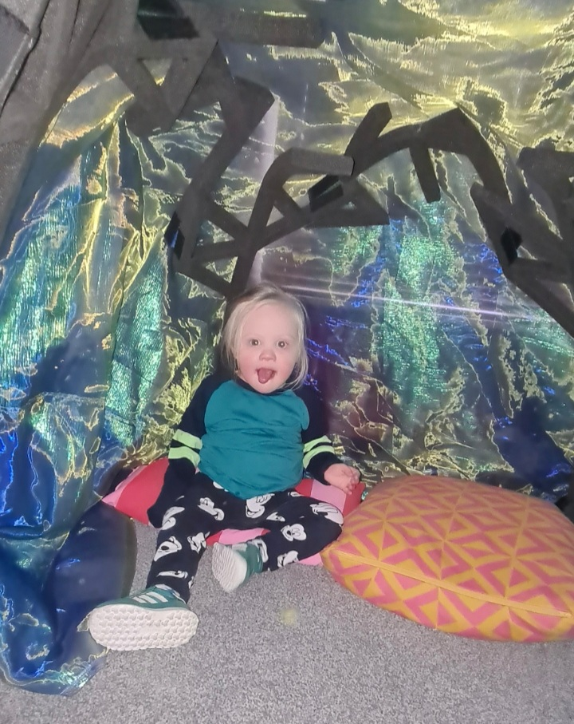

**Image 4.4: A little Hummm in the home planetarium. Credit: Photo supplied by family.**

*Thank you so much for the amazing effort, inspiration, thought and skill that went into this experience and thank you for letting us be part of it! :) (Audience Survey)*

*You have done much more than we expected so would feel cheeky asking for anything else, however if you to redo this idea again, we would love to do it again even if we paid a fee for the loan! (Audience Survey)*

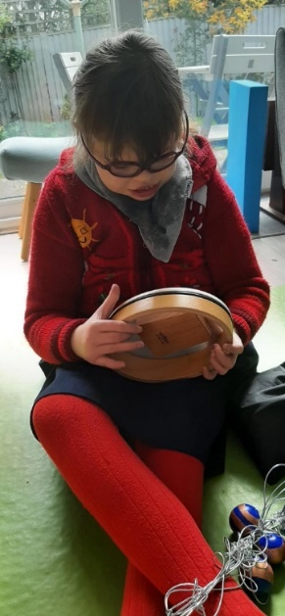

**Image 4.5: A young Humm explores the lyra next to the resonator of Box 4. Credit: Photo supplied by family.**

Summary

In summary, *Space to Be* was a sensory theatre production where the parent or carer facilitated a sequence of theatrical experiences, connected through the metaphor of constellations, with their disabled child and the other family members, guided by a series of audio pieces and using beautifully crafted sensory packages. The production spanned over 5 days with the aim to enable families who were shielding or who faced barriers to accessing sensory theatre experiences in arts and cultural venues to have this emotional, theatrical experience together, in the privacy of their home. Responses to online surveys and case studies highlighted the significant impact of *Space to Be* on promoting new ways of creating a sensory theatre production; on making rich sensory theatre experience accessible to many people due to it being remote; on opening up sensory theatre experiences for the whole family; and on including non-disabled family members as equally valued and appreciated participants of the production.

# Chapter 5: Something Love

|  |
| --- |
| **Summary**  This chapter is concerned with *Something Love,* an exploration into sensory film designed for and with Autistic young people. The creative team included Autistic and disabled artists, including those who have experienced social isolation due to barriers to access.  **Key points**   * *Something Love*, enabled disabled, non-disabled and Autistic artists to collaborate remotely to create two short films. * Scaffolding the creative process through offering support from a Creative Enabler, an Access Lead, and an Artistic Lead, recognised the extra layers of support that disabled and Autistic artists need in order to engage in creative and collaborative processes. * The different modes of communication that *Something Love* promoted beyond written emails gave voice to the diverse perspectives of the project participants enriching their communication. * Adopting ‘soft endings’ at the end of each session allowed for smooth transitions from group activities to time for individual refection and realisation, and offered opportunities to the participants to discuss accessibility issues with the Lead Artist and Access Lead. * The pacing of the creative process of *Something Love* took into consideration and responded to the various accessibility or communication needs of its participants, though the process could have been slowed down further. * Access audits, surveys, and check-ins collected feedback from the participants of *Something Love* about the challenges that they faced at different moments of the process. * *Something Love* made targeted efforts to cater for the changing needs of young, aspiring and professional artists across the spectrum of disability and neurodivergence in accessing high quality artistic experiences and in producing artistic work of high standards. |

## Introduction

*Something Love* was an exploration into sensory film designed for and with Autistic young people. The creative team included Autistic and disabled artists, including those who have experienced social isolation due to barriers to access. *Something Love* was the initial research and development phase of the creative process, aiming to experiment with how sensory theatre can translate into film work, and how to create in an accessible way, working remotely.

## Participants and Data analysis

Five conversations, here termed ‘Case Studies’, between a member of the Oily Cart team with the creative team of disabled, neurodivergent, Autistic and non-disabled artists; including the parents of the two young artists and one of the young artists themselves, were analysed.

The responses of three members of the creative team to a short survey at the end of the project were also included in the data analysis. Finally, the two short films – *Green Straw* and *Cubbious –* thatwere created as part of *Something Love*, informed the analysis of the data from the other two types of sources.

As it emerged from the analysis of the Case Studies, the creative process was facilitated in a layered way (see Figure 5.1). At the heart of the creative venture were the core team of five collaborating artists: two Autistic young people, two disabled artists, and a Creative Facilitator, who was also Autistic. One of the disabled artists was supported by a ‘Creative Enabler’. Oily Cart offered further scaffolding to the creative process by allocating creative and administrative support to two extra roles: a Lead Artist, who worked on developing an accessible creative process structure; and an Access Lead, who was working on the project with a focus on access (outer circle).

**Figure 5.1: Structuring the creative process – the layers of creative support**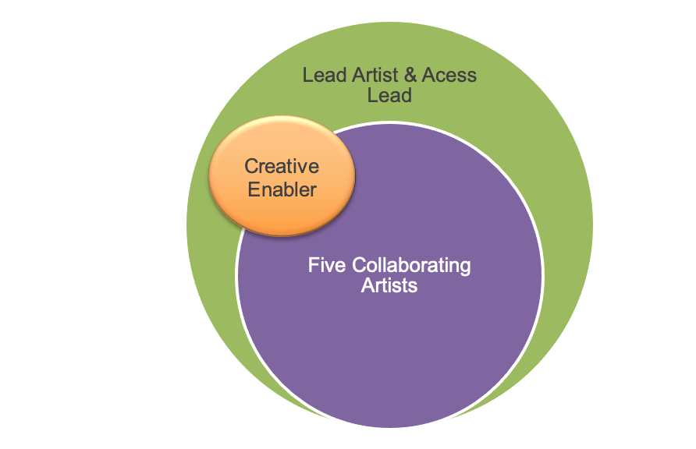

All Case Study participants were asked the same four questions during their conversations regarding (1) what worked well, including any positive strategies adopted that worked for them during the creative process; (2) the challenges that they faced and how these could be overcome; (3) top tips or things that other artists or organisations can do that can help make the creative process accessible; and (4) any other comment.

The survey sent to the creative team at the end of the project included three questions: (1) what worked well? (2) what could we do differently in the future? and (3) any other comment. The responses of the artists (including a parent on behalf of one young artist and a parent alongside the other young artist) to the Case Studies, and the creative team to the surveys are presented jointly under key themes.

## Key themes

The key themes that emerged from the analysis of the data were: Enhancing Accessibility, Fostering Communication, and Facilitating Artistic Expression: Process and Product.

### Enhancing Accessibility

Accessibility emerged as one of the salient features of this project. The Case Study participants spoke extensively about accessibility. On the one hand they reported that *Something Love* was *‘the most accessible experience from the very start of the project’ (Case Study A)*. Having an Access Lead, who they could go to for guidance or support; having mid-way conversations about their experiences of the project; and having these conversations orally as opposed to in a written form, featured as three key parameters to accessibility.

*One thing I have been reflecting on about working with Oily Cart, is that I really believe the organisation is serious about accessibility – these evaluation conversations, having an* ***access person*** *on hand whose role is reinforced at each meeting. I found the* ***mid-way chat*** *really useful, which is partly about knowing you as the access person were the person who was really thinking about it or the person to go to, but also for me because it was a conversation rather than having to answer questions in written form, especially when it's about this material which is really quite tough actually. Having* ***a friendly conversation*** *was important for me so that I could genuinely share any kind of problems or issues I was having, and it wasn’t going to result in defensiveness. (Case Study A)*

The collaborating artists underscored that the support that they received from the Creative Facilitator / Collaborating Artist, Max Alexander, as well as the Access Lead, helped them navigate a process that was remote and that they experienced for the first time.

*In terms of the process, it’s structural things that make it more accessible, so having Max on board as a facilitator was really important and essential. He wasn’t just a facilitator for [the young artists]– we were all being facilitated by Max in some ways and that was really important, probably even more important because we were doing everything on Zoom and it was remote and it was a film, all things we’ve never done before. (Case Study A)*

*For me, what worked well was having contacts, like being able to reach out and knowing that people were available. At the forefront of all of it really that that was helpful for me - I knew that I could* ***reach out*** *and that people were approachable, which is great. I think that's the main thing for me really, that's what makes it anything accessible is people being approachable…I found it was quite nice to be asked as a member of the team what* ***my access requirements*** *are, which is quite rare, as an access worker. (Case Study D)*

On the other hand, the sense of accessibility that was experienced overall, was challenged when decisions had to be made about the ways that the creative process could be organised, such as the timeline and work schedule. One survey participant acknowledged that changes are bound to occur, especially for ventures that take place for the first time, but they expressed the wish that these changes were communicated clearly and at earlier stages of the process. They concluded by highlighting that Oily Cart is receptive to offering accessible creative opportunities, nonetheless, by its nature, the process of achieving this is not straightforward and it requires people and organisations to be ready to listen and respond to the barriers that disabled people face.

*The answer of how to truly co-create or truly make an accessible process for people involved is really quite messy and maybe not conducive to organisational working – like, maybe it’s impossible for an organisation to do. Oily Cart’s strength is being able to adapt a process and make it better, but that process is still structurally not fit for the people working within it…*

*…You [organisations] have to really be looking to listen to how the ways you are working is inaccessible. No one gets it right all the time – the most important thing is to really genuinely be trying to listen to the stuff that’s difficult to hear. (Case Study A)*

Working remotely was not identified as a barrier to participation in creative projects. Engaging in creative collaborative activities remotely was effective and it indeed opened up access, as it allowed the pacing to be tailored to the needs of each individual.

*Elements or the whole process online can be done and really opens up access for some artists. It allows shorter bursts of activity where energy is focused purely on the project rather than travel etc (Case Study D).*

This view was echoed by the participants in Case Study C. However, they expressed the view that being in the same room with the young artist would help other people to understand them better.

*…In front of a screen in the living room with a jumble of toys around him, you're only gonna learn so much about him. (Case Study C).*

Nonetheless, continuing remoteness had reportedly been having an impact on artists’ self-motivation to start creative endeavours afresh. This was echoed by the parent of one of the young artists, who highlighted the negative impact that the lockdown has had on their child’s wellbeing.

*I’m trying to really get my head into and be fully into my next project, but I have found the* ***continuing remoteness*** *of everything quite challenging. I’m not in a rush to get back into a room with a million people, but it continues to be challenging – you have to* ***self-motivate****…if you don’t have much space, maybe it’s about prompts like, if you’ve only got one table and you’ve been facing one direction for one project, try moving and facing the unknown. (Case Study A)*

*That's another thing, lockdown for us has been crazy. Not good. You'll have heard that lots, I'm sure, for disabled children lockdown has been a* ***struggle*** *from how. But [the young artist] definitely enjoyed Something Love more than it not existing, which is my qualification for him to do it. (Case Study C)*

On the issue of accessibility, the participants of Case Study B expressed the view that the young artist not only found the whole project accessible but also that they were aware that through their involvement, they contributed to making theatre more accessible for other young people.

*I say all in all, he really enjoyed the whole thing. He just loves being part of it and he is very aware of the whole issue around access for people with additional needs, and he will tell people, I helped to make theatre more accessible, you know, he’s proud of that, so he does understand the need for that. (Case Study D)*

To conclude, *Something Love* was identified as a very accessible project due to Oily Cart offering different layers of support: 1) the Artistic Lead, Access Lead and Creative Enabler dealt with issues around accessibility; 2) access audits, surveys and check-ins monitored the challenges that the project participants faced; and 3) oral communication replaced written emails when participants felt that this was a more accessible approach for them.

**Image 5.1: Something Love – Still Image. Credit: Franki Ayres.**



**Image 5.2: Something Love – Still Image. Credit: Franki Ayres.**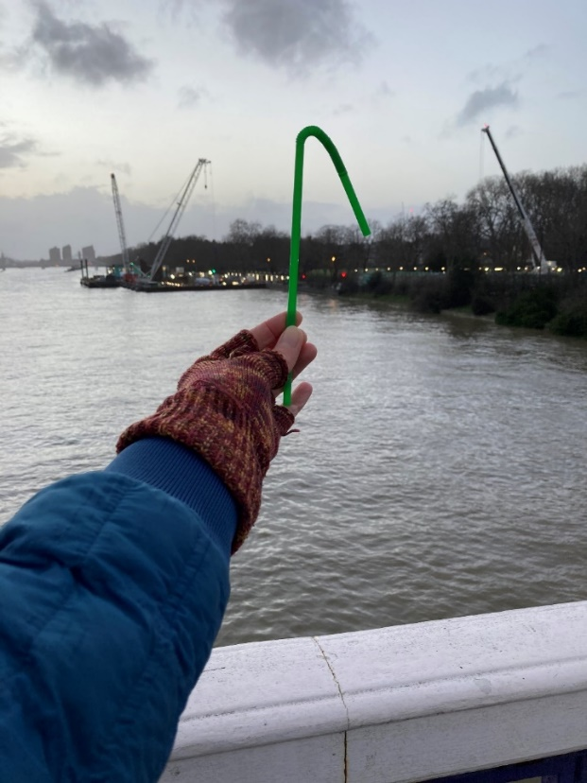

### Fostering Communication

The theme of Accessibility intertwined with the theme of Communication. When discussing accessibility, the artists recognised that, on the one hand, working remotely opened up access, but on the other hand it created communication barriers, for instance in relation to schedules for meetings, or personal responsibilities.

*Working remotely opened up access but also created some* ***communication barriers*** *and it was hard to judge how everyone was feeling or getting on with the creative process. (Case Study D)*

*[It would have been better to] Receiv[e] schedules for meetings etc. a bit earlier- a couple of days earlier ideally (Survey Anonymous)*

*I felt I had to infer expectations and my responsibilities, so I was quite often nervous that I wasn’t doing it right. (Case Study A)*

These three artists unanimously praised Oily Cart’s openness to promoting communication beyond written emails, such as through pre-recorded videos or Slack[8] messages. This variety of modes of communication allowed participants to express themselves beyond written language, which at times could be difficult to decipher. They stressed, however, that when communication came from different angles it often became overwhelming.

***Slack*** *worked well as people could dip in when they had energy and capacity, it took away the time pressure. It meant people could work independently and connect. Doing* ***pre-recorded videos*** *to communicate was helpful so artists could watch in their own time. (Case Study D)*

*There was a lot of* ***communication*** *coming from different angles, on different platforms, which for me personally was at times a bit overwhelming. Sometimes it was Slack, sometimes it was emails, sometimes there was a crossover of the two. But I think that also might have to do with the fact that I wasn't in the process from the very beginning, so I wasn't used to what was being used for what things, for instance I learnt that a lot of the videos and photos were being shared on Slack. I also think language, written language can be more difficult to decipher sometime - I can’t guess what people might be feeling about a situation, for instance, and I know for sure that it takes me twice as long to write a response to someone as it does to share it verbally or when in person. It’s part of the shift that’s had to happen as part of working remotely. (Case Study E)*

Oily Cart’s flexibility to facilitate communication in ways that suited each individual was equally praised by the young artists and their parents.

*And the creative facilitator and other artists would understand the fact that he didn't want to verbalize anything, and be very patient with him typing out all his answers in the* ***chatbox****, and whatever. And he found that really fun… And of course, I think Max [Autistic Creative Enabler who the young artist has met before] just gets it, as well. If there was any fidgeting or anything, he would pick up on things that maybe other people wouldn’t. He could, I think, kind of empathize with certain things with [the young artist], like certain stim movements, because Max also needs that kind of sensory feedback, so that there were maybe things that he could pinpoint that other people may have overlooked. (Case Study B)*

To sum up, the Case Study participants underlined that overall they were satisfied with the levels and quality of communications amongst the members of the *Something Love* team. Nevertheless, they stressed that it was important for them to be clear about project schedules, project roles and project outcomes from the beginning of the process. Additionally, they suggested that sustaining and promoting a variety of communication routes, such as through online applications, or video-recorded messages, could make project participants in collaborative teams who work remotely, be more mindful and aware of the use of language as a means for communication.

### Facilitating Artistic Experiences – process and product

The Case Study participants were encouraged to talk about their artistic experiences of creating *Something Love*. One participant identified the ‘soft ending’ of sessions as a very productive part of the creative and collaborative processes. These were moments where they had the opportunity to make a smooth transition to being on their own after a group session, and to comfortably express what they felt about the creative process or make a new contribution.

*I liked the* ***soft endings*** *at the end of sessions. What it offers me in particular is a way to transition from being with others to being on my own, which can be really abrupt, and so I appreciate it for that. It also gives an opportunity for you to say, if there wasn’t previously an accessible way for you to say whatever was on your mind, your contribution. You can make that contribution in the soft ending. It might be worth people in charge formalizing that, like a way of noting ‘Did something come up in the soft ending that actually we think is important’… I think Oily Cart’s adaptability to emerging realisations about the needs of the participants and collaborating artists is a real strength. (Case Study A)*

The participants of Case Study C offered their perspective on how they felt artistic experiences were **scaffolded** for the young artists. To begin with, they identified music as an important ingredient of the creative process and outcome that offered structure by linking the different components of the film together. They advocated for music to continue to play such a role in creative activities with Autistic children and young people.

*The* ***music*** *made a hell of a difference as well, I thought that was really interesting. I think that's something I kind of take note from because the music really helps adhere the films, make it into a coherent structure and I think [the young artist] enjoyed it and that's, you know, I imagine one of the things that you want to do. (Case Study C)*

They also noted that the young artist sought to create and follow a narrative during the artistic process. The parent was surprised noting the perception that Autistic children are less able to follow narratives.

*But I think both the young artists ended up* ***wanting narrative****, which is brilliant research on your part, because that's exactly what Autistic people are meant to have no knowledge of whatsoever. And I don’t know if that’s weird for you guys because a lot of the footage that went into the final films was touching on high art and the abstract, and in that way a narrative can be really kind of restrictive, but he did want a narrative and definitely connected with it. I just thought that was interesting, because I personally think that a lot of what we ascribe to autism, some of it's wrong and some of its human, you know, some of it we all have and some of it is kind of a little bit fictitious, particularly that* ***non-comprehension of narrative****. When you're dealing with people with that low level of communication, they are going to miss out on a lot of narrative, but it still seems to be a really important thing to them. Hence, you know, shows like Thomas the Tank Engine remain with them because Thomas the Tank Engine is pure narrative. (Case Study C)*

Following from this observation, they highlighted that focusing inwards on small abstract details, repetition and the recurrence of objects such as the straw in the *Green Straw* film enabled the young artists to create an internal narrative that could keep them interested and engaged.

*One of the things that I think is telling is that idea on focusing inwards on* ***small abstract details****…and also kind of* ***repetitive mechanisms****. Again, you know, we go to the narrative, but you've got the straw in the film that is recurrent and keeps on reappearing. They do that in video games, use* ***recurrent objects*** *to kind of continue a theme and help you join together the narrative, but also give people weird details to focus in on as an escape route for people if they’re not particularly enjoying the experience. With the Something Love film, it was almost like the other way round to a neurotypical narrative where character development is the plot and the spice is a little bit of detail in the background. For [the young artist], the background detail is the focus but you still need the spice of a narrative (Case Study C).*

Lastly, it was highlighted that the final product, the two films, met the artists’ expectations and they enjoyed the fact that they viewed the premier of these films together with the whole team.

*It was interesting to see the final films and how they turned out, he* ***liked*** *it with the straw on the train, he kept saying what people must have been thinking to see someone walking around with the straw (Case Study B).*

*I think the choice to gather everyone together for a premiere was really important too, for closure and a sense of* ***collective achievement****. (Case Study A).*

To conclude, including music to bring the different elements of the creative process together, adopting ‘soft endings’ at the end of each session, and supporting the artists in creating a narrative through repetition and reoccurrence of objects, were recognised as effective ways of facilitating the creative process.

## Developing the Something Love experience further

The artists in *Something Love* recognised that having access audits at the beginning of the process were elements to be sustained and built upon by Oily Cart. They also expressed the view that further attention needs to be given to communicating the timeline and work schedules, so that all participants involved are clear about the practicalities of the project from as soon as possible in the creative process. Working remotely was not recognised as a barrier to engaging in a creative collaborative process by the artists. However, one of them stressed that it created communication barriers, and one of the parents of the young artists expressed the view that working face-to-face with Autistic young people could help neurotypical young people and adults to better collaborate with young Autistic artists.

Asked what tips they would share with other companies looking to make their creative processes more accessible, the artists included making sure that there is always an Access worker and / or Creative Enabler from the beginning of the project to support disabled artists. In addition, access audits were identified as having significant importance, alongside the provision of emotional support to all involved in these creative endeavours.

*And finally, an* ***access worker or creative enabler*** *on projects from the start. When applying for funding around access, have a big contingency pot because the likelihood of always needing that additional time or more access is always quite high. (Case Study A)*

*Do* ***Access audits****, make sure you have* ***access riders****, budget for creative enablers, put as much in place to support barriers through mental health as you do any other disability. Emotional support is required for this, including for the core team. (Case Study D).*

Regarding the pacing of the creative process, an artist explained that following a slow process made them overwhelmed, because they felt unclear about the overall process and their responsibilities. Another artist, however, expressed the opposite view – that allowing more time for every step of the process would be necessary.

*Being flexible and responsive, and doing a* ***'slow process'*** *with less pressure than the standard made the process feel unclear and hard to navigate. This meant …I was feeling the same lack of clarity so it was very hard to lead. I felt quite overwhelmed and responsible most the way through. (Case Study D)*

*Time is another thing, just give people more time, factor in more time – it’s always better for everybody just to have a bit more time. (Case Study E)*

Recommendations on how to support more effective communication amongst team members who work remotely included being mindful of how one uses language and one’s attitudes within a space.

*So, I’d say that’s something to be really mindful of – my top tip would be to be mindful of language and attitudes within a space. (Case Study E)*

## Summary

In summary, this chapter explored the experiences of the artists that collaborated in *Something Love* through five Case Studies and the responses to the Access Survey returned by three members of the Oily Cart creative team who were involved in the process of creating *Something Love*. Overall, this project reportedly enhanced accessibility through regular monitoring of the artists’ accessibility experiences; and through offering a variety of platforms and ways that the artists could communicate with Oily Cart staff (See Figure 5.2). Furthermore, *Something Love* explored different ways of communicating, and of working together remotely honouring creative diversity. Finally, high-quality artistic experiences were facilitated through specific techniques such as ‘soft endings’, responsive pacing; creating a narrative through repetition and reoccurrence of objects; and through the use of music.

**Figure 5.2: The impact of *Something Love* on future Practice – guiding principles for creative collaborative work undertaken remotely**

# Chapter 6: Conclusions and Key messages

This evaluation report set out to explore the impact of the three projects of Oily Cart’s *Uncancellable Programme – Doorstep Jamboree, Space to Be*, and *Something Love –* on the people who collaborated on and experienced the productions physically or over online platforms; on Oily Cart, as an organisation with many years of expertise in devising sensory theatre productions; and on Sensory Theatre practice for the future.

## The impact of the Uncancellable Programme on the audience and creative collaborators

With regard to the audience in the projects, there was strong evidence through their responses to online surveys, Case Studies, and through photographs and videos of the productions that:

* all three projects were **captivating**; **enjoyable**; a **shared experience** amongst non-disabled, disabled and neurodivergent people;
* all three projects, but especially *Space to Be*, created opportunities for adults and siblings to **observe** the disabled child or young person and to **connect** with them in different ways during and after the shows;
* the theme of each production was based on an **interesting** idea;
* the audience felt **safe** in terms of COVID-19 precautions;
* the projects were **well thought-through**;
* all three projects were **relevant** to today’s world;
* it was important that they took place **during lockdown** and when families were shielding. This was a period that many UK families with disabled and / or neurodivergent children and young people experienced isolation and a decrease in their wellbeing;
* all three shows **challenged** the audience and the cast to equal measure: *Space to Be,* for instance, took place only remotely and this involved a lot of organisation and discipline on the part of the families who needed to carve time from their daily routines to devote to these sensory theatre experiences;
* the artists were not afraid to **try new things**; and
* that the shows were **ground-breaking** and the best examples of its type that they had seen.

The audience identified **elements of the shows** that were particularly liked:

* **Music** was time and again identified as the most liked sensory experience for all involved. In *Doorstep Jamboree*, the music took centre stage in the show, as the show itself was about an interactive gig performed by the Jamboree Band. In *Space to Be* the music from the soundtrack sent alongside the props; and the kalimba instrument were loved by the family members. Many families were reportedly planning to purchase a kalimba instrument for daily use at home. In *Something Love*, the music was identified as the glue that kept the different parts of the creative process together.
* The **costumes**, **dancing** and **movement**, other **props** and audience-performer interactions (either face to face or via Zoom) were also identified as liked in *Doorstep* *Jamboree*. The use of lights, the resonance box, mirrors, voices and other sounds, enhanced the sensory theatre experiences of *Space to Be*.
* In *Something Love* ‘soft endings’ at the end of each session, tailoring the pacing of the creative process to the needs of the individual artists, and supporting the artists in creating a narrative through repetition and reoccurrence of objects, were identified as effective ways of facilitating the creative process and their overall sensory theatre experiences.

**Differences in participation, communication and focus during and after the show**:

* In *Doorstep Jamboree* the adult audience members highlighted that regardless of the type of performance, the child or young person was focused, engaged, captivated, calm, happy, and vocally or physically active during the show. After the show, the children and young people were reportedly communicative, stimulated, and some were humming or singing. Only a couple of adult audience members observed no difference in the responses of their children during and after *Doorstep Jamboree*.
* In *Space to Be*, the disabled children and young people were more focused, engaged, calm, and relaxed after the family sensory theatre experiences.
* In *Something Love*, the parent of one of the young artists was surprised to find out that their Autistic child looked for a narrative in the stories they created, which would help them stay engaged in the project.

All three projects were identified by the audience themselves as having a significant **social impact** in terms of widening access, ways of communication and a sense of inclusion.

**Access**

* *Doorstep Jamboree’s* public performances on one’s doorstep or in a school playground raised the general public’s awareness on issues around arts and cultural participation for disabled children and young people, as well as the visibility of disabled artists and of disabled children and young people as artists.
* *Space to Be* was accessible to all members of the family – non-disabled, disabled and / or neurodivergent – to enjoy together in their own time and at their own space, supporting family coexistence during the difficult COVID-19 lockdown periods.
* The parents of one of the young artists in *Something Love* reported that their child was proud that through participating in the project they had contributed to raising awareness around access for disabled people.

**Communication**

* *Something Love* fostered communication by promoting a variety of communication routes, such as through online platforms, or video-recorded messages.
* Through *Doorstep Jamboree,* Oily Cart also tested ways to communicate over Zoom with young people who communicate differently and do not rely on verbal language.

**Inclusion and Diversity**

* Performances on Zoom for *Doorstep Jamboree* were identified as the most effective in reaching families who were shielding.
* Zoom performances for *Doorstep Jamboree* and supporting video resources available as part of the *Space to Be* performances reportedly made sensory theatre experiences more inclusive for the whole family and for families with disabled children who would not have otherwise visited arts and cultural venues.
* *Space to Be* included a special sensory theatre experience for the parent or carer to enjoy alone.
* All three projects included diverse casts and creative teams, such as disabled lead artists / decision-makers; neurodivergent artists, non-disabled artists, and cast and creative team members from different cultural backgrounds.

## The impact of the Uncancellable Programme on Oily Cart

Oily Cart met their intended aims for each project. Overall the *Uncancellable Programme*:

1. Enabled families who have at least one disabled child to enjoy a safe, high-quality piece of theatre during the COVID-19 pandemic.
2. Offered the parents and carers creative ideas and tools (props such as the kalimba instrument or the shiny mirrors sheets and torch light) to use to connect with their disabled child.
3. Had a positive impact on the wellbeing of the audience, with *Space to Be* being reported as having the strongest impact on both the disabled child and the family as a whole.
4. Managed to involve families who have fewer opportunities to experience Oily Cart’s work as well as face barriers to accessing arts and cultural venues.
5. Explored ways of remotely reaching young people who face barriers to engagement with in-person performances. *Something Love*, in particular, worked with disabled and Autistic artists to identify barriers created by standard Oily Cart creative processes. The barriers identified were connected to accessibility and ways of communication.

Direct links could be drawn between the findings from the evaluation of the *Uncancellable Programme* and Oily Cart’s Theory of Change Key Objectives (See Table 6.1).

**Table 6.1: Oily Cart’s Theory of Change Key Objectives**

|  |  |  |  |  |
| --- | --- | --- | --- | --- |
| Oily Cart’s Theory of Change Key Objectives | | | | |
| 1 | **2** | **3** | **4** | **5** |
| Shows and creative projects | **Exploration** | **Creative Diversity** | **Driving Change** | **Resilience** |
| High-quality theatrical experiences created for and with disabled babies, children and young people who experience multiple barriers to access, across the UK and internationally. | Pushing the boundaries of sensory performance practice through research, collaboration and artistic development. | Inviting diverse perspectives to enrich all of our working practices. | Advocating for the rights of disabled individuals to lead active cultural lives. | Making sustainable choices that nurture our resources (creative, financial, organisational and the planet). These resources will allow us to be responsive to our audiences’ changing needs. |

* **Key Objective 1**: The music in *Doorstep Jamboree* had been **co-created** with disabled people and the audience had agency over the set list and improvisation. *Space to Be* was the first Oily Cart production to offer high-quality sensory theatre experiences **remotely**. This was really powerful because it allowed families with disabled and / or neurodivergent children who may not typically access arts and cultural venues to engage with high-quality sensory theatre experiences. *Something Love*, also enabled disabled, non-disabled and Autistic artists to **collaborate remotely** to create two high quality artistic films.
* **Key Objective 2**: *Doorstep Jamboree* was performed in three different formats: on people’s doorstep, in school playgrounds and through the online app Zoom. Experimentation with these three types of performance, and the very positive feedback that Oily Cart received about the Zoom performances, helped the organisation realise that productions that were 100% online and remote could have an equally significant impact on the sensory theatre experiences of the audience as face-to-face productions. The parents and carers of the *Doorstep Jamboree* audience agreed that Zoom Performances were actually better at achieving a more direct dialogue between the performers and the participating audience. *Space to Be* explored new ways of both working remotely to devise a new production and of delivering a production that participant families could experience at home, with no performer present either physically or virtually. This remote collaborative and creative process meant that sensory theatre experiences embraced the diverse needs of neurodivergent and disabled children and their families. Similarly, *Something Love*, explored ways that disabled artists, non-disabled artists and Autistic artists could collaborate remotely to create short films.
* **Key Objective 3**: The format and content of *Doorstep Jamboree* were developed through collaborative conversation amongst the disabled and non-disabled artists, the creative team, and the audience. Similarly, in *Space to Be,* the creative team in collaboration with consultant families, and disabled artists worked remotely to devise the new production. The different modes of communication that *Something Love* promoted beyond written emails gave voice to the diverse perspectives that disabled, non-disabled and Autistic artists had on enhancing accessibility, fostering communication and facilitating artistic experiences that could enrich their collaborative practices.
* **Key Objective 4**: The *Uncancellable Programme* has taken several steps to *Drive Change* by advocating for the rights of disabled individuals to lead active cultural lives.
  + *Doorstep Jamboree* included a diverse cast, such as disabled and non-disabled artists and performers and creative team members from different cultural backgrounds, through all the stages of developing the production.
  + By delivering *Doorstep Jamboree* in open spaces such as people’s doorsteps or school playgrounds, Oily Cart managed to bring the community together raising the visibility of disabled children and young people as well as the profile of disabled audience as artists.
  + In *Space to Be* the only performer was someone with lived experience of being a wheelchair user; the voices of disabled young people were integrated into the recorded soundtrack; and the story was all about reflecting the families’ experiences and stories back to them.
  + In *Space to Be* the parent or carer felt appreciated and special by engaging in a sensory theatre experience entirely designed for them.
  + *Something Love* adopted devising approaches, such as ‘soft endings’, that allowed for smooth transitions from group activities to time for individual refection and realisation. It also created structures that offered opportunities to the artists to discuss accessibility issues through the Access Lead; and to get support with creative processes such as through the Lead Artist and the Creative Enabler.
  + The pacing of the creative process of *Something Love* took into consideration and responded to the various accessibility or communication needs of its participants.
  + Access audits, surveys, and check-ins collected feedback from the artists of *Something Love* about the challenges that they faced at different moments of the process.
* **Key Objective 5:** In terms of promoting *Resilience*, the three different types of performance of *Doorstep Jamboree* offered variety of access and catered for the changing needs of the audience. Likewise, *Space to Be* recognised and catered for the need for shared sensory theatre experience amongst family members, where the disabled child or young person could take a leadership role permitting the other members of the family to ‘enter their world’ (Grace, 2018). The shared experience of *Space to Be* re-enforced special bonds between family members and siblings, and enabled the parents/ carers to dedicate time to sharing these experiences with their children. The need for inclusion and collaboration amongst people across the spectrum of neurodivergence and disability was also promoted in *Something Love*, acknowledging the changing needs of young, aspiring and professional artists in accessing high quality artistic experiences and in being offered support to produce artistic work of high standards.

## The impact of the Uncancellable Programme on practice for the future

There are many implications for future sensory theatre practice that have emerged from the *Uncancellable Programme*.

* **Giving the audience options to engage in the way that suits them best**: Online and remote sensory theatre experiences were equally valued to face-to-face experiences, and in the case of *Doorstep Jamboree* and *Space to Be* they were rated higher than face-to-face experiences in managing to achieve a more direct dialogue between the performers and the participating audience, and in being more accessible.
* Offering a **blended approach** to sensory theatre experiences: Oily Cart will continue to offer a blended approach to sensory theatre experiences beyond the pandemic so that it can reach families still shielding or experiencing barriers to accessing venues.
* **Taking accessible practices forward**:
  + Collaborative processes of devising a sensory theatre production should involve from the very first stages of the process the voices, experiences and perspectives of the target audience and the creative team, including, importantly, disabled artists themselves.
  + Offering disabled and neurodivergent artists different layers of support on artistic and operational issues could facilitate their creative and collaborative engagement throughout all the stages of creating sensory theatre experiences for others.

To conclude, designing productions whilst being guided by recommendations and the practice of experts in the field of disability, could create greater potential for future projects to be more accessible and inclusive. For instance, one could identify strong links between the content and elements of *Space to Be* and suggestions on ways to facilitate ‘sensory being’ (p. 144) found in Joanna Grace’s book *Sensory Being for Sensory Beings* (2018). In particular, ‘A space to be’ was proposed by Grace (2018, p. 144) as the starting point of planning the facilitation process of sensory activities for sensory being. This suggestion could have inspired the Oily Cart creative team to start *Space to Be* on Day 1 with a sensory theatre activity just for the adult. What is more, the resonator, an artefact that allows disabled young people to feel and hear sounds, became one of the tools included in Box 4 of the *Space to Be* production. Moreover, the ritual of carefully packing away items used for the different sensory activities of *Space to Be* chimes with a recommendation by Grace (2018, p. 147) to create rituals that demonstrate respect and appreciation for others’ experience of moving on from sensory being. Influences and recommendations that come directly from research (also see Goodwin’s doctoral thesis, 2019) and the guidance of disability experts signify how salient it is for practice and research on sensory theatre to go hand in hand.

Last but not least, it is important to acknowledge the challenge of collecting data from disabled young people on their experiences of sensory theatre. This is definitely an area that merits further attention from sensory theatre researchers and artists. Nonetheless, as it emerged from the feedback received through online surveys and Case Study conversations with the parents / carers in *Space to Be* and *Something Love*, it is salient that future productions and projects allow the audience and artists to offer their feedback regularly and through a variety of modes of communication: from written evaluation forms to video and audio messages, to oral conversations and written emails, as well as through Zoom calls when young audience and / or artists communicate differently and do not rely on verbal language.

## Summary

Taking everything into account, the *Uncancellable Programme* explored alternative routes to experiencing sensory theatre after the pandemic which revolved around digital engagement via Zoom or remotely, even with no live performer involved. These routes emerged as equally powerful and viable for experiencing high-quality artistic sensory theatre activities. In particular, remote productions were identified as more accessible and inclusive, especially to families who would not feel comfortable undertaking onsite visits to venues, either due to COVID-19 precautions; to their children’s complex health needs; to lack of appropriate / accessible facilities at venues, to their children’s processing time, or due to considering theatre an art form that does not appeal to them. Additionally, this report made recommendations on how Oily Cart and other organisations could respond to the pressing need to incorporate disabled and neurodivergent artists into the development and performance of sensory theatre productions so that they create authentic experiences for this target audience.

# Bibliography

Autismtoolbox, (2019) ‘What does neurodiversity mean’, Retrieved on 20th January 2021 from <http://www.autismtoolbox.co.uk/what-does-neurodiversity-mean>

Caldwell, P. and Horwood, J. (2008) *Using Intensive Interaction and Sensory Integration.* London: Jessica Kingsley Publishers.

Disabled Children’s Partnership (2021) #LeftInLockDown – Parent carers’ experiences of lockdown. London. Retrieved on 25th March 2021 from <https://disabledchildrenspartnership.org.uk/wp-content/uploads/2020/06/LeftInLockdown-Parent-carers%E2%80%99-experiences-of-lockdown-June-2020.pdf>

Doukas, T., Fergusson, A., Fullerton, M. and Grace, J. (2017) *Supporting people with Profound and Multiple learning disabilities – Core and essential service standards.* Retrieved on 20th January 2021 from <http://www.pmldlink.org.uk/wp-content/uploads/2017/11/Standards-PMLD-h-web.pdf>

Fergusson, A. (2019) Raising the Bar Through Inclusive Theatre. Evaluation by the *Isle of Brimsker* by Frozen Light, Norwich: Frozen Light. Retrieved on 10th December 2020 from <http://frozenlighttheatre.com/evaluation-report/>

Goodwin, J. (2019) *Sharing an aesthetic space of refuge with a school for pupils with profound and multiple learning disabilities: Golden Tent.* Unpublished Doctoral thesis. Winchester*:* University of Winchester.

Grace, J. (2018) *Sensory-Being for sensory-beings: Creating entrancing sensory experiences.* Oxon: Routledge.

Griffiths, E. (2016) ‘Looking to the Future: Sensory Performance Work for Neurodivergent Audiences.’ [*Winston Churchill Memorial Trust*](https://www.wcmt.org.uk/fellows/reports/looking-future-sensory-performance-work-neurodiverse-audiences)*,* Accessed on 23rd June 2021.

Mattaini, M. (2020) ‘Creating autistic space in ability-inclusive sensory theatre’, *Youth Theatre Journal,* 34:1, 42-54.

Morgül, E., Kallitsoglou, A. and Essau, C. (2020) ‘Psychological effects of the COVID-19 lockdown on children and families in the UK’, *Revista de Psicologia Clinica con Niños y Adolescentes,* 7(3), 42-48.

Oily Cart, (2021) ‘About [Oily Cart]’, Retrieved on 20th January 2021 from <https://oilycart.org.uk/about/>

Shoenenberger, H. (2019) ‘Slow Theatre: Creating Multi-Sensory Experiences.’ [*ASSITEJ Magazine*](https://www.assitej-international.org/en/assitej-in-the-world/the-magazine/)*,* 58-59.

Terribile, B. (2020) *Interactive Theatre for Children: A Multi-sensory and enabling practice.* BA dissertation, Malta: Department of Theatre Studies, School of Performing arts, University of Malta.

# Performance Dimensions Glossary

**Captivation:** It held their interest and attention.

**Challenge:** It challenged us to think in a different way.

**Concept:** It was an interesting idea.

**Distinctiveness:** It was different from things I've experienced before.

**Excellence:** It is one of the best examples of its type that I have seen.

**Innovation:** I expect that it will be introduced to the audience in a new way.

**Local Impact**: It was important that the event is happening here.

**Originality:** It was ground-breaking.

**Relevance:** It had something to say about today's world.

**Rigour:** It was well thought through and put together.

**Risk:** The artists were not afraid to try new things.

# Appendices

## Appendix 1 – An overview of Oily Cart evaluation findings (2016 – 19) from the shows

The evaluations of the shows LIGHT SHOW (2016), MIRROR MIRROR (2017), KUBLA KHAN (2018) and SPLISH SPLASH (2019) aimed to explore the audience perception of 1) how the specific ways in which the material resources and strategies used created an experience that was relevant to the children and young people attending the show; 2) The specific ways in which each different show had engaged the children and young people attending; and 3) recommendations on the ways that Oily Cart could improve the quality of the experience offered in each of the four shows. On the evaluation of the 2019 show, I also focused on identifying techniques that observers (carers, teachers, and/or family members) would take from the show and use in the future with their children or students. The evaluation of SPLISH SPLASH (2019) also investigated the casts’ experiences from facilitating the show.

It should be noted that these shows came in different versions, tailored to specific audience groups. These were identified with language Oily Cart is no longer comfortable using. LIGHT SHOW and MIRROR MIRROR had versions for Autistic audiences and audiences labelled as having Profound and Multiple Learning Disabilities (PMLD). In addition to these, KUBLA KHAN and SPLISH SPLASH also had a version adapted for Deafblind/ Multi-sensory Impaired audiences.

Overall, Oily Cart productions have been identified as age-appropriate and relevant to the abilities, needs and interests of the disabled children and young people participating and as having a significant impact on carers’ and observers’ appreciation for live theatre for disabled children. An overwhelming majority of the participants across all shows, which often reached a 100% response rate, underscored that they would take their child or children to live theatre again. The following section summarises some of the key findings from feedback responses from the audience and observers (student participants, carers and teachers), as well as the cast of these four shows, on:

### Aspect 1: Material resources and Strategies / techniques used.

* The live music, including singing and sounds, was the element that across all shows had been reported as having the greatest relevance to the participants as it facilitated the audience’s engagement in the performance and interactions with the cast. Also, music reportedly had made the experience of the shows more enjoyable.
* A wide variety of multi-sensory experiences have been included in the Oily Cart shows. For example, tactile stimuli such as mud, water, bubbles, sand, warm sand, mirrors, brushes, glitter and sponges calmed the participants and reportedly encouraged some children who were tactile-sensitive to become more tolerant of touching material and of being touched by material. Visual stimuli such as LED lights; and olfactory stimulation through various smells has been reported as relevant features of the shows. The audience emphasised that there was great flexibility in adjusting each stimulus to individual needs.

### Aspect 2: The specific ways in which each different show had engaged the children and young people attending.

* The children and young people participating in Oily Cart shows have engaged in different ways, primarily by responding to the numerous stimuli through looking and watching, smiling and laughing and by showing that they had activated all their senses. The children have often been described by the carers and observers as ‘attentive’ and ‘engaged’ reaching out for the materials used, listening to what was going on around them, and responding physically to the sounds and music through dancing or tapping along.
* The cast has played a prominent role in enhancing the experience of the young audience. The way the cast interacted with the children reportedly generated a sense of calmness and security that facilitated the development of rapport and trust. As a consequence, the majority of the children participated actively throughout the show, they ‘came live’, became more involved and ‘were able to express themselves just as they wanted’.
* The children have interacted with the cast by vocalizing, singing along, and by clapping along to the sound and music.
* Many participants expressed their great satisfaction with the structure, pacing and timing of the show, which they found inclusive and entertaining.

### Aspect 3: Recommendations on the ways that Oily Cart could improve the quality of the experience offered in each of the four shows.

Recommendations for changes in future shows included seating arrangements – such as adding a tray for those children on beds; adding more smell-related stimuli; lighting arrangements – such as the use of spotlights during the shows and the addition of more coloured lights; and reducing the waiting time prior to the show.

Other recommendations included facilitatinggreater familiarity with the show components beforehand through awareness of the existence of online resources, when possible ‘leav[ing] the children with the props a bit longer’, use of large symbols, more sign language, and mats for the children to lie on.

What is more, the audience made recommendations not directly related to the Oily Cart shows but to the space, chairs and changing facilities of the venues that hosted Oily Cart shows.

Lastly, some audience members would have liked to also see more shows for disabled and neurodivergent adults. The latter two recommendations have been proposed by audience members of similar shows for adults labelled as having profound and multiple learning disabilities (PMLD) underscoring the significance of considering the impact that venues and facilities have on how sensory theatre is experienced by people with PMLD and their carers (also in Fergusson, 2019).

### Aspect 4: Techniques for use in the future outside the shows, and casts’ experiences (SPLISH SPLASH, 2019).

* The techniques identified as inspiring for future use with the children and students in the pool or the bathtub at home were a water colander, bubbles, music and musical instruments, more singing and songs; and offering more opportunities for play that are child-directed and interactive.
* The cast identified several impactful moments from the SPLISH SPLASH show. The most impactful were moments of mutual trust between cast and audience, and moments where the freedom experienced through being immersed in the water allowed the participants to communicate their feelings in a more direct way. Impactful elements of SPLISH SPLASH included the use of certain props such as the colander, water instruments, boxes and bubbles; certain activities such as the name song and the simple choreography; and interpersonal elements such as collaboration amongst cast and organisers as well as receiving guidance from experts.
* According to the cast, SPLISH SPLASH was particularly suitable for participants labelled as having PMLD because of the freedom of movement and communication that the water afforded, the minimal language used and the inclusion of many pauses that gave space to the participants to react to the stimuli.
* According to the cast, elements of SPLISH SPLASH that were particularly suitable for Autistic students included The Oasis as a meeting space and the use of a Social Story; careful use of language; and opportunities for exploration. A limitation was the limited time available, especially during the 2019 tour.
* According to the cast, in order for SPLISH SPLASH to be suitable for Deafblind / Multisensory Impaired students they needed to make certain adjustments to the props used and to the volume of the music.
* Participating in SPLISH SPLASH was a unique experience for the cast as it helped them to develop greater trust in the process of preparing a show for disabled children and young people, to realise that ‘less is more’ in terms of their facilitation of the activities, and to enhance their professional skills.

## Appendix 2 – Doorstep Jamboree Audience Feedback Survey

|  |
| --- |
| Survey Questions  Doorstep Jamboree 2020 - Oily Cart Values Your Opinion Evaluation: Doorstep Jamboree 2020   1. Please select the type of performance you saw    * Zoom Performance    * Performance Outside Your Home    * Performance Outside Your School / Organisation   *Custom – Dropdown*   1. Captivation: It held their interest and attention   *Dimension – Slider*   1. Rigour: It was well thought through and put together   *Dimension – Slider*   1. Distinctiveness: It was different from things we've experienced before   *Dimension – Slider*   1. Relevance: It had something to say about today's world   *Dimension – Slider*   1. Challenge: It challenged us to think in a different way   *Dimension – Slider*   1. Local Impact: It's important that it's happening here   *Dimension – Slider*   1. Concept: It was an interesting idea   *Dimension – Slider*   1. Innovation: It was introduced to the audience in a new way   *Dimension – Slider*   1. What did the young person / people you were with particularly like about the experience? What elements (music, costumes etc) particularly drew their attention?   *Custom – Free text*   1. Did you notice a difference in their participation, communication and / or focus during or after the experience?   *Custom – Free text*   1. Please tell us anything we could change to better meet the needs of the audience.   *Custom – Free text*   1. Please write three words to describe your experience   *Custom – Short text*   1. The young person / people responded well to the live music   *Custom – Slider*   1. The experience was fun for the young person / people attending   *Custom – Slider*   1. It was an enjoyable shared experience for us   *Custom – Slider*   1. It felt safe and well thought-through in terms of Covid-19 precautions   *Custom – Slider*   1. I would recommend this experience to others   *Custom – Slider*   1. What is the age of the young person/s you were with?   *Custom – Short text*   1. Would you describe the young person you were with as D/deaf, disabled, or living with a long-term health condition?    * Yes    * No    * Prefer Not To Say   *Custom – Multiple choice*   1. Ethnicity: How would you describe the ethnicity of the young person/people you were with?    * White British    * White Irish    * White Gypsy Or Irish Traveller    * Other White Background    * Asian / Asian British - Indian    * Asian / Asian British - Pakistani    * Asian / Asian British - Bangladeshi    * Asian / Asian British - Chinese    * Other Asian Background    * Mixed - White & Black Caribbean    * Mixed - White & Black African    * Mixed - White & Asian    * Other Mixed Background    * Black / Black British - African    * Black / Black British - Caribbean    * Other Black Background    * Arab    * Latin American    * Other Ethnic Group    * Prefer Not To Say   *Custom – Dropdown*   1. Any other comments?   *Custom – Free text* |

## Appendix 3 – Doorstep Jamboree Creative Team Pre-Survey

|  |
| --- |
| Survey Questions  Pre-Event Survey For Self-Respondents  Evaluation: Doorstep Jamboree 2020   1. Attendance-Date: What date do you plan to attend this event?   *Logic – Date*   1. Attendance-Date: What date do you plan to attend this event?   *Logic – Date*   1. If you are a peer reviewer, please complete this survey based on your experience of the work. If you are a self-assessor, please complete this survey based on the extent to which you think the work met your original objectives.   *Custom – Message*   1. Captivation: I expect it will hold their interest and attention   *Dimension – Slider*   1. Rigour: I expect that it will be well thought through and put together   *Dimension – Slider*   1. Distinctiveness: I expect that it will be different from things I've experienced before   *Dimension – Slider*   1. Relevance: I expect it will have something to say about today's world   *Dimension – Slider*   1. Challenge: I expect it will challenge us to think in a different way   *Dimension – Slider*   1. Concept: I expect that it will be an interesting idea   *Dimension – Slider*   1. Excellence: I expect that it will be one of the best examples of its type that I have seen   *Dimension – Slider*   1. Risk: I expect that the artists will not be afraid to try new things   *Dimension – Slider*   1. Originality: I expect that it will be ground-breaking   *Dimension – Slider*   1. Local Impact: It is important that it will be happening here   *Dimension – Slider*   1. Innovation: I expect that it will be introduced to the audience in a new way   *Dimension – Slider*   1. If you have any further comments, please write them here   *Custom – Free text*   1. What do you want to achieve artistically in this project?   *Custom – Free text*   1. From your perspective, how well do you think this project was able to engage the target audience (young people with complex needs and their families who have been shielding)? Please share any observations about the actual audience (if not the target audience)   *Custom – Free text*   1. How do you plan to represent the audience in this project?   *Custom – Free text*   1. Which elements of the project do you think will be most effective?   *Custom – Free text*   1. Do you plan to try anything new in this project?   *Custom – Free text*   1. Are there any aspects of the project which you think should be further developed?   *Custom – Free text* |

## Appendix 4 – Doorstep Jamboree Online Feedback Form to External Evaluator

1. Do you feel that Doorstep Jamboree in its three versions (Zoom performance, performance outside the home, and performance outside the school) **allowed the voices** of disabled young people **being heard** during the pandemic?
   1. If so, **how** was this achieved?
   2. **Which performance** **version** do you feel that it achieved this more widely/ fully?
2. What is the best way for Doorstep Jamboree to **reach families who are shielding**?
3. How could Oily Cart **advocate** beyond the pandemic **for the rights** of individuals labelled as having complex needs?
4. How could Oily Cart **push the boundaries of sensory theatre practice** beyond the pandemic?
5. How could Oily Cart **promote creative diversity** beyond the pandemic?
6. How could the experience of creating a show for one family at a time inform and/or enrich new models of sensory theatre practice for the future?

## Appendix 5 – Space to Be Audience Feedback Survey

|  |
| --- |
| Survey Questions  Space to Be 2021 - Oily Cart Values Your Opinion  Dimensions   1. Concept: It was an interesting idea   *Dimension – Slider*   1. Distinctiveness: It was different from things we've experienced before   *Dimension – Slider*   1. Challenge: It challenged us to think in a different way   *Dimension – Slider*   1. Captivation: It held their interest and attention   *Dimension – Slider*   1. Relevance: It had something to say about today's world   *Dimension – Slider*   1. Rigour: It was well thought through and put together   *Dimension – Slider*   1. Local Impact: It's important that it's happening here   *Dimension – Slider*   1. Can you give us some more information about that?   *Custom - Free text*   1. It was an enjoyable shared experience for us   *Custom – Slider*   1. We enjoyed the change to our daily routine   *Custom – Slider*   1. It created opportunities to connect with my child in a different way   *Custom – Slider*   1. It made my child and my family feel good   *Custom – Slider*   1. It felt safe and well thought-through in terms of COVID-19 precautions   *Custom – Slider*   1. It felt accessible for my child and my family   *Custom – Slider*   1. I would recommend this experience to others   *Custom – Slider*   1. How did you find the duration of Space to Be?   *Custom - Multiple Choice*   1. What did your child particularly like about the experience? What elements particularly drew their attention?   *Free text*   1. Did you notice a difference in your child's participation, communication and / or focus during or after the experience?   *Free text*   1. Has Space to Be given you any ideas you will use with your child in the future?   Yes  No   1. If you answered yes to the previous question, please provide further information:   *Free text*   1. Please tell us anything we could change to better meet the needs of the audience.   *Free text*   1. Who in the family engaged with Space To Be? What was their age range?   *Short text*   1. Would you describe your child as Deaf, disabled, or living with a long-term health condition?   Yes  No  Prefer Not To Say  *Custom – Multiple choice*   1. Would you describe yourself as Deaf, disabled, or living with a long-term health condition?   Yes  No  Prefer Not To Say  *Custom – Multiple choice*   1. Ethnicity: How would you describe the ethnicity of your child?   White British  White Irish  White Gypsy Or Irish Traveller  Other White Background  Asian / Asian British - Indian  Asian / Asian British - Pakistani  Asian / Asian British - Bangladeshi  Asian / Asian British - Chinese  Other Asian Background  Mixed - White & Black Caribbean  Mixed - White & Black African  Mixed - White & Asian  Other Mixed Background  Black / Black British - African  Black / Black British - Caribbean  Other Black Background  Arab  Latin American  Other Ethnic Group  Prefer Not To Say  *Custom – Dropdown*   1. What socio-economic class do you identify with?   Working class  Lower middle class  Middle class  Upper middle class  Prefer Not To Say  *Custom – Dropdown*   1. Is there anything Oily Cart could offer that would benefit you as a parent/guardian or your family at this time?   *Custom – Free text*   1. Would you be interested in a parent's workshop on sensory techniques?   Yes  No   1. Are you happy to be contacted for a follow up chat about Space To Be?   Yes  No   1. If you answered yes to either of the previous questions, please write your name and contact details.   Free text   1. Any other comments?   *Custom – Free text* |

## Appendix 6 – Space to Be Creative Team Pre-Survey

|  |
| --- |
| Survey Questions  Space to Be 2021 - Oily Cart Values Your Opinion  Dimensions   1. Concept: It was an interesting idea   *Dimension – Slider*   1. Distinctiveness: It was different from things we've experienced before   *Dimension – Slider*   1. Challenge: It challenged us to think in a different way   *Dimension – Slider*   1. Captivation: It held their interest and attention   *Dimension – Slider*   1. Relevance: It had something to say about today's world   *Dimension – Slider*   1. Rigour: It was well thought through and put together   *Dimension – Slider*   1. Local Impact: It's important that it's happening here   *Dimension – Slider*   1. Innovation – I expect that it will be introduced to the audience in a new way   *Dimension – Slider*   1. Risk – I expect that the artists will not be afraid to try new things   *Dimension – Slider*   1. Originality – I expect that it will be ground breaking   *Dimension – Slider*   1. Excellence - I expect that it will be one of the best examples of its type that I have seen   *Dimension – Slider*   1. It will be an enjoyable shared experience   *Custom – Slider*   1. Parents / families will enjoy the change to their daily routine   *Custom – Slider*   1. It will create opportunities for parents / guardians to connect with their child in a different way   *Custom – Slider*   1. It will make the child and their family feel good   *Custom – Slider*   1. It will feel safe and well thought-through in terms of Covid-19 precautions   *Custom – Slider*   1. It will feel accessible for the child and their family   *Custom – Slider*   1. What do you want to achieve artistically in this project?   *Custom – Free text*   1. Do you plan to try anything new in this project?   *Custom – Free text*   1. How do you plan to represent the audience in this project?   *Custom – Free text*   1. From your perspective, how well do you think the show will be able to engage the target audience (young people with PMLD and their families)?   *Custom – Free text*   1. Which elements of the project do you think will be most effective?   *Custom – Free text* |

1. For more information, please access <https://www.weshallnotberemoved.com/>
2. *Neurodiversity* is ‘the notion’ that certain conditions such as Attention Deficit Hyperactivity Disorder (ADHD); Developmental Co-ordination Disorder (DCD) or Dyspraxia; Developmental Language Disorder (DLD); Epilepsy; Foetal Alcohol Spectrum Disorder; Intellectual Disability; Tourettes and Tic disorders; and Specific Learning Disorder/ Differences such as Dyslexia, and Dyscalculia, should be regarded as naturally occurring cognitive variations rather than checklists of deficits and dysfunctions’ (Silberman, 2015). This indicates that although neurodivergent individuals process information differently to ‘neurotypical’ individuals, they nevertheless, contributed to the evolution of technology and culture. The term was originally used by the Autistic community with the aim to ‘dispel the belief that autism is something to be treated and cured rather than an important and valuable part of human diversity’ (Autismtoolbox, 2019). Mattaini (2020, p.43) notes that similarly to discussions on multiculturalism as a means of enriching society, neurodiversity strengthens ‘the community of humanity… by an embrace of neurological variations’.
3. These companies are *Oily Cart,* *Bamboozle Theatre* and *Frozen Light* in the UK; Sensorium in Australia; *Seesaw Theatre*, *Yellow Finch Theatre*, *Bluelaces Theatre*, and *Jumping Jack Theatre* in the USA.
4. These are *Replay Theatre* in Northern Ireland; and *Chicago Children’s Theatre* and *Trusty Sidekicks* in the USA.
5. These companies are *The Rose Theatre* and *Bricolage Production Company*, both in the USA.
6. Contrary to ‘Sensory Beings’, ‘Linguistic Beings’ have acquired language and may be able to read, speak or write. Grace (2018) argues that linguistic beings (most of typically developing individuals) think about the world in a linear way, ‘in terms of beginnings, middles and ends’ (p. 9). When linguistic beings interact and try to communicate with sensory beings, who tend to be ‘cyclical’ and to ‘experience meaning in the present’ (p. 9), they should avoid imposing their own ways of being or measuring them against standards that relate to them.
7. This is from a seminar ‘Introduction to Sensory Theatre’ delivered as part of the International Sensory Lab by Oily Cart and Rose Bruford online in August 2020.
8. Slack is a messaging software that can bring people together as a unified team offering them access to the information they need and by allowing to share and exchange messages.